3 July 2023 FOI Ref No. AA23/1021

Hon Ben Hood
Member of the Legislative Council
Sent via email: benhood.office@parliament.sa.gov.au

Dear Mr Hood

I refer to your application received on the 7 June 2023, requesting access to information under the Freedom of Information Act (SA) 1991 (the FOI Act).

Application

I note your application initially requested:

‘All documentation regarding your internal complaints process’.

On the 15 June 2023, ReturnToWorkSA (RTWSA) sought clarification of the scope of the application given the broadness of the request.

A response from your office was received on 23 June 2023, adjusting the scope of your application to:

‘Copies of all current internal formal and informal complaint management policy for staff complaints and grievances, including: policy; complaint forms, procedural and reference guides, and reporting requirements’.

Documents Sourced

Searches were undertaken by RTWSA’s HR Department in order to identify, and locate, documents within the scope of your application.

The table below provides a summary of the documents identified within the scope of your application.

Doc # | Document Name
1 | ReturnToWorkSA Enterprise Agreement 2021
2 | HR – Resolution procedure
3 | HR – Code of Ethics for the South Australian Public Sector
4 | HR- Resolution Process Flowchart
5 | HR – Behaviour and conduct policy
6 | HR – ReturnToWorkSA Standard of Conduct
7 | HR – Prevention of discrimination procedure
8 | HR – Prevention of bullying and harassment procedure

Determination

I have made a determination to release a copy of the documents identified above in accordance with section 23 of the FOI Act.

Fees and Charges

As the processing of your application did not exceed the threshold for members of parliament pursuant to regulation 6 of section 53(2) of the Act, no additional fees or charges have been applied on this occasion.

Disclosure Log
In accordance with the requirements of Premier and Cabinet Circular PC045, details of the application, and the documents to which you are given access, will be published on RTWSA’s Disclosure log. A copy of PC045 can be found at https://www.dpc.sa.gov.au/resources-and-publications/premier-and-cabinet-circulars.

Review Rights

If you are dissatisfied with this determination, you may apply for an internal review to the Chief Executive Officer within 30 days of receiving this notice.

Yours sincerely

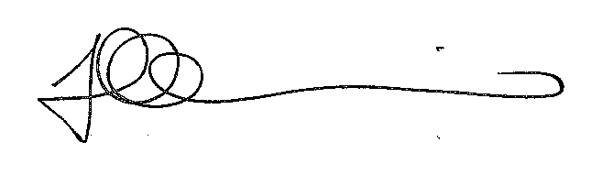
Fran Michelizzi
Accredited FOI Officer

