Early Medical Assessment
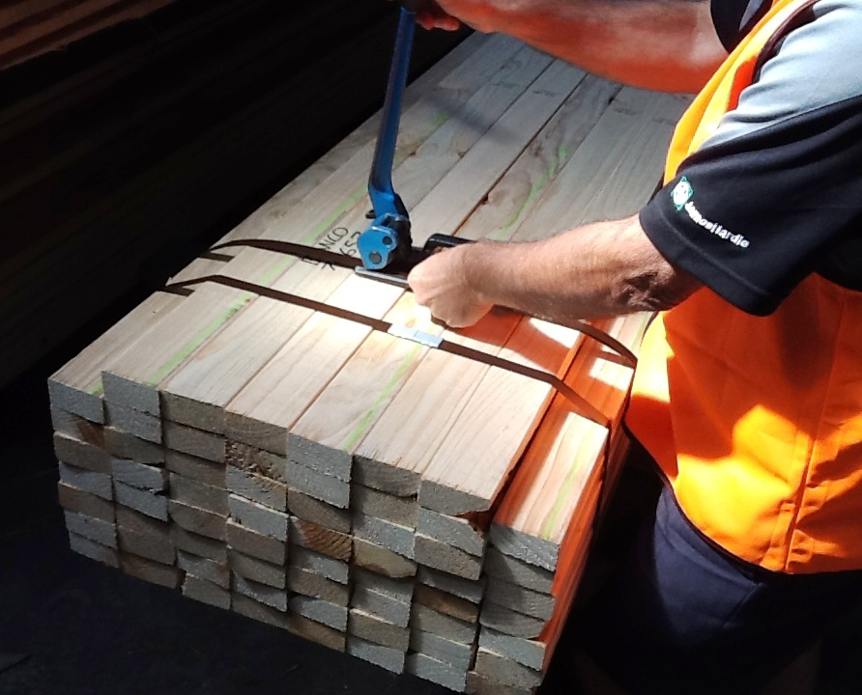

Building Supplies Wholesale
Picker

Building Supplies Wholesale
Picker
Dear Doctor: This form will take up to 5 minutes to complete. Please review each task the worker undertakes (both picture and written description) and tick whether or not the worker can complete this task. If modification required, please leave comments. Space at the end of this document is available for final comments and recommendations.
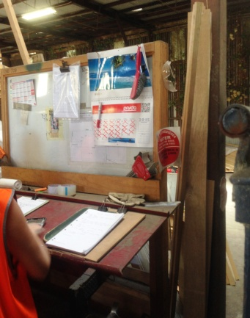  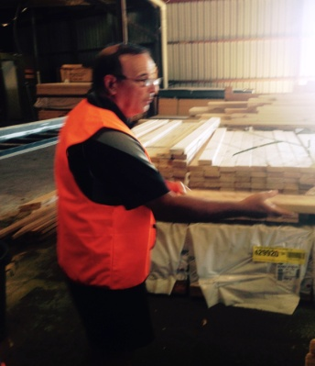  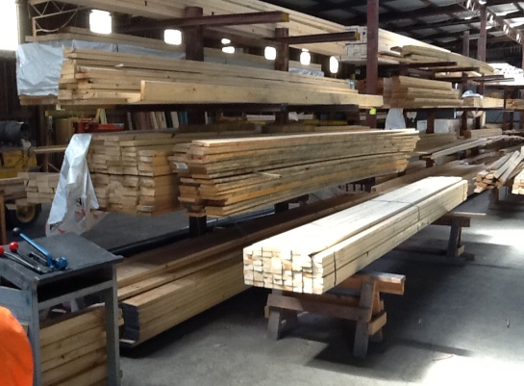  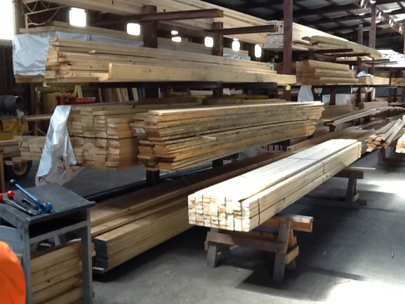 | Picking Timber  - Constant standing and walking.  - Obtaining order sheets from bench and placing on clip board.  - Once opened, timber stacks are located on trestles, trolleys or floor.  - Hand picking 1-2 pieces at a time from stacks (low level postures and gripping required) and placing on trestles.  - Timber lengths are up to 6m long and can be awkward. Counter balancing required to control load.  - Hand trolleys may be available for use with produce on pallets; push/pull force. | Doctor Approval  Yes No  Comments:
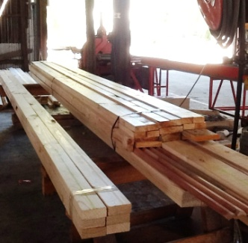  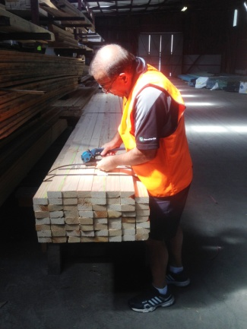  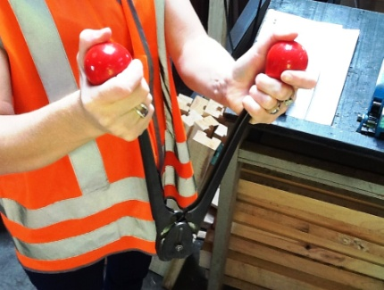 | Wrapping  - When order is completely picked; wrapping is required.  - Strapping machine – ratchet like motion required whilst gripping lever to pull strap tight. Power grip required by dominant hand. Fine gripping required by second hand to feed strap into machine.  - Clipping machine requires bilateral hand grip to squeeze handles together to place clip on strap. | Doctor Approval  Yes No  Comments:
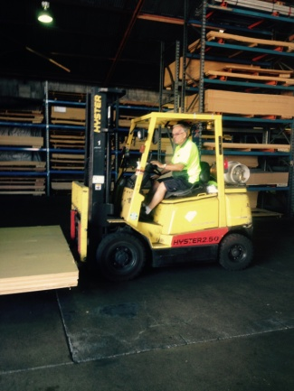 | Forklift driving  - Forklift is used to pick up order and take outside for delivery driver to collect.  - Driving the forklift requires the ability to  - mount the forklift repetitively;  - have unrestricted head and shoulder movement;  - demonstrate strength in arms and hands for gripping the gear stick and the steering wheel. | Doctor Approval  Yes No  Comments:
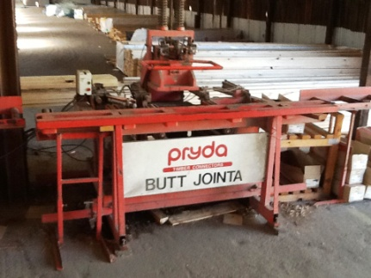  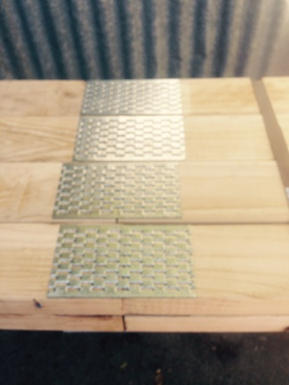 | Butt Jointa  - Occasionally timber lengths longer than the standard 6m are required.  - Picking the 2 lengths required to make required timber length from trestles or floor.  - Push/pull force required to position clamp and pulling of lever to join. Handle and lever are between waist and chest height.  - Pushing / rolling joined timber length onto trestle nearby.
Work Capacity Form
Doctor Review (include final comments)

I confirm that in my view, subject to the above comments, the worker is able to perform certain duties detailed in this Early Medical Assessment.
These duties should be reassessed on: |  | Date:

Signature : |  | Date:

Employers Declaration:
I confirm that I/we have reviewed the Doctor’s recommendations and comments. I/we will make suitable changes to make allowances for the Dr’s recommendations.
Signature : |  | Date:

Employees Declaration
My Doctor has discussed their recommendations with me. I have been given the opportunity to participate in this process.
Signature : |  | Date:
For information on completing this form, please contact Business SA on 08 8300 0000.
Disclaimer: This document is published by Business SA with funding from ReturnToWorkSA. All workplaces and circumstances are different and this document should be used as a guide only. It is not diagnostic and should not replace consultation, evaluation, or personal services including examination and an agreed course of action by a licensed practitioner. Business SA and ReturnToWorkSA and their affiliates and their respective agents do not accept any liability for injury, loss or damage arising from the use or reliance on this document. The copyright owner provides permission to reproduce and adapt this document for the purposes indicated and to tailor it (as intended) for individual circumstances. (C) 2016 ReturnToWorkSA

