Early Medical Assessment

Wholesale Medical Equipment Sales Representative
Professional Equipment Wholesaling SAWIC Code 473301

Wholesale Medical Equipment Sales Representative
Dear Doctor: This form will take up to 5 minutes to complete. Please review each task the worker undertakes (both picture and written description) and tick whether or not the worker can complete this task. If modification required, please leave comments. Space at the end of this document is available for final comments and recommendations.
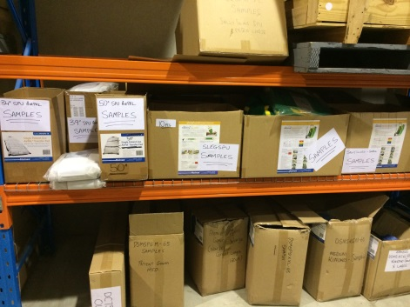 | Loading Vehicle  - Carrying and handling boxes of product to rear of 4WD  - Product samples < 2kg  - Multiple samples to 12kg  - Filled boxes of product to 15kg (19kg rolls)  - 22-25 kg equipment | Doctor Approval  Yes No  Comments:
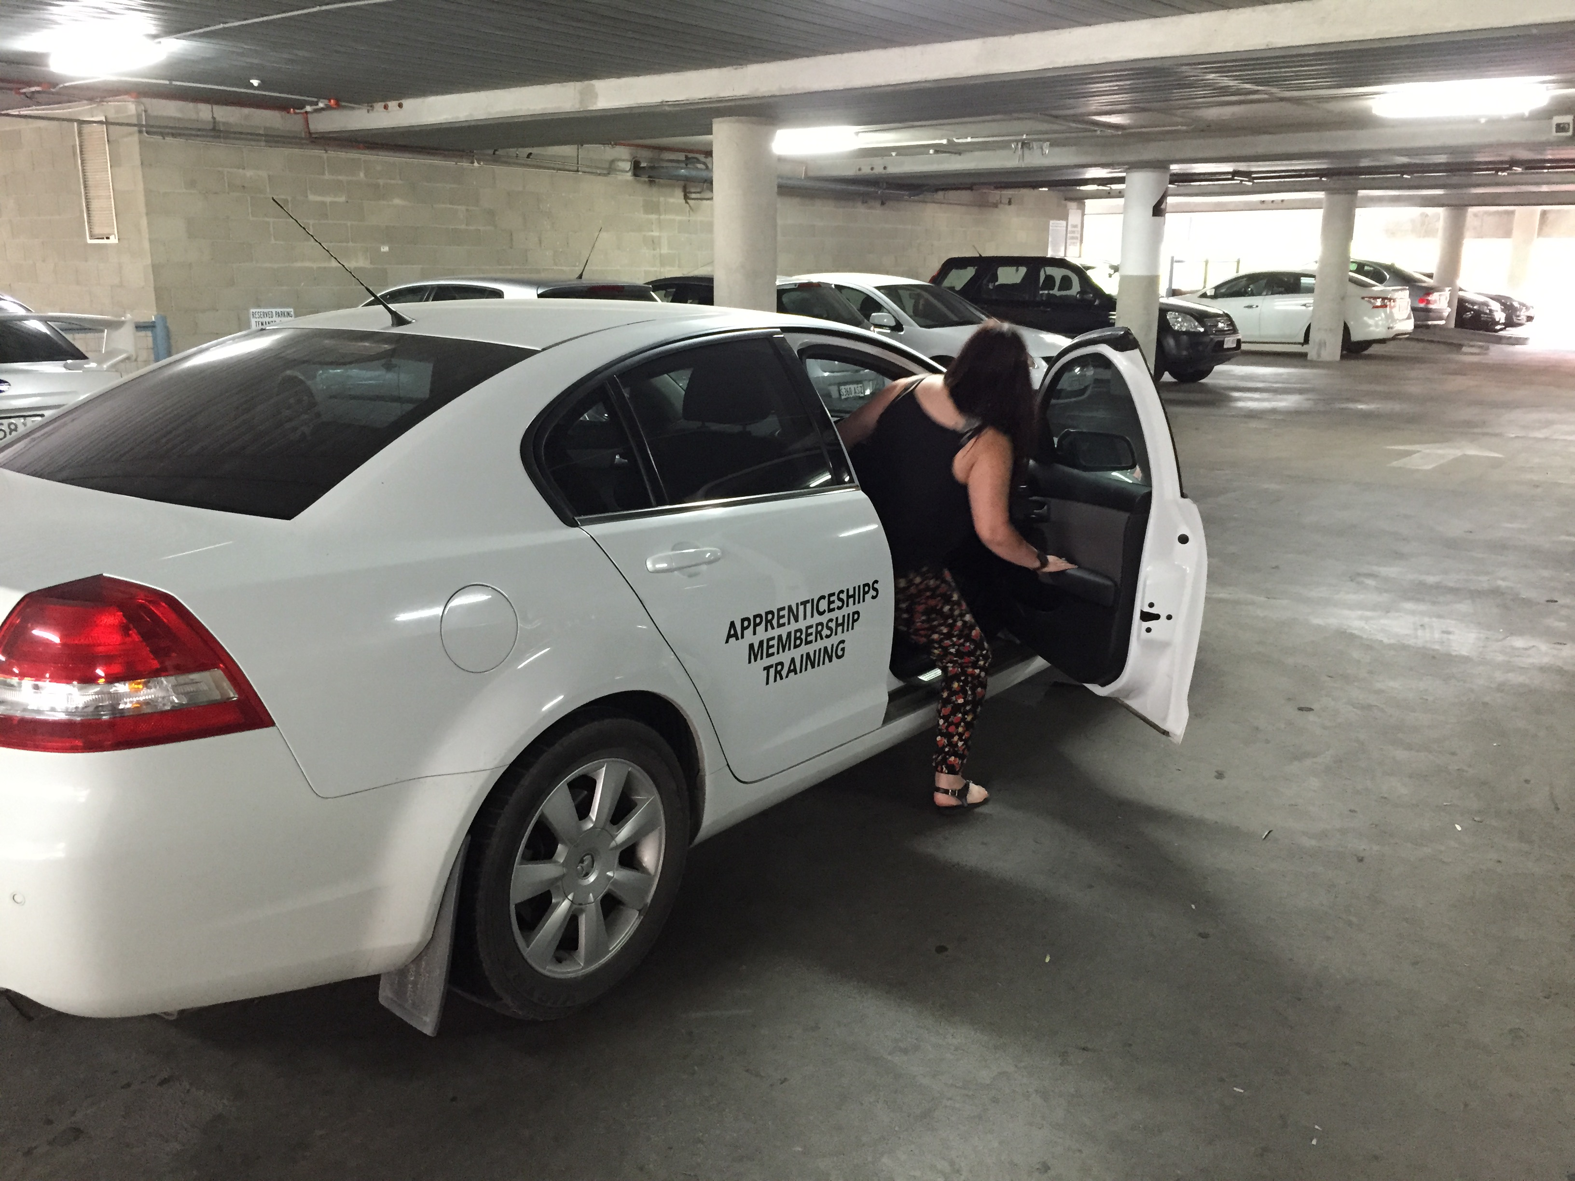 | Travelling to clients  - (40% of work)  - Located within Adelaide metropolitan area (majority)  - Country hospitals (occasionally)  - Interstate (air or car) – once a month | Doctor Approval  Yes No  Comments:
 | Demonstrating Equipment at Client’s Workplace  - Removal and transportation of equipment and samples  - Demonstrating techniques and equipment e.g. slide sheet; lifters and slings (medium push/pull forces); | Doctor Approval  Yes No  Comments:
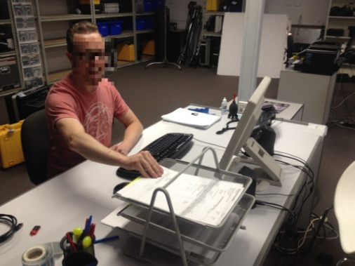 | Customer Liaison and Ordering in Office (60%)  - Computer work  - Telephone calls  - Handwriting | Doctor Approval  Yes No  Comments:
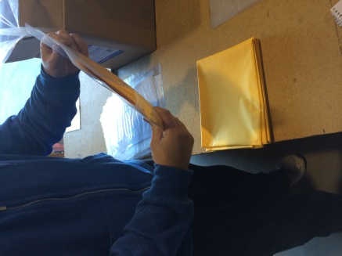 | Bagging Samples  - Removing boxes of product from pallet racking <1.65m and crates  - Handling items < ½ kg  - Bagging items at bench level (standing or sitting). | Doctor Approval  Yes No  Comments:
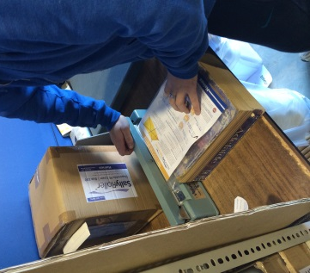 | Packing Single Products  - Removing item from box or crate  - Bagging product < 2kg  - Heat Sealing bag | Doctor Approval  Yes No  Comments:
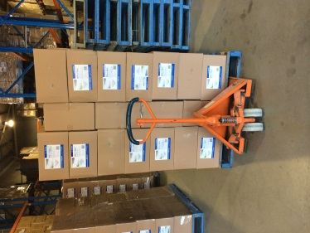 | Warehouse Assistance  - Receive and moving pallets (electric and manual pallet jack)  - Loading product from pallet to 1.65m shelving | Doctor Approval  Yes No  Comments:
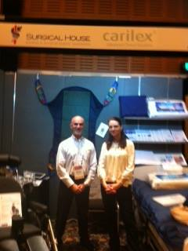 | Setting Up Stands at Conferences and Exhibitions  - Loading products onto tables  - Hanging posters onto panels (> 1.8m)  - Pushing sack truck with products from car park to exhibition hall | Doctor Approval  Yes No  Comments:
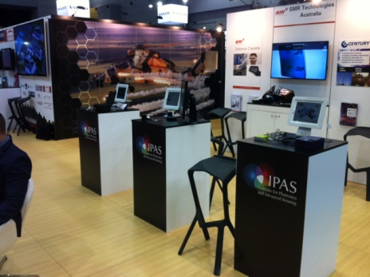 | Attending Conference Stands  - Standing statically talking with customers  - Short distance walking  - Occasional Sitting  - Handling of products, flyers and samples ½ - 5kg | Doctor Approval  Yes No  Comments:
Work Capacity Form
Doctor Review (include final comments)

I confirm that in my view, subject to the above comments, the worker is able to perform certain duties detailed in this Early Medical Assessment.
These duties should be reassessed on: |  | Date:

Signature : |  | Date:

Employers Declaration:
I confirm that I/we have reviewed the Doctor’s recommendations and comments. I/we will make suitable changes to make allowances for the Dr’s recommendations.
Signature : |  | Date:

Employees Declaration
My Doctor has discussed their recommendations with me. I have been given the opportunity to participate in this process.
Signature : |  | Date:
For information on completing this form, please contact Business SA on 08 8300 0000.
Disclaimer: This document is published by Business SA with funding from ReturnToWorkSA. All workplaces and circumstances are different and this document should be used as a guide only. It is not diagnostic and should not replace consultation, evaluation, or personal services including examination and an agreed course of action by a licensed practitioner. Business SA and ReturnToWorkSA and their affiliates and their respective agents do not accept any liability for injury, loss or damage arising from the use or reliance on this document. The copyright owner provides permission to reproduce and adapt this document for the purposes indicated and to tailor it (as intended) for individual circumstances. (C) 2016 ReturnToWorkSA

