Early Medical Assessment
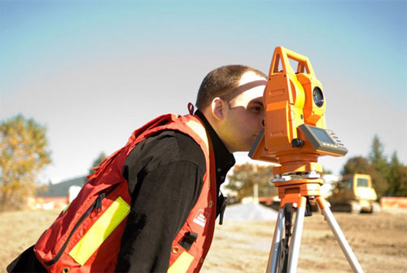

Surveying Instruments
Professional Equipment Wholesaling SAWIC Code 473301

Surveying Instruments
Dear Doctor: This form will take up to 5 minutes to complete. Please review each task the worker undertakes (both picture and written description) and tick whether or not the worker can complete this task. If modification required, please leave comments. Space at the end of this document is available for final comments and recommendations.
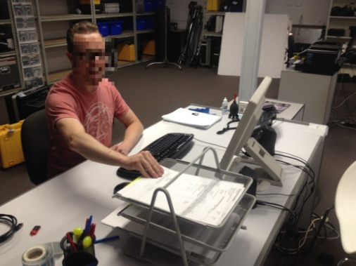 | Administrative Work  - Arrange client calls  - Attend to customer phone enquiries / technical support  - Computer work or quotations and ordering.  - Average duration = 1-3 hours per day | Doctor Approval  Yes No  Comments:
 | Loading Vehicle  - Load items into vehicle – utility or van  - Levelling staff - 1 to 2kgs  - Extendable tripod legs - 5 to 6kgs  - Theodolite contained within a carry case 12kgs | Doctor Approval  Yes No  Comments:
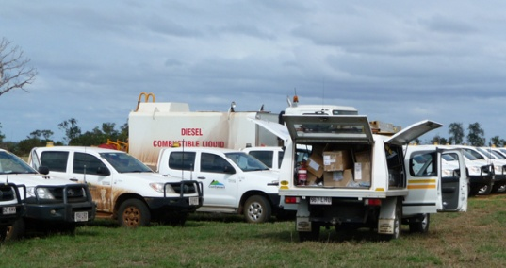 | Driving to Customer  - Drive automatic and power steered vehicle.  - Variable duration depending on worksite. | Doctor Approval  Yes No  Comments:
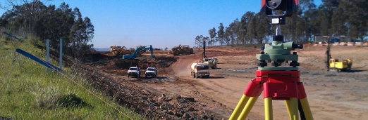 | Access worksites  - Walkover uneven ground; unsealed surfaces and flat surfaces e.g. bitumen to access job site.  - Carry equipment to location (as above) | Doctor Approval  Yes No  Comments:
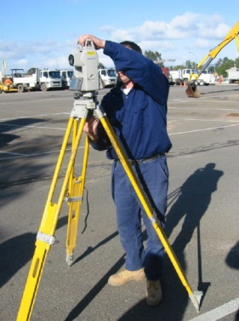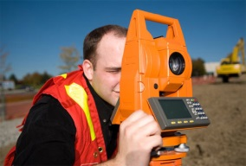 | Demonstrating & Training On-site  - Set up tripod legs (506kg)  - Lift and carry theodolite (12kg)  - Place theodolite on tripod – hand to 1.65m  - Demonstrate use of theodolite | Doctor Approval  Yes No  Comments:
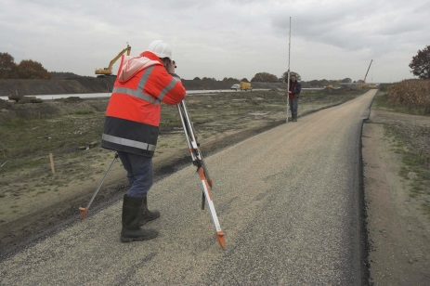 | Levelling  - Walk to a specific location carrying the levelling staff and hold it in an upright position.  - Terrain variable | Doctor Approval  Yes No  Comments:
 | Hammer Pegs  - Locate specific point  - Hammer pegs into the ground at specific point. Hammering resistance is variable depending on ground surface. | Doctor Approval  Yes No  Comments:
 | Office Training  - Drive to customer office  - Teach specifics of equipment  - Teach data / computer operations associated with readings | Doctor Approval  Yes No  Comments:
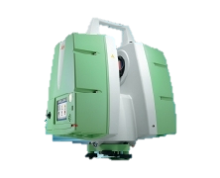 | 3D Laser Scanning  - Supply and teach use of scanner unit (20-25kg)  - Demands as above | Doctor Approval  Yes No  Comments:
Work Capacity Form
Doctor Review (include final comments)

I confirm that in my view, subject to the above comments, the worker is able to perform certain duties detailed in this Early Medical Assessment.
These duties should be reassessed on: |  | Date:

Signature : |  | Date:

Employers Declaration:
I confirm that I/we have reviewed the Doctor’s recommendations and comments. I/we will make suitable changes to make allowances for the Dr’s recommendations.
Signature : |  | Date:

Employees Declaration
My Doctor has discussed their recommendations with me. I have been given the opportunity to participate in this process.
Signature : |  | Date:
For information on completing this form, please contact Business SA on 08 8300 0000.
Disclaimer: This document is published by Business SA with funding from ReturnToWorkSA. All workplaces and circumstances are different and this document should be used as a guide only. It is not diagnostic and should not replace consultation, evaluation, or personal services including examination and an agreed course of action by a licensed practitioner. Business SA and ReturnToWorkSA and their affiliates and their respective agents do not accept any liability for injury, loss or damage arising from the use or reliance on this document. The copyright owner provides permission to reproduce and adapt this document for the purposes indicated and to tailor it (as intended) for individual circumstances. (C) 2016 ReturnToWorkSA

