Early Medical Assessment

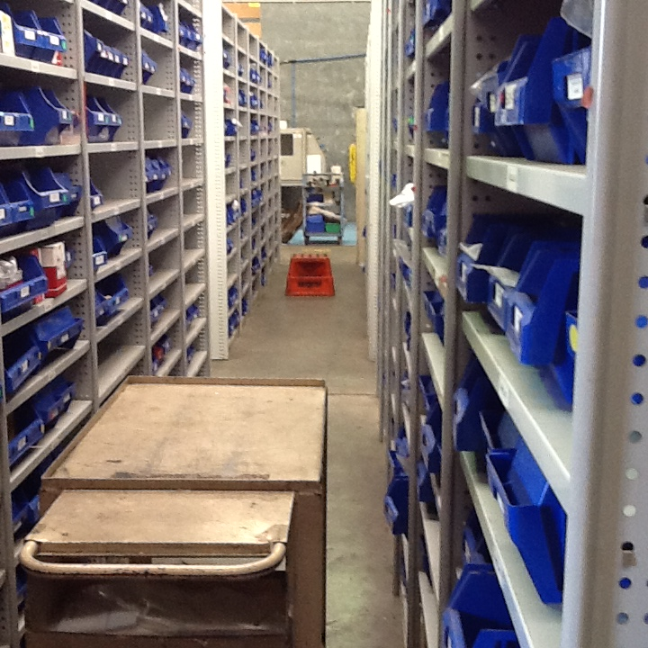

1. Storeperson
2. Professional Equipment Wholesaling SAWIC Code 473301
3. Professional Equipment Wholesaling
4. Storeperson

Dear Doctor: This form will take up to 5 minutes to complete. Please review each task the worker undertakes (both picture and written description) and tick whether or not the worker can complete this task. If modification required, please leave comments. Space at the end of this document is available for final comments and recommendations.

|  |  |  |
| --- | --- | --- |
| L:\RTW Fund Project\Stage One SAWIC Codes 473301 & 484001\Professional Equipment\Cooper Fluid Systems\IMG_0323.JPG | **Administrative Tasks**   * Sitting at bench/desk performing administrative tasks, e.g. * computer work for receipts, dispatches, invoicing and sales orders as well as manage stock/storage space * use phone to liaise/communicate with management/staff, clients, suppliers & transport companies * Bench top: 1.05m (h) Shelf under bench: 0.3m (h) * Adjustable stool | Doctor Approval  Yes  No  Comments: |
| L:\RTW Fund Project\Stage One SAWIC Codes 473301 & 484001\Professional Equipment\Cooper Fluid Systems\IMG_0335.JPG | **Processing Stock and Orders**   * Receive and lift boxes – depending on size and weight of the boxes, items are moved by either forklift, hand truck, trolley jack or using a 1-men or 2‑men‑lift * Unpack goods – involves * bending and lifting | Doctor Approval  Yes  No  Comments: |
| L:\RTW Fund Project\Stage One SAWIC Codes 473301 & 484001\Professional Equipment\Cooper Fluid Systems\IMG_0330.JPG | **Moving stock**   * Use forklift to move bulky and heavy items * Driving the forklift requires the driver to * be able to mount the forklift * have unrestricted head and shoulder movement * demonstrate strength in arms and hands for gripping the gear stick and the steering wheel | Doctor Approval  Yes  No  Comments: |
| L:\RTW Fund Project\Stage One SAWIC Codes 473301 & 484001\Professional Equipment\Cooper Fluid Systems\IMG_0324.JPG L:\RTW Fund Project\Stage One SAWIC Codes 473301 & 484001\Professional Equipment\Cooper Fluid Systems\IMG_0327.JPG | **Moving stock**   * Using trolley jack to move heavy and bulky items * involves pushing and pulling action * needs physical strength in arms, legs and body | Doctor Approval  Yes  No  Comments: |
| L:\RTW Fund Project\Stage One SAWIC Codes 473301 & 484001\Professional Equipment\Cooper Fluid Systems\IMG_0339.JPG | **Moving stock**   * Load trolley with bulky items * Push trolley with bulky items * Unload trolley with bulky items | Doctor Approval  Yes  No  Comments: |
| L:\RTW Fund Project\Stage One SAWIC Codes 473301 & 484001\Professional Equipment\Cooper Fluid Systems\IMG_0338.JPG | **Dispatch**   * Wrap items for dispatch * Reaching up for bubble wrap * Cutting bubble wrap * Pack items for dispatch into boxes – involves a.o. * Bending, lifting, reaching * Height of work bench: 0.9m | Doctor Approval  Yes  No  Comments: |
| L:\RTW Fund Project\Stage One SAWIC Codes 473301 & 484001\Professional Equipment\Cooper Fluid Systems\IMG_0340.JPG | **Managing Stock/Storage Place**   * Maintenance of stock and its storage on both floor and shelves – involves * bending, reaching, climbing ladder and lifting * Height of shelves: floor to 2.18m | Doctor Approval  Yes  No  Comments: |
| L:\RTW Fund Project\Stage One SAWIC Codes 473301 & 484001\Professional Equipment\Cooper Fluid Systems\IMG_0342.JPG L:\RTW Fund Project\Stage One SAWIC Codes 473301 & 484001\Professional Equipment\Cooper Fluid Systems\IMG_0349.JPG | **Machinery**   * Operate crimp machine with foot pedal * Use etcher for tags | Doctor Approval  Yes  No  Comments: |
| L:\RTW Fund Project\Stage One SAWIC Codes 473301 & 484001\Professional Equipment\Cooper Fluid Systems\IMG_0358.JPG L:\RTW Fund Project\Stage One SAWIC Codes 473301 & 484001\Professional Equipment\Cooper Fluid Systems\IMG_0357.JPG  L:\RTW Fund Project\Stage One SAWIC Codes 473301 & 484001\Professional Equipment\Cooper Fluid Systems\IMG_0352.JPG | **Machinery**   * Operate re-usable fitting whizzer for feeding hose * Use rotating motion for tightening * Use foot pedal for operation * Use pressure for re-usable fittings * Extend arm and reach buttons for operation | Doctor Approval  Yes  No  Comments: |

1. Work Capacity Form

**Doctor Review (include final comments)**

|  |
| --- |
|  |
|  |
|  |
|  |
|  |
|  |
|  |
|  |
|  |
|  |

I confirm that in my view, subject to the above comments, the worker is able to perform certain duties detailed in this Early Medical Assessment.

|  |  |  |
| --- | --- | --- |
| These duties should be reassessed on: |  | Date: |

|  |  |  |
| --- | --- | --- |
| Signature : |  | Date: |

**Employers Declaration:**

I confirm that I/we have reviewed the Doctor’s recommendations and comments. I/we will make suitable changes to make allowances for the Dr’s recommendations.

|  |  |  |
| --- | --- | --- |
| Signature : |  | Date: |

**Employees Declaration**

My Doctor has discussed their recommendations with me. I have been given the opportunity to participate in this process.

|  |  |  |
| --- | --- | --- |
| Signature : |  | Date: |

For information on completing this form, please contact Business SA on 08 8300 0000.

***Disclaimer:*** *This document is published by Business SA with funding from ReturnToWorkSA. All workplaces and circumstances are different and this document should be used as a guide only. It is not diagnostic and should not replace consultation, evaluation, or personal services including examination and an agreed course of action by a licensed practitioner. Business SA and ReturnToWorkSA and their affiliates and their respective agents do not accept any liability for injury, loss or damage arising from the use or reliance on this document. The copyright owner provides permission to reproduce and adapt this document for the purposes indicated and to tailor it (as intended) for individual circumstances*. (C) 2016 ReturnToWorkSA