Early Medical Assessment

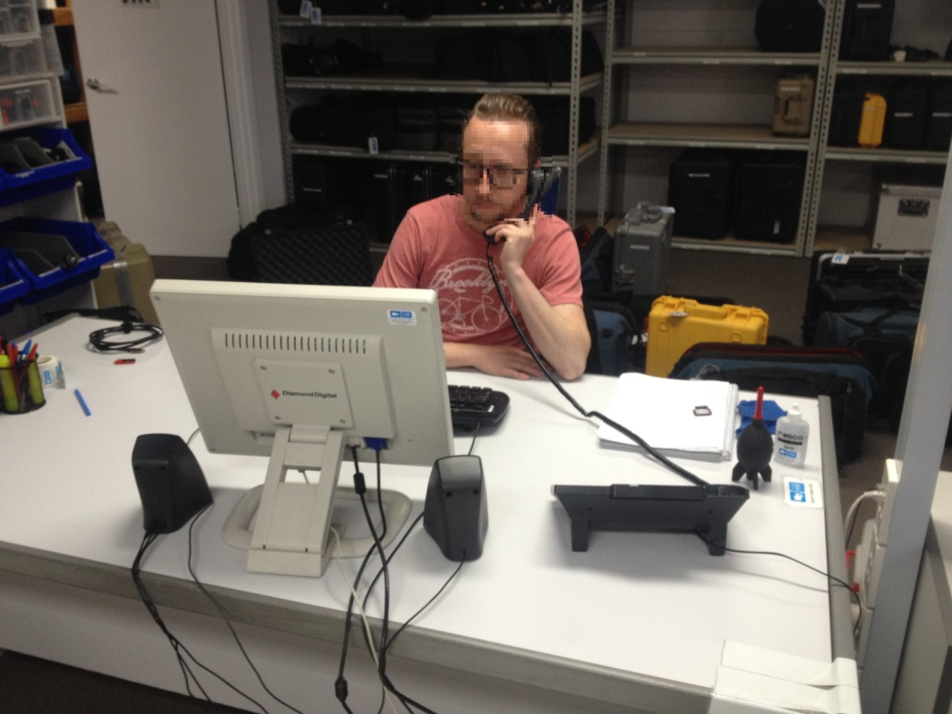

Rental Equipment Manager
Professional Equipment Wholesaling SAWIC Code 473301

Rental Manager
Dear Doctor: This form will take up to 5 minutes to complete. Please review each task the worker undertakes (both picture and written description) and tick whether or not the worker can complete this task. If modification required, please leave comments. Space at the end of this document is available for final comments and recommendations.
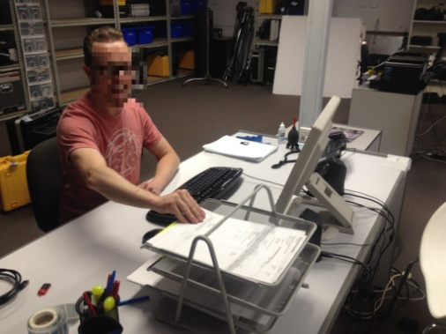 | Desk duties  - Remain in a seated position for approximately 60% of the working day (desk 700mm) with regular breaks  - Quoting and invoicing  - Answer phone calls  - Conduct client meetings | Doctor Approval  Yes No  Comments:
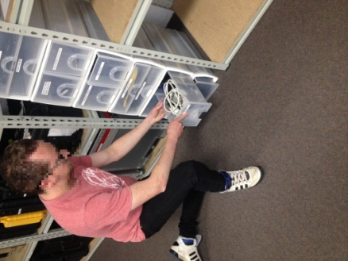  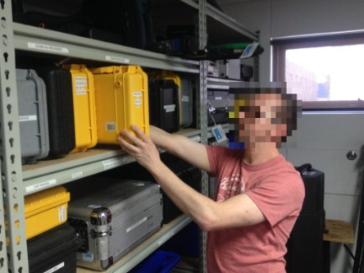  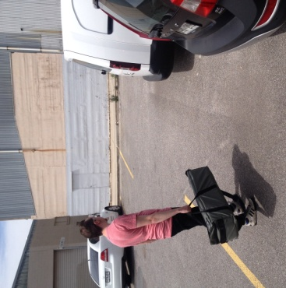 | Manual handling duties  - Manual handling of equipment for approximately 40% of the working day  - Occasional rolling of items larger than 50kg stored at floor level, requiring claw grasping and internal/external shoulder movements  - Occasional lifting of large items (approximately 30kg), accessed from the shelving in a standing position  - Frequent accessing and carrying medium to large pieces of equipment  - Frequent handling, checking and packing of medium sized items  - Frequent handling of small parts | Doctor Approval  Yes No  Comments:
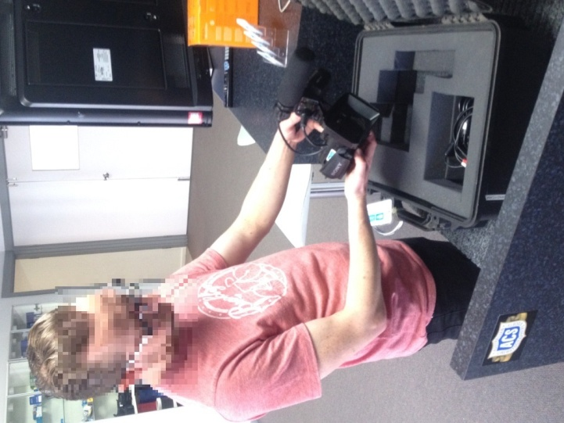  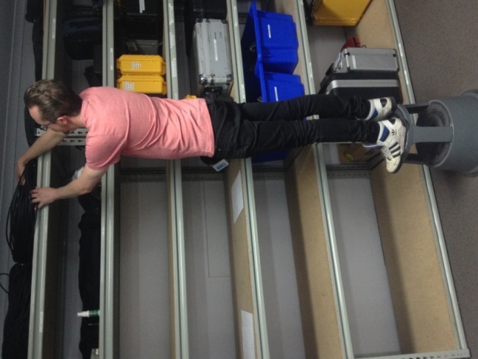 | Movement requirements  - Checking and packing of equipment at 750mm high level, some stooping is required  - Frequent manual handling requiring claw grasping and internal/external shoulder movements  - Access items from floor to above head heights requiring squatting/kneeling, lumbar stooping and overhead reaching with shoulders flexed to greater than 160° | Doctor Approval  Yes No  Comments:
Work Capacity Form
Doctor Review (include final comments)

I confirm that in my view, subject to the above comments, the worker is able to perform certain duties detailed in this Early Medical Assessment.
These duties should be reassessed on: |  | Date:

Signature : |  | Date:

Employers Declaration:
I confirm that I/we have reviewed the Doctor’s recommendations and comments. I/we will make suitable changes to make allowances for the Dr’s recommendations.
Signature : |  | Date:

Employees Declaration
My Doctor has discussed their recommendations with me. I have been given the opportunity to participate in this process.
Signature : |  | Date:
For information on completing this form, please contact Business SA on 08 8300 0000.
Disclaimer: This document is published by Business SA with funding from ReturnToWorkSA. All workplaces and circumstances are different and this document should be used as a guide only. It is not diagnostic and should not replace consultation, evaluation, or personal services including examination and an agreed course of action by a licensed practitioner. Business SA and ReturnToWorkSA and their affiliates and their respective agents do not accept any liability for injury, loss or damage arising from the use or reliance on this document. The copyright owner provides permission to reproduce and adapt this document for the purposes indicated and to tailor it (as intended) for individual circumstances. (C) 2016 ReturnToWorkSA

