Early Medical Assessment

Medical Warehouse Storeperson
Professional Equipment Wholesaling SAWIC Code 473301

Medical Warehouse Storeperson
Dear Doctor: This form will take up to 5 minutes to complete. Please review each task the worker undertakes (both picture and written description) and tick whether or not the worker can complete this task. If modification required, please leave comments. Space at the end of this document is available for final comments and recommendations.
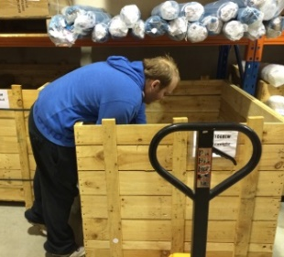 | Pick Orders  - Slide boxes from shelf onto the trolley.  - Open boxes and remove selected product.  - Retrieve items from wooden crate  - Weights handled:  - < 5kg  - 5-12kg (boxes)  - 19kg rolls  - 22-25kg equipment | Doctor Approval  Yes No  Comments:
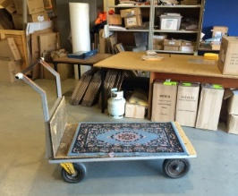  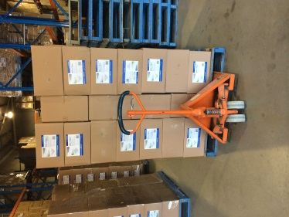  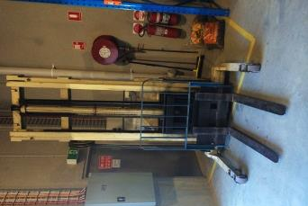 | Receipt of Deliveries  - Receive stock delivery drivers and trucks.  - Receive palletised goods from truck and move to pallet racking using walking forklift +/- manual pallet jack (medium push force) | Doctor Approval  Yes No  Comments:
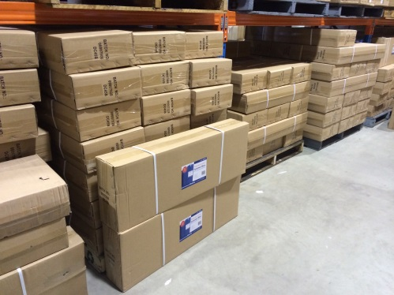 | Bulk Stock  - Check off goods  - Move pallets and large stock using manual pallet jack and walking forklift  - Moving single items by sliding onto trolley | Doctor Approval  Yes No  Comments:
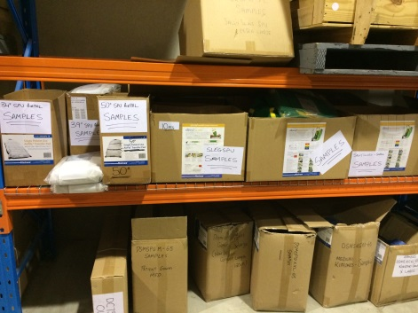 | Stacking Shelves  - Placing single boxes (5-12kg) into shelves (0.75;1.3m)  - Upending rolls (up to 19kg full) and tilting onto shelf at 1.35 m | Doctor Approval  Yes No  Comments:
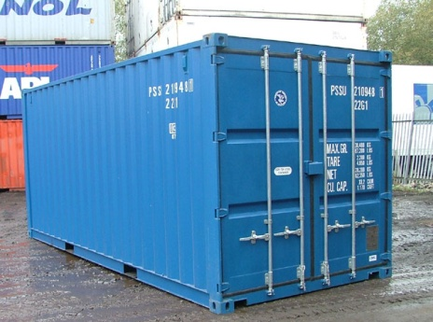 | Emptying Shipping Container  - Removing boxes of product from pallet racking <1.65m and crates  - Handling items < ½ kg  - Bagging items at bench level (standing or sitting). | Doctor Approval  Yes No  Comments:
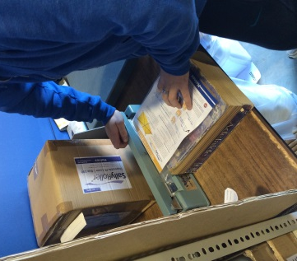 | - Packing Single Products  - Removing item from box or crate  - Bagging product < 2kg  - Heat Sealing bag | Doctor Approval  Yes No  Comments:
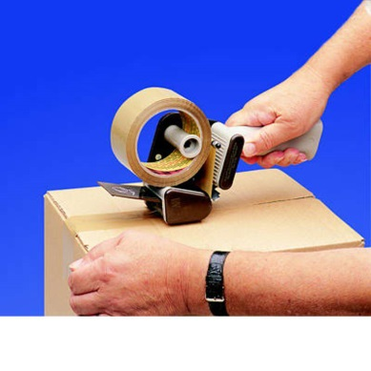 | Taping boxes  - Hold ½ kg hand held tape sealing tool to tape cartons shut.  - Lift carton to pallet or bench destination (3 -12kg)  - Lift carton to pallet or bench destination (12 - 22kg) | Doctor Approval  Yes No  Comments:
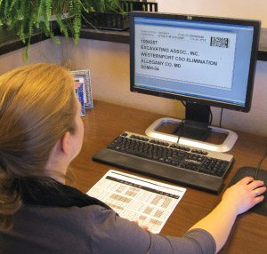 | Inventory Control  - Sit on a basic computer chair at a 0.75m high computer workstation in the warehouse  - Sitting duration is intermittent up to 30 minutes at a time | Doctor Approval  Yes No  Comments:
Work Capacity Form
Doctor Review (include final comments)

I confirm that in my view, subject to the above comments, the worker is able to perform certain duties detailed in this Early Medical Assessment.
These duties should be reassessed on: |  | Date:

Signature : |  | Date:

Employers Declaration:
I confirm that I/we have reviewed the Doctor’s recommendations and comments. I/we will make suitable changes to make allowances for the Dr’s recommendations.
Signature : |  | Date:

Employees Declaration
My Doctor has discussed their recommendations with me. I have been given the opportunity to participate in this process.
Signature : |  | Date:
For information on completing this form, please contact Business SA on 08 8300 0000.
Disclaimer: This document is published by Business SA with funding from ReturnToWorkSA. All workplaces and circumstances are different and this document should be used as a guide only. It is not diagnostic and should not replace consultation, evaluation, or personal services including examination and an agreed course of action by a licensed practitioner. Business SA and ReturnToWorkSA and their affiliates and their respective agents do not accept any liability for injury, loss or damage arising from the use or reliance on this document. The copyright owner provides permission to reproduce and adapt this document for the purposes indicated and to tailor it (as intended) for individual circumstances. (C) 2016 ReturnToWorkSA

