Early Medical Assessment

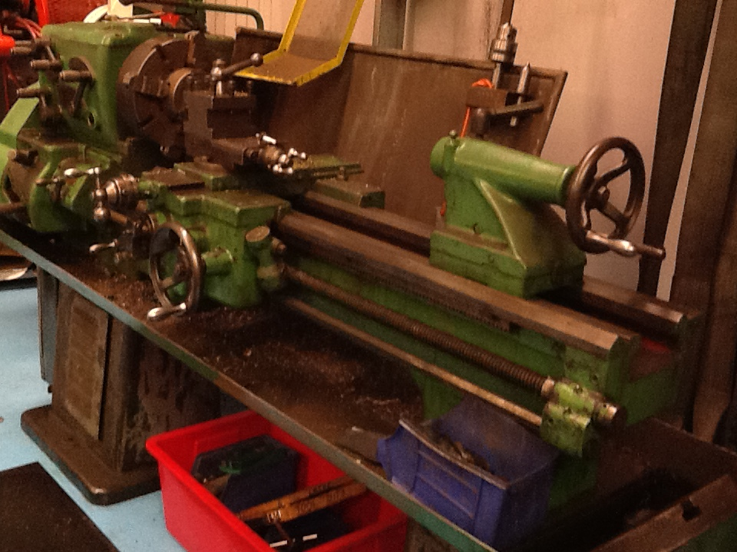

1. Fitter
2. Professional Equipment Wholesaling SAWIC Code 473301
3. Fitter

Dear Doctor: This form will take up to 5 minutes to complete. Please review each task the worker undertakes (both picture and written description) and tick whether or not the worker can complete this task. If modification required, please leave comments. Space at the end of this document is available for final comments and recommendations.

|  |  |  |
| --- | --- | --- |
| L:\RTW Fund Project\Stage One SAWIC Codes 473301 & 484001\Professional Equipment\Cooper Fluid Systems\IMG_0382.JPG | **Workload Management**   * Walk to front office to collect job cards and walk to designated area to see whether items for service and repair have come in * Move items for service and repair to fitter’s work area * Depending on size and weight, either forklift, hand truck, trolley jack or 2‑men lift are used * (This position involves walking, standing, bending and lifting heavy items all day.) | Doctor Approval  Yes  No  Comments: |
| L:\RTW Fund Project\Stage One SAWIC Codes 473301 & 484001\Professional Equipment\Cooper Fluid Systems\IMG_0324.JPG L:\RTW Fund Project\Stage One SAWIC Codes 473301 & 484001\Professional Equipment\Cooper Fluid Systems\IMG_0325.JPG | **Aids to Move Heavy/Bulky Items**   * Trolley jack – involves pushing and pulling action * Forklift – requires the driver to be able to mount the forklift, have unrestricted head and shoulder movement and have strength in arms/hands needed for gripping gear stick and steering wheel |  |
| L:\RTW Fund Project\Stage One SAWIC Codes 473301 & 484001\Professional Equipment\Cooper Fluid Systems\IMG_0360.JPG | **Fitter’s Main Tools**   * Pipe Wrenches (tools used for tightening or loosening) * max. weight 10kg * (Using these kinds of tools requires physical strength in arms, legs and body.) | Doctor Approval  Yes  No  Comments: |
| L:\RTW Fund Project\Stage One SAWIC Codes 473301 & 484001\Professional Equipment\Cooper Fluid Systems\IMG_0365.JPG | **Fitter’s Main Tools**   * Vice (a holding device or clamp that holds an object in a fixed position) * (Using these kinds of tools requires physical strength in arms, legs and body.) | Doctor Approval  Yes  No  Comments: |
| L:\RTW Fund Project\Stage One SAWIC Codes 473301 & 484001\Professional Equipment\Cooper Fluid Systems\IMG_0372.JPG | **Fitter’s Main Tools/Machinery**   * Lathe (a machine that rotates metal pieces on its axis, enabling it to cut or drill a work piece evenly) * (Using the lathe requires some physical strength in arm and hands. Repeated gripping and rotating action of the wrist is needed for loosening or tightening various components including the work piece.) | Doctor Approval  Yes  No  Comments: |
| L:\RTW Fund Project\Stage One SAWIC Codes 473301 & 484001\Professional Equipment\Cooper Fluid Systems\IMG_0368.JPGL:\RTW Fund Project\Stage One SAWIC Codes 473301 & 484001\Professional Equipment\Cooper Fluid Systems\IMG_0369.JPG | **Fitter’s MainTools/Machinery**   * Hot washer (automatic Turbo wash that cleans large items at 80°C) * Lift lid of washer and place item for cleaning inside * (This process involves heavy lifting for placing the item in the washer, bending and pushing lid upwards to open washer then pulling down to close washer.) | Doctor Approval  Yes  No  Comments: |
| L:\RTW Fund Project\Stage One SAWIC Codes 473301 & 484001\Professional Equipment\Cooper Fluid Systems\IMG_0370.JPG | **Fitter’s Main Tools**   * Pressurised running water that enables small items to be hand washed | Doctor Approval  Yes  No  Comments: |
| L:\RTW Fund Project\Stage One SAWIC Codes 473301 & 484001\Professional Equipment\Cooper Fluid Systems\IMG_0375.JPGL:\RTW Fund Project\Stage One SAWIC Codes 473301 & 484001\Professional Equipment\Cooper Fluid Systems\IMG_0379.JPG | **Fitter’s Main Tools/Machinery**   * Press for final testing * (Using the press requires some physical strength in arms and hands.) | Doctor Approval  Yes  No  Comments: |

1. Work Capacity Form

**Doctor Review (include final comments)**

|  |
| --- |
|  |
|  |
|  |
|  |
|  |
|  |
|  |
|  |
|  |
|  |

I confirm that in my view, subject to the above comments, the worker is able to perform certain duties detailed in this Early Medical Assessment.

|  |  |  |
| --- | --- | --- |
| These duties should be reassessed on: |  | Date: |

|  |  |  |
| --- | --- | --- |
| Signature : |  | Date: |

**Employers Declaration:**

I confirm that I/we have reviewed the Doctor’s recommendations and comments. I/we will make suitable changes to make allowances for the Dr’s recommendations.

|  |  |  |
| --- | --- | --- |
| Signature : |  | Date: |

**Employees Declaration**

My Doctor has discussed their recommendations with me. I have been given the opportunity to participate in this process.

|  |  |  |
| --- | --- | --- |
| Signature : |  | Date: |

For information on completing this form, please contact Business SA on 08 8300 0000.

***Disclaimer:*** *This document is published by Business SA with funding from ReturnToWorkSA. All workplaces and circumstances are different and this document should be used as a guide only. It is not diagnostic and should not replace consultation, evaluation, or personal services including examination and an agreed course of action by a licensed practitioner. Business SA and ReturnToWorkSA and their affiliates and their respective agents do not accept any liability for injury, loss or damage arising from the use or reliance on this document. The copyright owner provides permission to reproduce and adapt this document for the purposes indicated and to tailor it (as intended) for individual circumstances*. (C) 2016 ReturnToWorkSA