Early Medical Assessment

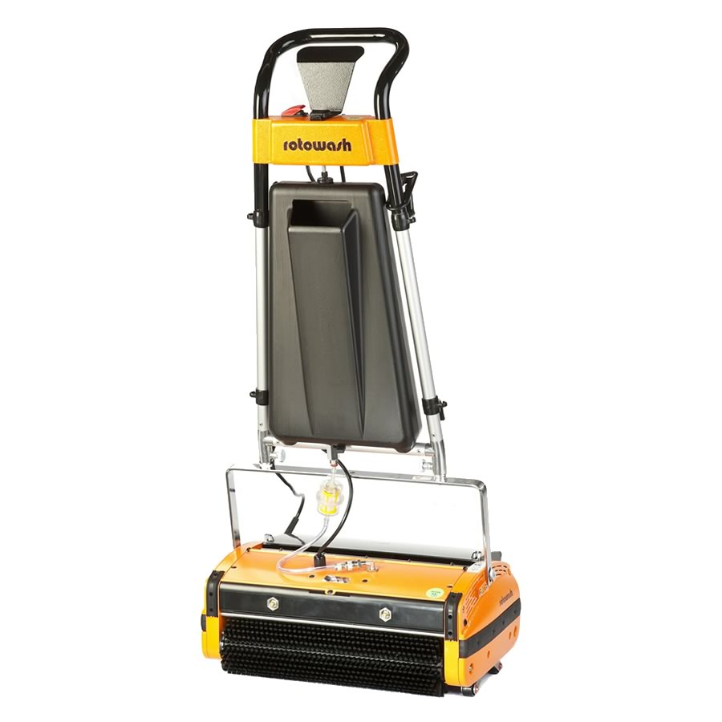

Professional Equipment Wholesaling
Electric Floor Polisher Retailing

Professional Equipment Wholesaling
Electric Floor Polishing Retailing
Dear Doctor: This form will take up to 5 minutes to complete. Please review each task the worker undertakes (both picture and written description) and tick whether or not the worker can complete this task. If modification required, please leave comments. Space at the end of this document is available for final comments and recommendations.
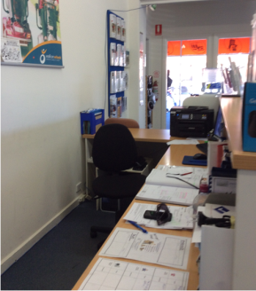 | Administrative Work  - Average 2 hours per day.  - Arranging client calls using telephone.  - Seated computer work or quotations and ordering.  - Accounts. | Doctor Approval  Yes No  Comments:
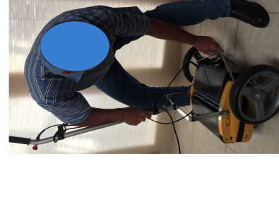  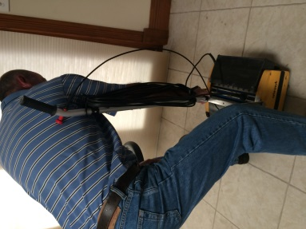 | Loading Vehicle  - Attaching wheels to cleaning machine involving bending/squatting.  - Pushing machine to utility vehicle (medium level force).  - Lifting 23kg machine and chemicals (1 litre/ 1kg) into utility tray. | Doctor Approval  Yes No  Comments:
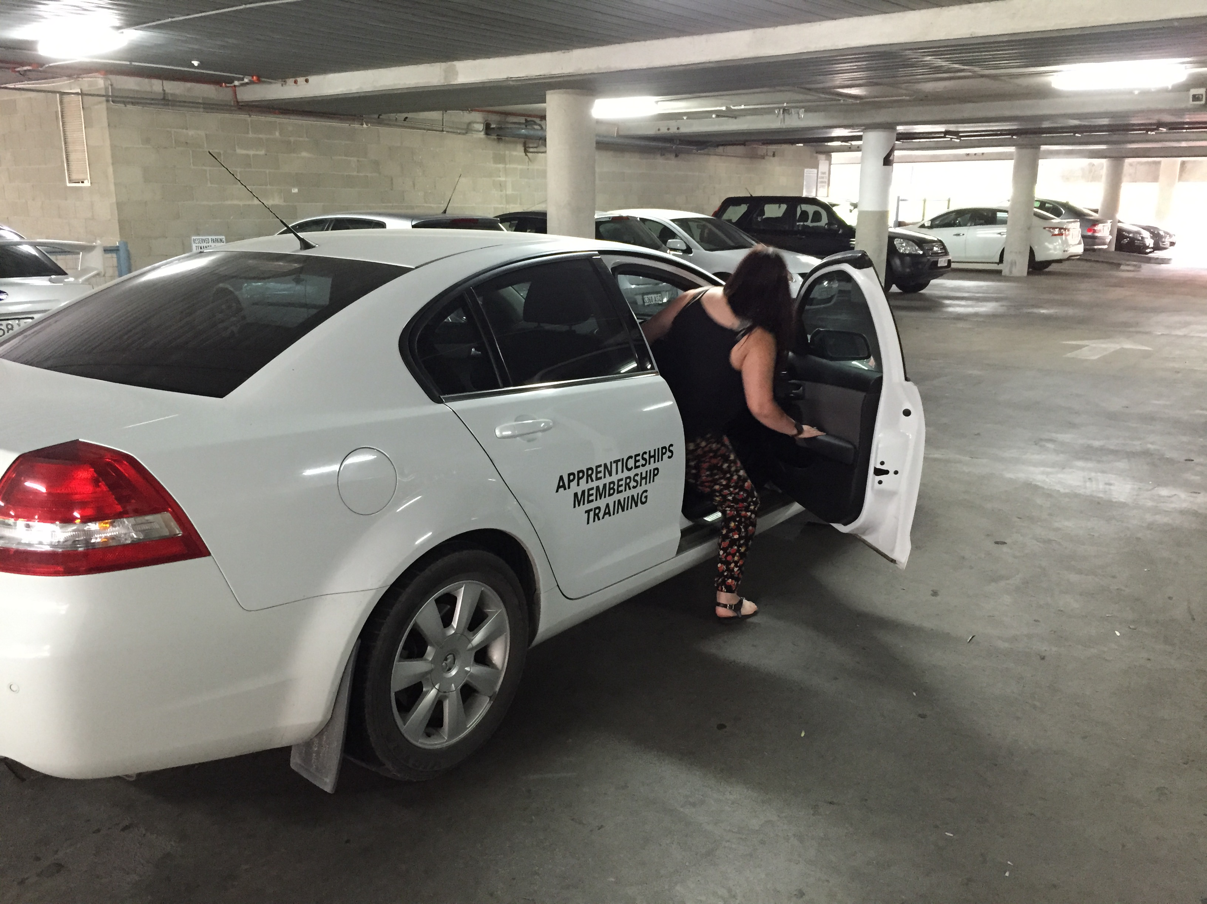 | Driving to Customer  - Driving automatic and power steered vehicle.  - Variable duration 10 minutes to 1 hour.  - Like suburbs are scheduled together. | Doctor Approval  Yes No  Comments:
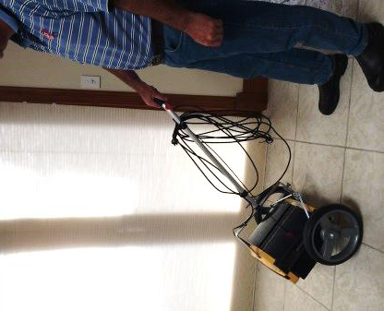 | Unloading Vehicle at Customer  - Lifting machine and chemical (1 litre/ 1kg) from utility tray  - Attaching wheels to cleaning machine involving bending/squatting.  - Pushing machine to customer; occasional lifting and step/stair climbing. | Doctor Approval  Yes No  Comments:
 | Discussing Product  - Static standing during discussion – 5 minutes.  - Inner range stooping or sitting to display brochures on bench or table. | Doctor Approval  Yes No  Comments:
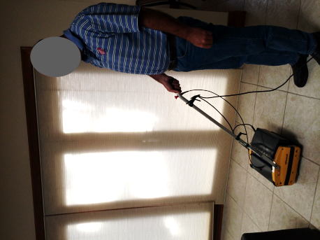 | Demonstrating Equipment  - Plugging power in to socket (low level posture).  - Attaching receptacles and adding water (2 litres/ 2kg).  - Walking behind pushing machine (light level force) for < 5 mins to demonstrate machine’s ability. | Doctor Approval  Yes No  Comments:
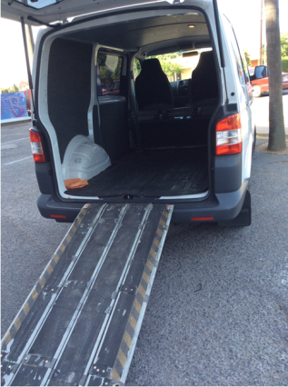 | Delivery and training  - Delivering machine (15-27.5kg) to customer by driving to site and unloading.  - Training customer in attachment /detachment of wheels and machine operation. | Doctor Approval  Yes No  Comments:
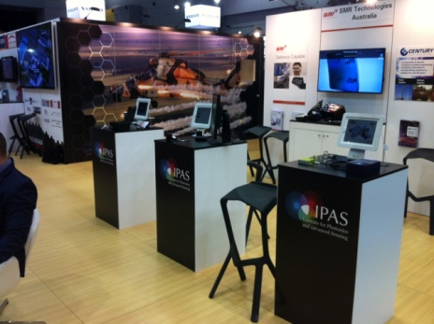 | Attending Exhibitions  - Transporting machine to site (as per demonstration).  - Affixing posters to partitions.  - Standing statically talking with customers.  - Short distance walking.  - Occasional sitting.  - Handling of products, flyers and samples ½ - 5kg. | Doctor Approval  Yes No  Comments:
Work Capacity Form
Doctor Review (include final comments)

I confirm that in my view, subject to the above comments, the worker is able to perform certain duties detailed in this Early Medical Assessment.
These duties should be reassessed on: |  | Date:

Signature : |  | Date:

Employers Declaration:
I confirm that I/we have reviewed the Doctor’s recommendations and comments. I/we will make suitable changes to make allowances for the Dr’s recommendations.
Signature : |  | Date:

Employees Declaration
My Doctor has discussed their recommendations with me. I have been given the opportunity to participate in this process.
Signature : |  | Date:
For information on completing this form, please contact Business SA on 08 8300 0000.
Disclaimer: This document is published by Business SA with funding from ReturnToWorkSA. All workplaces and circumstances are different and this document should be used as a guide only. It is not diagnostic and should not replace consultation, evaluation, or personal services including examination and an agreed course of action by a licensed practitioner. Business SA and ReturnToWorkSA and their affiliates and their respective agents do not accept any liability for injury, loss or damage arising from the use or reliance on this document. The copyright owner provides permission to reproduce and adapt this document for the purposes indicated and to tailor it (as intended) for individual circumstances. (C) 2016 ReturnToWorkSA

