Early Medical Assessment

Health Care Sales Professional/Manager
Professional Equipment Wholesaling SAWIC Code 473301

Health Care Sales Professional / Manager
Dear Doctor: This form will take up to 5 minutes to complete. Please review each task the worker undertakes (both picture and written description) and tick whether or not the worker can complete this task. If modification required, please leave comments. Space at the end of this document is available for final comments and recommendations.
 | Customer Service  - Stand and discuss product with client  - Assist clients with mobile items, e.g.  - retrieve product (average weight of a wheel chair is approx. 15kg)  - demonstrate product’s usage  - help client to test product  - (The above requires some bending, strength and pulling/pushing, however, staff have had OH&S instructions in lifting techniques.) | Doctor Approval  Yes No  Comments:
 | Customer Service  - Handle stock (⅓ - 5kg) from the display board (height: 2.5m)  - This involves  - reaching up  - slight bending | Doctor Approval  Yes No  Comments:
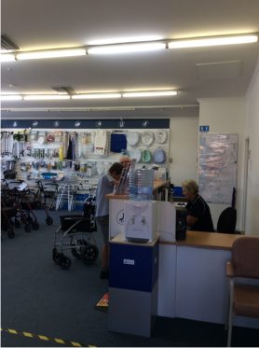 | Process Transaction  - Walk to – and serve client at – front counter (height: 1.2m)  - Handle cash or EFT  - Bag items at desk (desk height: 0.77m) | Doctor Approval  Yes No  Comments:
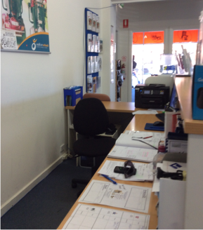 | Administration  - Desk work (4-5 hrs/day)  - Desk height: 0.77m  - Using computer  - Attending to phone calls and emails  - Hand writing | Doctor Approval  Yes No  Comments:
 | Other Daily Tasks  - Set up display (on wheels)  - Receive goods (courier delivers to back door)  - Move item by using a sack trolley  - Unpack items  - (Staff have had OH&S instructions in lifting and bending techniques)  - Dust and clean surfaces/glass  - Use (pull) vacuum cleaner on carpet | Doctor Approval  Yes No  Comments:
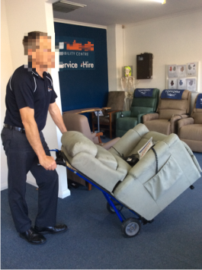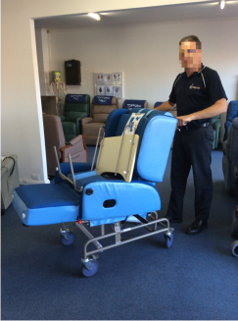  Photo 1 Photo 2 | Other Tasks (only performed by male staff)  - Deliver recliners to clients in one of the company vans  Photo 1  - Tip recliner so sack trolley can fit underneath  - Pushing the handles down, tip sack trolley so it can be wheeled  Photo 2  - Wheel recliner to the van  - Attach ramp to van  - Push and/or pull the sack trolley and/or recliner into van by using a ramp | Doctor Approval  Yes No  Comments:
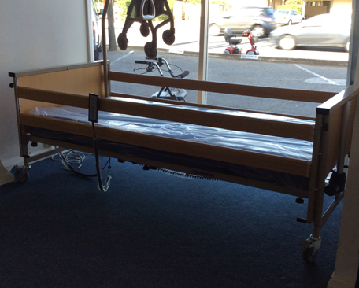 | Other Tasks (only performed by male staff)  - Deliver beds on wheels to clients in one of company vans (2 people job)  - Dismantle bed so it fits into van (sides of bed)  - Push and/or pull the bed into van by using a ramp | Doctor Approval  Yes No  Comments:
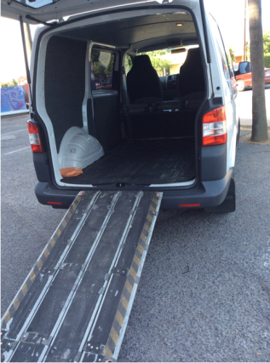 | - Other Tasks (only performed by male staff)  - Drive the company van (approx. 3-4 hrs/day)  - Open hatch at the back  - Attach ramp to van | Doctor Approval  Yes No  Comments:
Work Capacity Form
Doctor Review (include final comments)

I confirm that in my view, subject to the above comments, the worker is able to perform certain duties detailed in this Early Medical Assessment.
These duties should be reassessed on: |  | Date:

Signature : |  | Date:

Employers Declaration:
I confirm that I/we have reviewed the Doctor’s recommendations and comments. I/we will make suitable changes to make allowances for the Dr’s recommendations.
Signature : |  | Date:

Employees Declaration
My Doctor has discussed their recommendations with me. I have been given the opportunity to participate in this process.
Signature : |  | Date:
For information on completing this form, please contact Business SA on 08 8300 0000.
Disclaimer: This document is published by Business SA with funding from ReturnToWorkSA. All workplaces and circumstances are different and this document should be used as a guide only. It is not diagnostic and should not replace consultation, evaluation, or personal services including examination and an agreed course of action by a licensed practitioner. Business SA and ReturnToWorkSA and their affiliates and their respective agents do not accept any liability for injury, loss or damage arising from the use or reliance on this document. The copyright owner provides permission to reproduce and adapt this document for the purposes indicated and to tailor it (as intended) for individual circumstances. (C) 2016 ReturnToWorkSA

