Early Medical Assessment

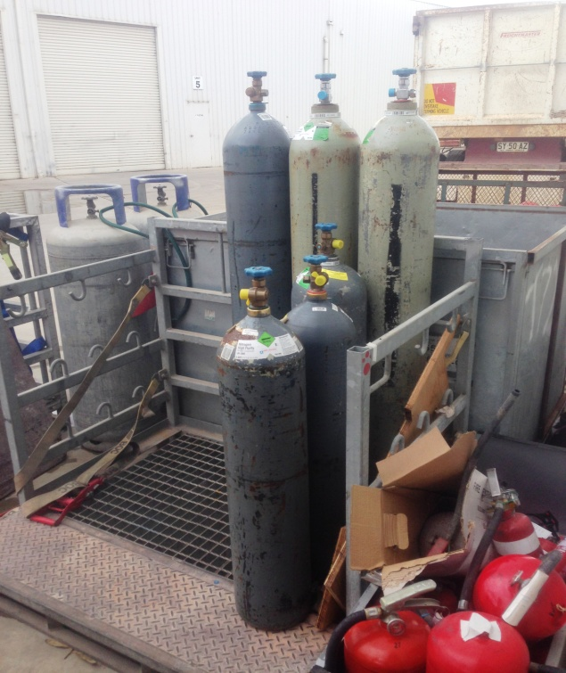

Machinery and Equipment Wholesale
Workshop

Machinery and Equipment Wholesale
Workshop
Dear Doctor: This form will take up to 5 minutes to complete. Please review each task the worker undertakes (both picture and written description) and tick whether or not the worker can complete this task. If modification required, please leave comments. Space at the end of this document is available for final comments and recommendations.
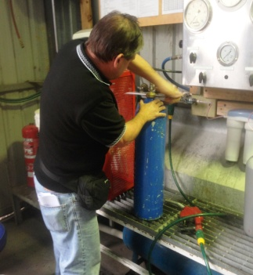  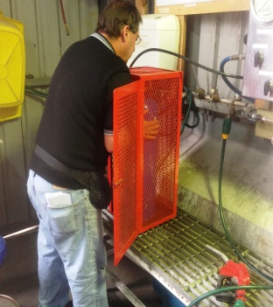  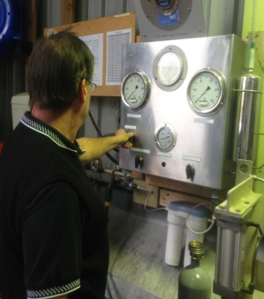  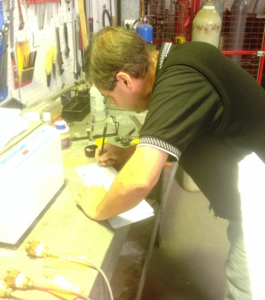  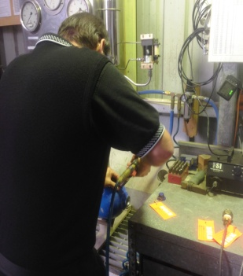 | Cylinder Re-Test Station  - Inspecting external surface of cylinder.  - Unscrewing plug (fine motor) and inspecting inside cylinder using light and magnifier for checking the thread. Neck flexion to see inside cylinder which is on a bench at 560mm.  - Filling cylinder with water using hose – power grip on nozzle.  - Screwing in top – bilateral grip for tightening.  - Lifting cylinder into safety cage (scuba up to 50kg; if more than this a rotator* is used) and inserting hose (approx shoulder height).  (*rotator holds larger cylinders and is moved with a forklift. Worker turns a handle to rotate cylinder so no lifting is required.)  - Static forward reach to approx. shoulder height to work knobs which fill the tank with air to increase pressure.  - Writing / recording in book on bench.  - Checking inside cylinder again with light.  - Stamping tank with date using drill type machine (power grip).  - Carrying cylinder to drying rack about 3m away. | Doctor Approval  Yes No  Comments:
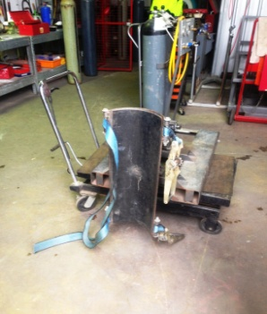

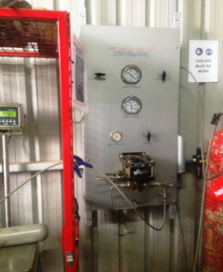  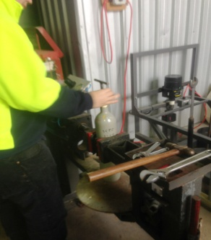  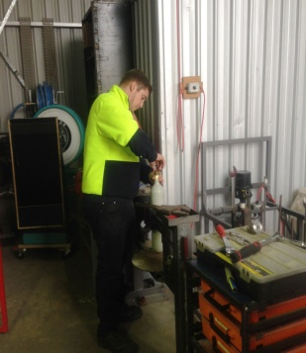 | Filling Cylinders  - Lifting empty cylinder onto scales and attaching hose.  - Closing cage door and adjusting knobs (approx. shoulder heights) to fill cylinder with gas.  - Lifting full cylinder out and placing upright to tighten lid and remove plug. Bilateral gripping with force required. | Doctor Approval  Yes No  Comments:
Work Capacity Form
Doctor Review (include final comments)

I confirm that in my view, subject to the above comments, the worker is able to perform certain duties detailed in this Early Medical Assessment.
These duties should be reassessed on: |  | Date:

Signature : |  | Date:

Employers Declaration:
I confirm that I/we have reviewed the Doctor’s recommendations and comments. I/we will make suitable changes to make allowances for the Dr’s recommendations.
Signature : |  | Date:

Employees Declaration
My Doctor has discussed their recommendations with me. I have been given the opportunity to participate in this process.
Signature : |  | Date:
For information on completing this form, please contact Business SA on 08 8300 0000.
Disclaimer: This document is published by Business SA with funding from ReturnToWorkSA. All workplaces and circumstances are different and this document should be used as a guide only. It is not diagnostic and should not replace consultation, evaluation, or personal services including examination and an agreed course of action by a licensed practitioner. Business SA and ReturnToWorkSA and their affiliates and their respective agents do not accept any liability for injury, loss or damage arising from the use or reliance on this document. The copyright owner provides permission to reproduce and adapt this document for the purposes indicated and to tailor it (as intended) for individual circumstances. (C) 2016 ReturnToWorkSA

