Early Medical Assessment

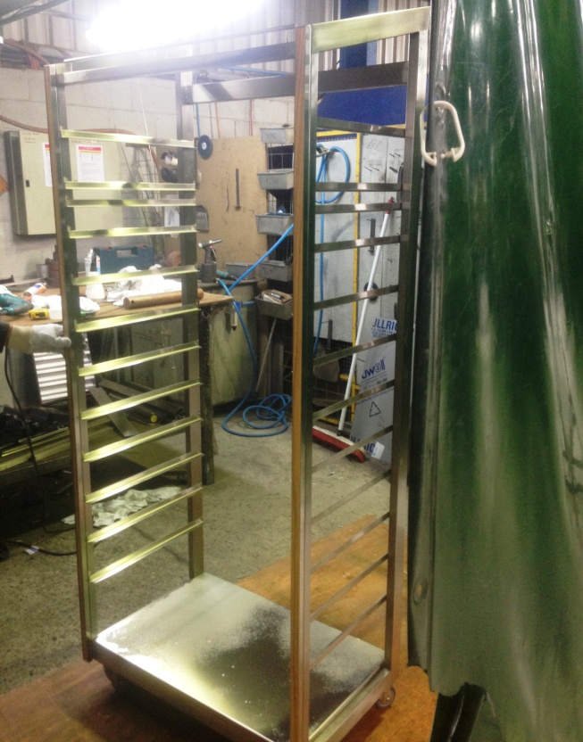

Machinery and Equipment Wholesaling
Welder

Machinery and Equipment Wholesaling
Welder
Dear Doctor: This form will take up to 5 minutes to complete. Please review each task the worker undertakes (both picture and written description) and tick whether or not the worker can complete this task. If modification required, please leave comments. Space at the end of this document is available for final comments and recommendations.
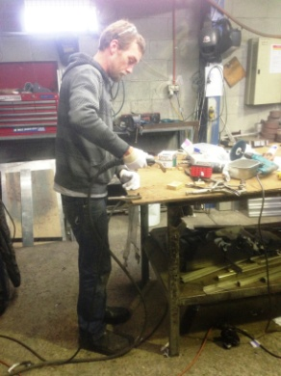  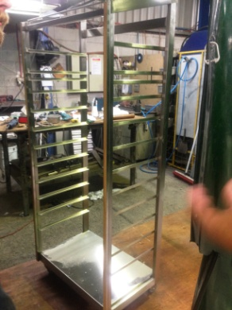 | Welding  - Cutting steel, bending, welding, and polishing.  - Power grip required to use most tools.  - Constant standing at work bench to undertake work. Neck flexion to view items worked on at bench height.  - Neck flexion and some lower level postures for shelves close to floor on trolleys.  - Trolleys made up to 1800mm high therefore some reaching required. | Doctor Approval  Yes No  Comments:
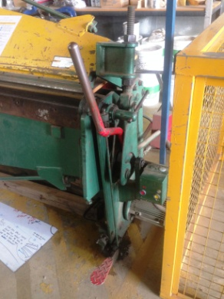 | Bending Machine  - 6m length of metal (lightweight). Placing it into machine for cutting and bending.  - Foot pedal operated. | Doctor Approval  Yes No  Comments:
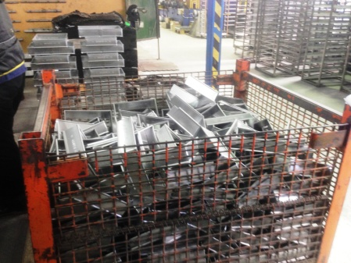  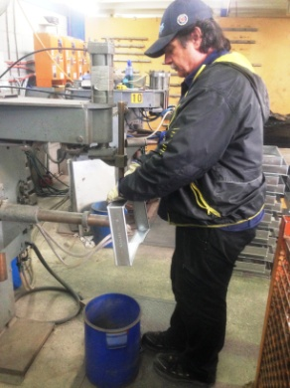  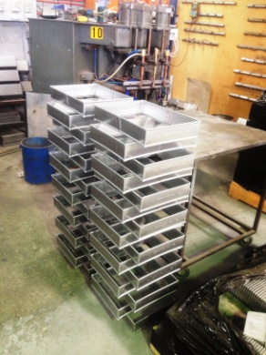 | Bread Pans  - Constant standing required for this position.  - Grasp 2 halves of breadpan from deep container. Bending and twisting to access items when supply low. Placing together on press.  - Bilateral hand movement to arrange pan together and hold in place for welding to occur using foot press to operate. All reaching to use press is within comfortable forward reaching range.  - Stack completed bread pan from floor. | Doctor Approval  Yes No  Comments:
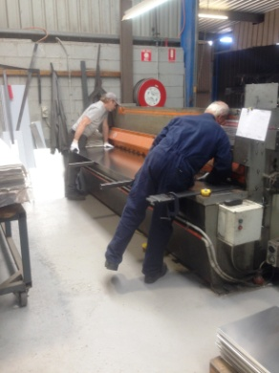  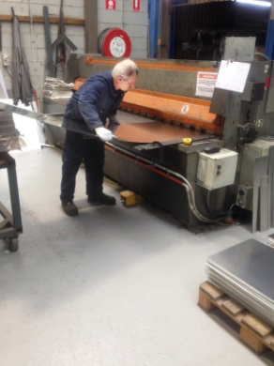  Insert image  1609  1612  1618 | Guillotine  - Measuring on bench.  - Lifting sheet of aluminium and placing on guillotine.  - Guillotine is operated using a foot pedal.  - Repetitive bending and reaching forward to feed aluminium through guillotine.  - Full sheet can weigh up to 20kg. Two people required for full sheet as it is awkward to handle. | Doctor Approval  Yes No  Comments:
Work Capacity Form
Doctor Review (include final comments)

I confirm that in my view, subject to the above comments, the worker is able to perform certain duties detailed in this Early Medical Assessment.
These duties should be reassessed on: |  | Date:

Signature : |  | Date:

Employers Declaration:
I confirm that I/we have reviewed the Doctor’s recommendations and comments. I/we will make suitable changes to make allowances for the Dr’s recommendations.
Signature : |  | Date:

Employees Declaration
My Doctor has discussed their recommendations with me. I have been given the opportunity to participate in this process.
Signature : |  | Date:
For information on completing this form, please contact Business SA on 08 8300 0000.
Disclaimer: This document is published by Business SA with funding from ReturnToWorkSA. All workplaces and circumstances are different and this document should be used as a guide only. It is not diagnostic and should not replace consultation, evaluation, or personal services including examination and an agreed course of action by a licensed practitioner. Business SA and ReturnToWorkSA and their affiliates and their respective agents do not accept any liability for injury, loss or damage arising from the use or reliance on this document. The copyright owner provides permission to reproduce and adapt this document for the purposes indicated and to tailor it (as intended) for individual circumstances. (C) 2016 ReturnToWorkSA

