Early Medical Assessment

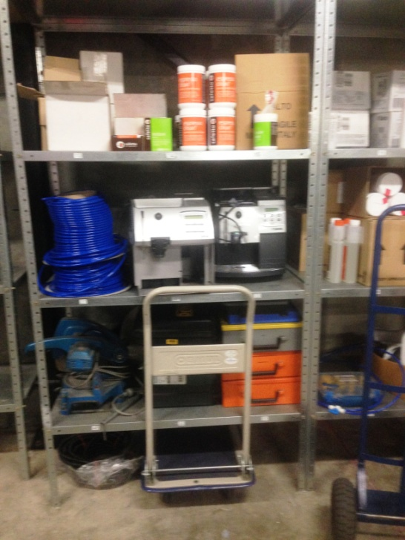

Machinery and Equipment Wholesaling
Technician

Machinery and Equipment Wholesailing
Technician
Dear Doctor: This form will take up to 5 minutes to complete. Please review each task the worker undertakes (both picture and written description) and tick whether or not the worker can complete this task. If modification required, please leave comments. Space at the end of this document is available for final comments and recommendations.
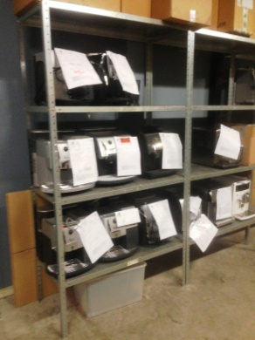  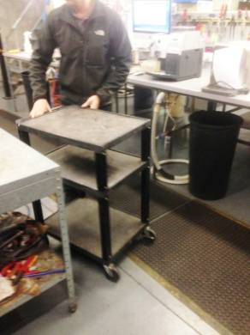 | Warehouse  - Customers drop coffee machines off for service/repairs.  - Stored on shelving in warehouse between floor and overhead height.  - Flat bed trolleys are used to move machines between shelves and workbenches. | Doctor Approval  Yes No  Comments:
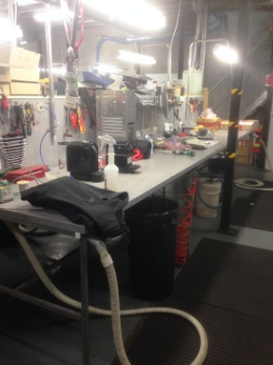  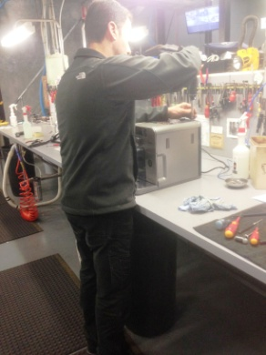 | Service and Repairs  - Constant standing at workbench whilst working on machines.  - Constant neck flexion whilst undertaking repairs at bench height.  - Frequent tool use; fine dexterity required to use tools eg. solder, screwdriver etc.  - Shelving with spare parts located close by to workbenches all within easy reaching range.  - Lifting up to 10kg machines to trolley and pushing to workbenches.  - Commercial machines weigh up to 50kg, 2 person lift and trolley to move.  - Bilateral use of hands and upper limbs to undertake repairs and services at bench within close reaching range. Shoulder flexion/rotation to 90 degrees required to access all areas of machine whilst on bench. Occasional bending/twisting required. | Doctor Approval  Yes No  Comments:
Work Capacity Form
Doctor Review (include final comments)

I confirm that in my view, subject to the above comments, the worker is able to perform certain duties detailed in this Early Medical Assessment.
These duties should be reassessed on: |  | Date:

Signature : |  | Date:

Employers Declaration:
I confirm that I/we have reviewed the Doctor’s recommendations and comments. I/we will make suitable changes to make allowances for the Dr’s recommendations.
Signature : |  | Date:

Employees Declaration
My Doctor has discussed their recommendations with me. I have been given the opportunity to participate in this process.
Signature : |  | Date:
For information on completing this form, please contact Business SA on 08 8300 0000.
Disclaimer: This document is published by Business SA with funding from ReturnToWorkSA. All workplaces and circumstances are different and this document should be used as a guide only. It is not diagnostic and should not replace consultation, evaluation, or personal services including examination and an agreed course of action by a licensed practitioner. Business SA and ReturnToWorkSA and their affiliates and their respective agents do not accept any liability for injury, loss or damage arising from the use or reliance on this document. The copyright owner provides permission to reproduce and adapt this document for the purposes indicated and to tailor it (as intended) for individual circumstances. (C) 2016 ReturnToWorkSA

