Early Medical Assessment

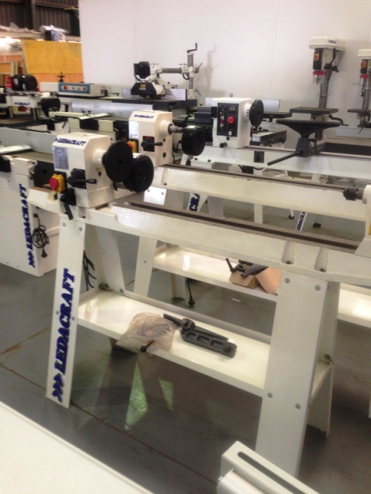

Machinery and Equipment Wholesaling
Storeperson

Machinery and Equipment Wholesaling
Storeperson
Dear Doctor: This form will take up to 5 minutes to complete. Please review each task the worker undertakes (both picture and written description) and tick whether or not the worker can complete this task. If modification required, please leave comments. Space at the end of this document is available for final comments and recommendations.
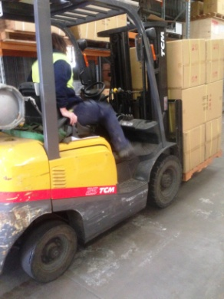 | Forklift Driving  - Climbing in / out of forklift frequently.  - Frequent – constant sitting.  - Forward reaching and gripping required to use steering wheel and gear stick.  - Rotation of neck and spine required for driving and reversing.  - Neck extension for placing pallets on high shelves. | Doctor Approval  Yes No  Comments:
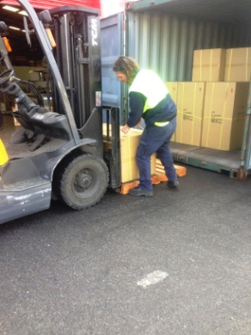  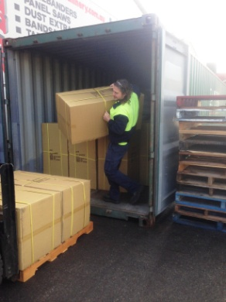 | Unpacking Container  - Predominantly unpacking container using forklift.  - Shifting of boxes into position onto a pallet may be required (weight varies from 20kg – 110kg max). Can involve pushing, lifting, carrying, twisting, bending, reaching between knee and overhead height and gripping. Two men may be used for heavier boxes which are not able to be accessed by forklift.  - For crates at the back of the container a ramp is put into place so that the forklift can be driven in to reduce the need to lift. | Doctor Approval  Yes No  Comments:
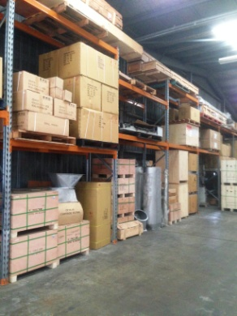  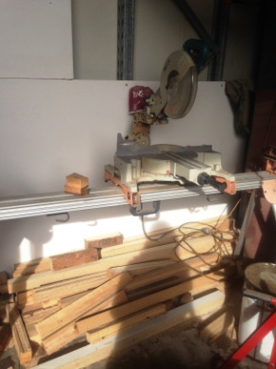  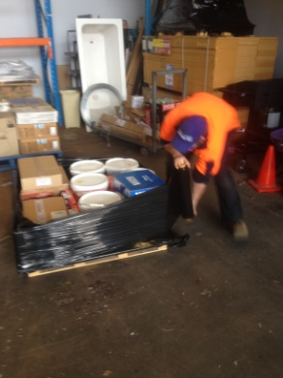  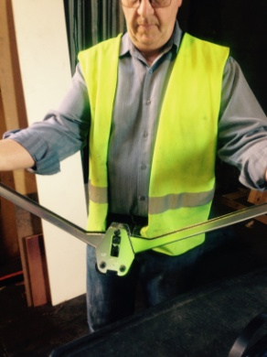 | Picking Orders  - Using forklift to undertake lifting from storage area / shelving.  - Drop saw may be used to cut bearers to hold the order. Pulling downwards on handle after positioning wood.  - Once items have been collected using forklift, they are placed on pallets.  - Wrapping pallets with shrink wrap involving prolonged bending, whilst walking around pallet. Both hands are used to grip wrap at either end to allow it to run out. Pulling required.  - Strapping - securing palletized goods with plastic strapping using a strapping machine (power grip) and applying clip with 2 handled clamp.  - Sack truck and pallet truck available for use if forklift not required. Weights are clearly recorded on boxes.  - Shifting of boxes may be required.  - Can involve pushing, lifting, carrying, twisting, bending, reaching between knee and overhead height and gripping. | Doctor Approval  Yes No  Comments:
 | Cleaning  - Emptying bins.  - Sweeping as required. | Doctor Approval  Yes No  Comments:
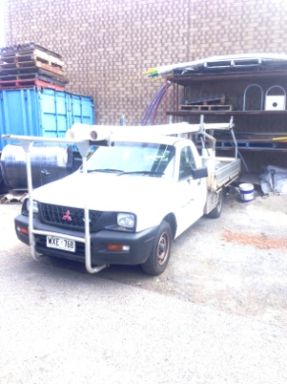 | Deliveries  - Driving van or ute to deliver smaller consumable items to technicians onsite or drop off a customers spare parts.  - Using forklift to assist other delivery drivers to unload heavier items at the storeroom. | Doctor Approval  Yes No  Comments:
Work Capacity Form
Doctor Review (include final comments)

I confirm that in my view, subject to the above comments, the worker is able to perform certain duties detailed in this Early Medical Assessment.
These duties should be reassessed on: |  | Date:

Signature : |  | Date:

Employers Declaration:
I confirm that I/we have reviewed the Doctor’s recommendations and comments. I/we will make suitable changes to make allowances for the Dr’s recommendations.
Signature : |  | Date:

Employees Declaration
My Doctor has discussed their recommendations with me. I have been given the opportunity to participate in this process.
Signature : |  | Date:
For information on completing this form, please contact Business SA on 08 8300 0000.
Disclaimer: This document is published by Business SA with funding from ReturnToWorkSA. All workplaces and circumstances are different and this document should be used as a guide only. It is not diagnostic and should not replace consultation, evaluation, or personal services including examination and an agreed course of action by a licensed practitioner. Business SA and ReturnToWorkSA and their affiliates and their respective agents do not accept any liability for injury, loss or damage arising from the use or reliance on this document. The copyright owner provides permission to reproduce and adapt this document for the purposes indicated and to tailor it (as intended) for individual circumstances. (C) 2016 ReturnToWorkSA

