Early Medical Assessment

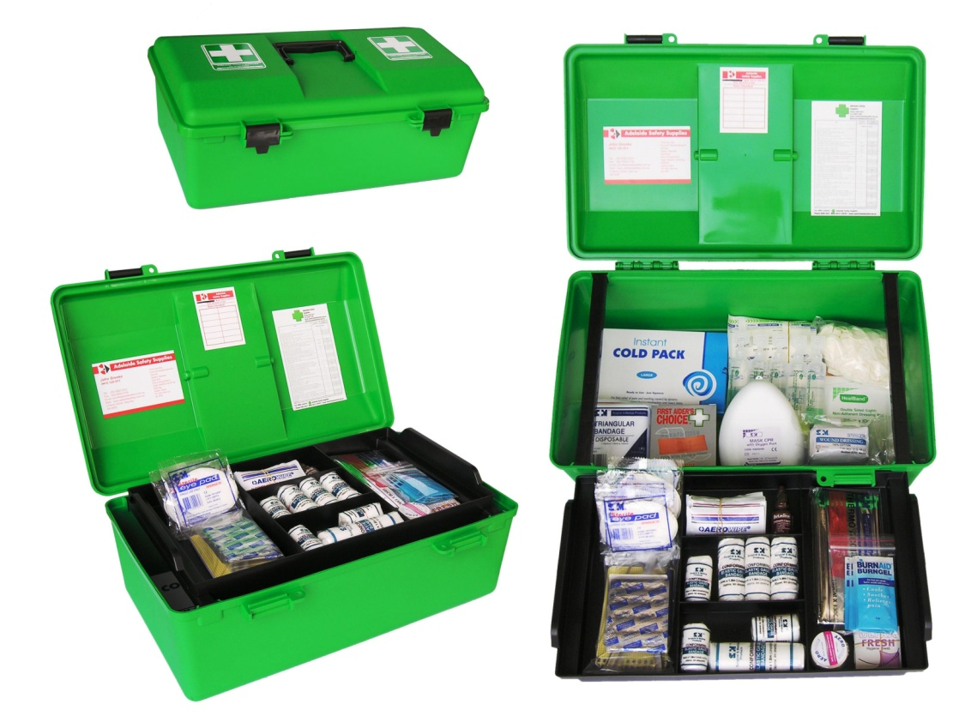

Machinery and Equipment Wholesaling
Storeperson

Machinery and Equipment Wholesaling
Storeperson
Dear Doctor: This form will take up to 5 minutes to complete. Please review each task the worker undertakes (both picture and written description) and tick whether or not the worker can complete this task. If modification required, please leave comments. Space at the end of this document is available for final comments and recommendations.
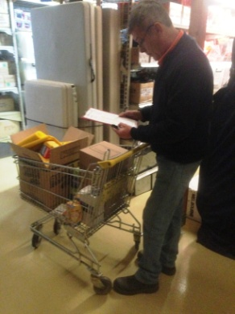  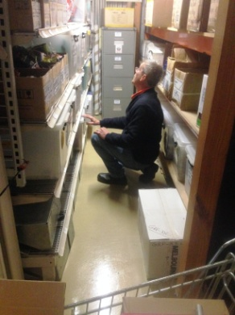  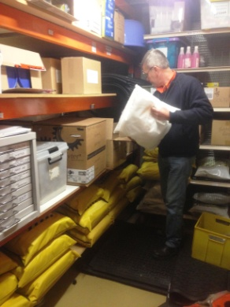  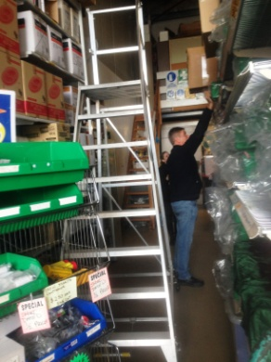 | Picking  - Order received by manager and given to store person to pick.  - Referring to ordering sheet and checking off with pen.  - Picking orders from shelves using a lightweight trolley or shopping trolley to hold items. Pushing with light force.  - Shelving located between floor and overhead height requiring reaching through the whole range. Gripping required to obtain items.  - Step stool and platform ladder available to reach higher shelving. Light items on high shelves.  - No item is over 10kg.  - Many items are small and lightweight.  - Stanley knife may be used to open boxes. | Doctor Approval  Yes No  Comments:
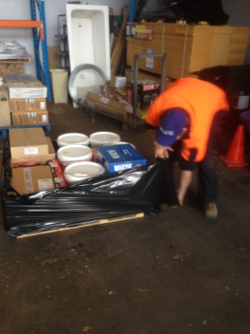  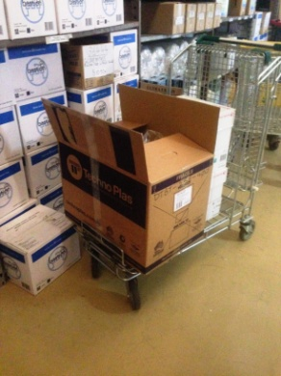 | Dispatch and Receiving  - Sitting to undertake computer work .  - Placing orders in recycled boxes and taping up for collection.  - Large orders are palletized and wrapped manually requiring bending and twisting.  - Orders are received daily. If large, may arrive on a pallet and forklift from business across street is used to bring into shed. Stanley knife used to break wrapping.  - Shelving orders between floor and overhead height requiring repetitive reaching through full range of heights.  - Maximum weight of box 25kg.  - Pallet jack is available to move pallets inside shed. | Doctor Approval  Yes No  Comments:
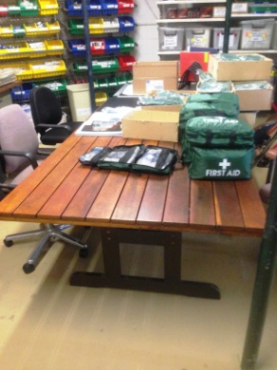  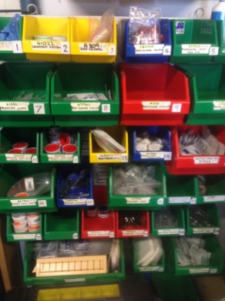 | Making Kits  - Small individual items packed into first aid kits.  - Undertaken seated at a 720mm table, adjustable chairs available.  - Shelves containing items close by with openings between floor and head height, most between waist and shoulder height.  - Items are picked into a cardboard box then taken to the table to pack into the appropriate kit bag.  - Packing bandaids from individual boxes into snap lock bags to reduce space for packing into first aid kit.  - Repetitive pinching and gripping; rotation between sitting and standing/moving to shelves.  - Lightweight items only. | Doctor Approval  Yes No  Comments:
Work Capacity Form
Doctor Review (include final comments)

I confirm that in my view, subject to the above comments, the worker is able to perform certain duties detailed in this Early Medical Assessment.
These duties should be reassessed on: |  | Date:

Signature : |  | Date:

Employers Declaration:
I confirm that I/we have reviewed the Doctor’s recommendations and comments. I/we will make suitable changes to make allowances for the Dr’s recommendations.
Signature : |  | Date:

Employees Declaration
My Doctor has discussed their recommendations with me. I have been given the opportunity to participate in this process.
Signature : |  | Date:
For information on completing this form, please contact Business SA on 08 8300 0000.
Disclaimer: This document is published by Business SA with funding from ReturnToWorkSA. All workplaces and circumstances are different and this document should be used as a guide only. It is not diagnostic and should not replace consultation, evaluation, or personal services including examination and an agreed course of action by a licensed practitioner. Business SA and ReturnToWorkSA and their affiliates and their respective agents do not accept any liability for injury, loss or damage arising from the use or reliance on this document. The copyright owner provides permission to reproduce and adapt this document for the purposes indicated and to tailor it (as intended) for individual circumstances. (C) 2016 ReturnToWorkSA

