Early Medical Assessment

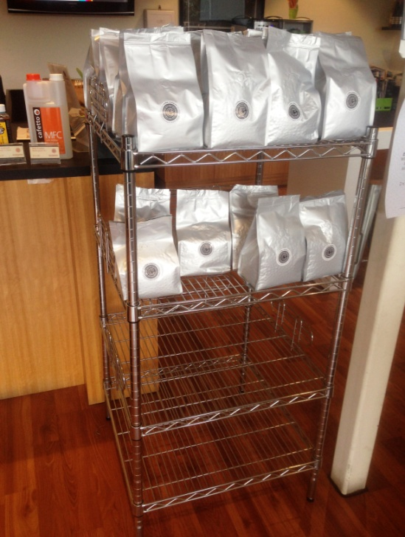

Machinery and Equipment Wholesaling
Packing

Machinery and Equipment Wholesailing
Packing
Dear Doctor: This form will take up to 5 minutes to complete. Please review each task the worker undertakes (both picture and written description) and tick whether or not the worker can complete this task. If modification required, please leave comments. Space at the end of this document is available for final comments and recommendations.
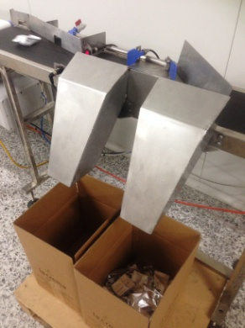  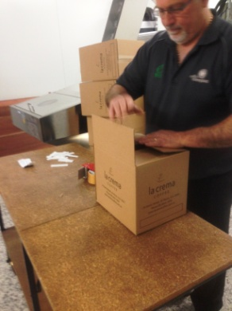  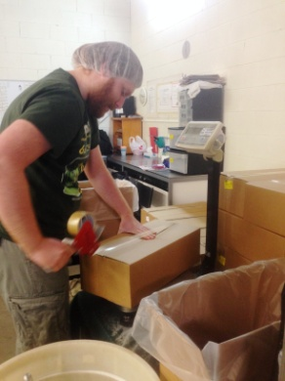  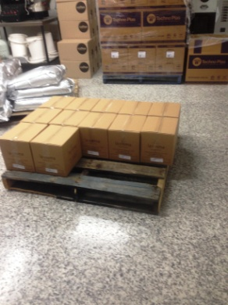 | Packing  - 90% automated.  - Lifting 10kg bag of coffee beans and pouring into tub on wheels (top waist height). Pushing tub to packing machine (light force).  - Machine sucks up beans, grinds and packs into pods. Pods are moved down chute into a waiting box.  - Folding boxes using two hands and placing under chute.  - Removing full box (<2kg) and lifting onto bench to tape shut.  - Using taping gun to seal box. Bilateral activity, one hand holding box shut and the dominant hand using power grip to hold tape gun.  - Lifting box onto pallet on the floor.  - Constant standing and walking.  - Twice per day lifting a roll of film (17.6kg) to reload into the packing machine. | Doctor Approval  Yes No  Comments:
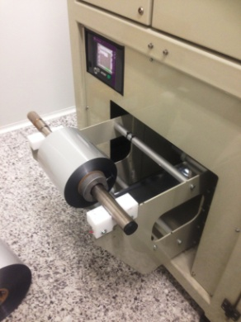

3794
3807
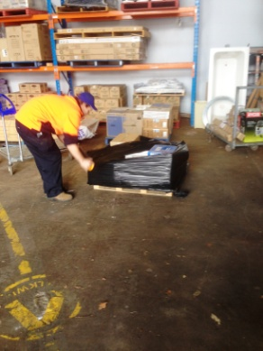 | Deliveries  - Interstate orders are palletized and wrapped manually.  - Wrapping pallets with shrink wrap involving prolonged bending, whilst walking around pallet. Both hands are used to grip wrap at either end to allow it to run out. Pulling required.  - Local deliveries remain loose and are packed straight into trucks. Involves lifting and carrying light boxes.  - Forklift is available to move pallets as required.  - Bilateral upper and lower limb coordination to operate the foot and hand controls;  - Cervical neck flexion, extension and rotation ;  - Occasional thoracic lumbar twisting to view behind forklift when reversing. | Doctor Approval  Yes No  Comments:
Work Capacity Form
Doctor Review (include final comments)

I confirm that in my view, subject to the above comments, the worker is able to perform certain duties detailed in this Early Medical Assessment.
These duties should be reassessed on: |  | Date:

Signature : |  | Date:

Employers Declaration:
I confirm that I/we have reviewed the Doctor’s recommendations and comments. I/we will make suitable changes to make allowances for the Dr’s recommendations.
Signature : |  | Date:

Employees Declaration
My Doctor has discussed their recommendations with me. I have been given the opportunity to participate in this process.
Signature : |  | Date:
For information on completing this form, please contact Business SA on 08 8300 0000.
Disclaimer: This document is published by Business SA with funding from ReturnToWorkSA. All workplaces and circumstances are different and this document should be used as a guide only. It is not diagnostic and should not replace consultation, evaluation, or personal services including examination and an agreed course of action by a licensed practitioner. Business SA and ReturnToWorkSA and their affiliates and their respective agents do not accept any liability for injury, loss or damage arising from the use or reliance on this document. The copyright owner provides permission to reproduce and adapt this document for the purposes indicated and to tailor it (as intended) for individual circumstances. (C) 2016 ReturnToWorkSA

