Early Medical Assessment

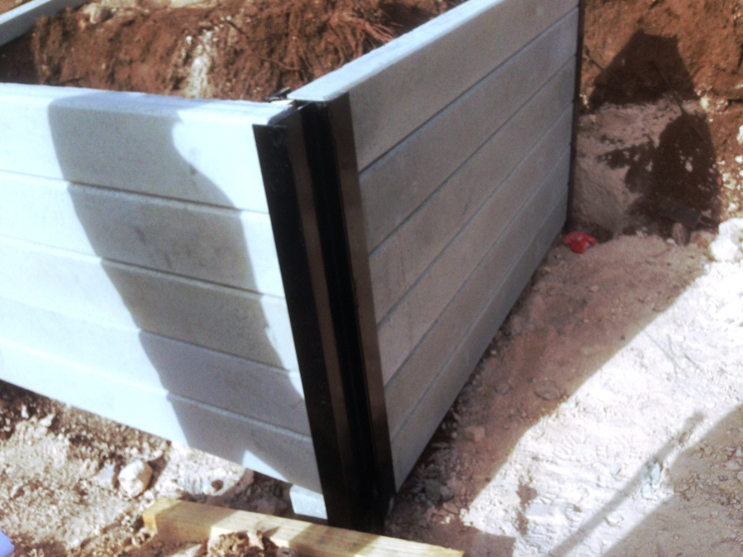

Machinery and Equipment Wholesalers
Field Worker

Machinery and Equipment Wholesalers
Field Worker
Dear Doctor: This form will take up to 5 minutes to complete. Please review each task the worker undertakes (both picture and written description) and tick whether or not the worker can complete this task. If modification required, please leave comments. Space at the end of this document is available for final comments and recommendations.
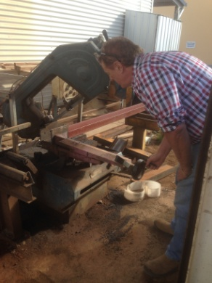  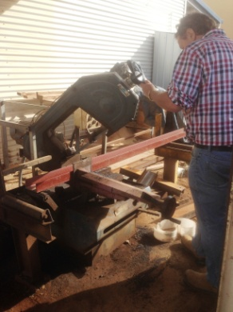 | Saw Operator  - Steel beams are cut to desired size using saw in yard.  - Driving forklift to lift steel onto platform.  - Pushing beam into place and measuring with tape.  - Bending to adjust with handwheel (dominant hand).  - Pushing button for automatic saw use.  - Collecting cut pieces and lifting to pallet. Small pieces lifted by hand, larger ones by forklift.  - Constant standing, frequent lifting, pushing, bending and gripping. | Doctor Approval  Yes No  Comments:
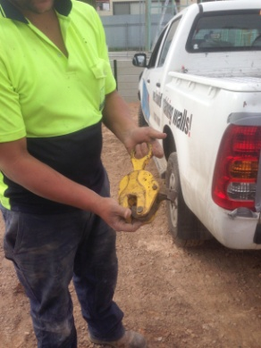  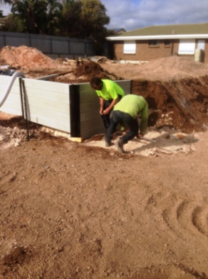 | Labourer  - Frequent hand tool use and shovels.  - Bending to position sleeper lifter onto sleeper (excavator lifts it into place). Guiding beams into hole and sleeper into place within steel beams. Pushing/pulling forces required. Shuffling around of sleepers on ground to get lifter into place (sleeper weighs 110kg).  - Laying drainage pipe and plastic in trench involving repetitive bending, gripping, cutting of plastic with a knife and climbing in/out of trench.  - Backfilling trench using excavator. | Doctor Approval  Yes No  Comments:
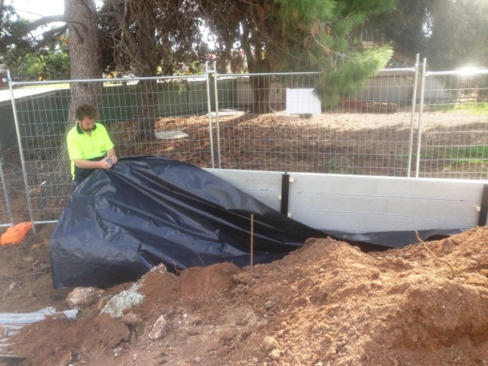  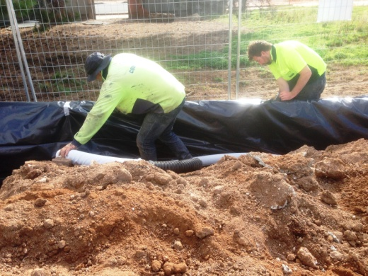  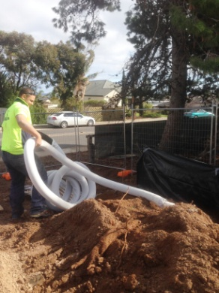 | - Using crow bar to reposition sleepers if not straight (bilateral activity, heavy force required to position and lift sleepers).  - Cleaning up site.  - Constant standing, frequent lifting / carrying, frequent bending and squatting, constant gripping and use of arms.  - Constant walking on uneven ground.
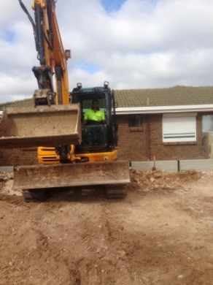  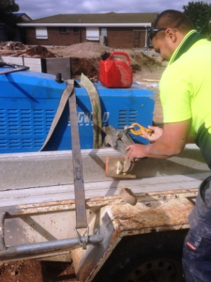 | Earthworks Equipment  Operator  - Constant sitting required whilst driving excavator and bobcat (license required). Can be rotated between staff depending on who is available with a license. Driving over uneven ground.  - Most digging, drilling, backfilling, lifting undertaken using excavator with different attachments.  - Occasional climbing in/out of excavator.  - Attachment of different tools to excavator may require some manual work eg. gripping and maneuvering of the sleeper lifter, bending. | Doctor Approval  Yes No  Comments:
Work Capacity Form
Doctor Review (include final comments)

I confirm that in my view, subject to the above comments, the worker is able to perform certain duties detailed in this Early Medical Assessment.
These duties should be reassessed on: |  | Date:

Signature : |  | Date:

Employers Declaration:
I confirm that I/we have reviewed the Doctor’s recommendations and comments. I/we will make suitable changes to make allowances for the Dr’s recommendations.
Signature : |  | Date:

Employees Declaration
My Doctor has discussed their recommendations with me. I have been given the opportunity to participate in this process.
Signature : |  | Date:
For information on completing this form, please contact Business SA on 08 8300 0000.
Disclaimer: This document is published by Business SA with funding from ReturnToWorkSA. All workplaces and circumstances are different and this document should be used as a guide only. It is not diagnostic and should not replace consultation, evaluation, or personal services including examination and an agreed course of action by a licensed practitioner. Business SA and ReturnToWorkSA and their affiliates and their respective agents do not accept any liability for injury, loss or damage arising from the use or reliance on this document. The copyright owner provides permission to reproduce and adapt this document for the purposes indicated and to tailor it (as intended) for individual circumstances. (C) 2016 ReturnToWorkSA

