Early Medical Assessment
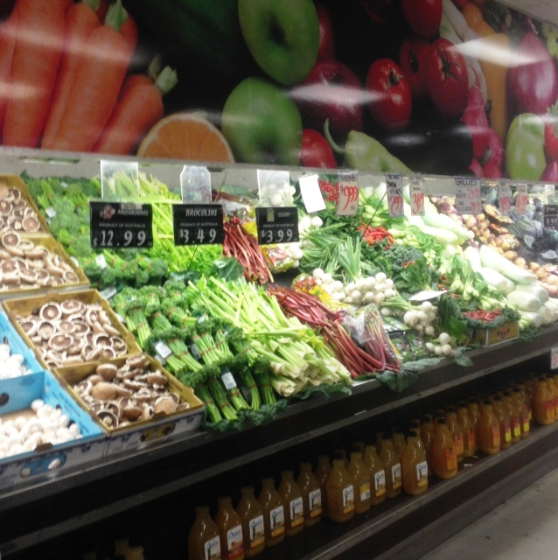

Fruit and Vegetable Retailer
Storeman/Deliveries

Fruit and Vegetable Retailer
Storeman/Deliveries
Dear Doctor: This form will take up to 5 minutes to complete. Please review each task the worker undertakes (both picture and written description) and tick whether or not the worker can complete this task. If modification required, please leave comments. Space at the end of this document is available for final comments and recommendations.
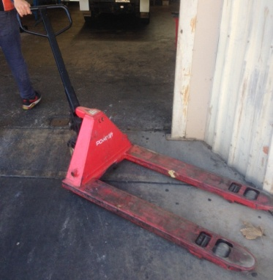  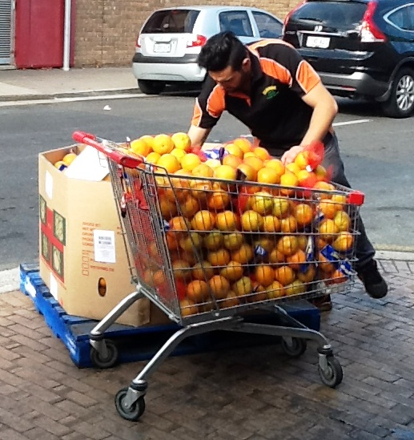 | Setting Up Shop – Morning  - Moving display bins to front (outside) of store using pallet jacks  - Accessing and stacking crates from floor level to approximately 1800mm requiring constant squatting, twisting, and bending  - Loading and unpacking trolleys with 5kg bags  - Goods also moved in trolleys (up to 100kg load)  Bringing In Stock – Evening  - Moving display bins into  - store using pallet jacks  - Goods also moved back in trolleys | Doctor Approval  Yes No  Comments:
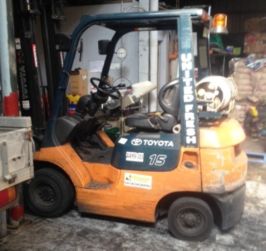 | Unloading Truck  - Large items unloaded using forklift otherwise lifting and reaching within normal body ranges  - Frequent maneuvering and lifting of all fruit and vegetable stock  - Packing stock into cool room | Doctor Approval  Yes No  Comments:
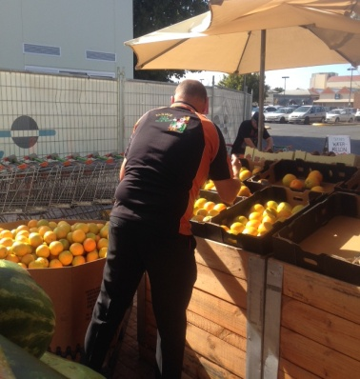  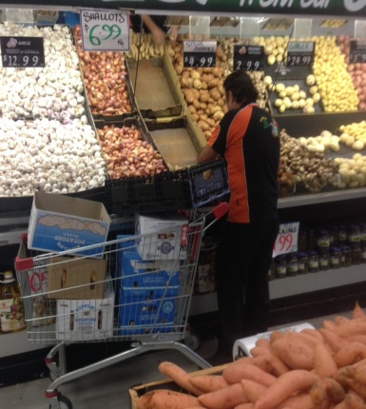 | Stock Replenishment  - Cutting up watermelons and pumpkins for display  - Unpacking stock for purchase requiring bending, twisting, squatting and lifting small loads of 5kgs  - Stocking of shelves requiring some reaching overhead.  - Requires stretching, leaning, twisting. Step stool available if required | Doctor Approval  Yes No  Comments:
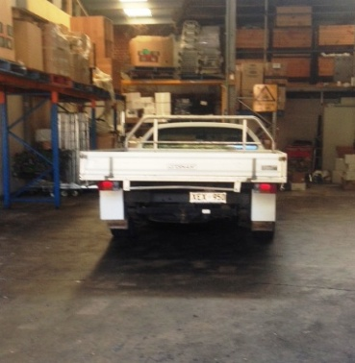 | Customer Orders  - Packing and delivering commercial customer orders using a ute.  - Climbing in/out of ute  - Sitting to drive  - Lifting of product to unload at delivery site | Doctor Approval  Yes No  Comments:
 | Cleaning and Ticketing  - Keeping shop floor clear of fruit to prevent falls  - Attaching appropriate tickets to produce and noting price changes | Doctor Approval  Yes No  Comments:
Work Capacity Form
Doctor Review (include final comments)

I confirm that in my view, subject to the above comments, the worker is able to perform certain duties detailed in this Early Medical Assessment.
These duties should be reassessed on: |  | Date:

Signature : |  | Date:

Employers Declaration:
I confirm that I/we have reviewed the Doctor’s recommendations and comments. I/we will make suitable changes to make allowances for the Doctor’s recommendations.
Signature : |  | Date:

Employees Declaration
My Doctor has discussed their recommendations with me. I have been given the opportunity to participate in this process.
Signature : |  | Date:
For information on completing this form, please contact Business SA on 08 8300 0000.
Disclaimer: This document is published by Business SA with funding from ReturnToWorkSA. All workplaces and circumstances are different and this document should be used as a guide only. It is not diagnostic and should not replace consultation, evaluation, or personal services including examination and an agreed course of action by a licensed practitioner. Business SA and ReturnToWorkSA and their affiliates and their respective agents do not accept any liability for injury, loss or damage arising from the use or reliance on this document. The copyright owner provides permission to reproduce and adapt this document for the purposes indicated and to tailor it (as intended) for individual circumstances. (C) 2016 ReturnToWorkSA

