Early Medical Assessment
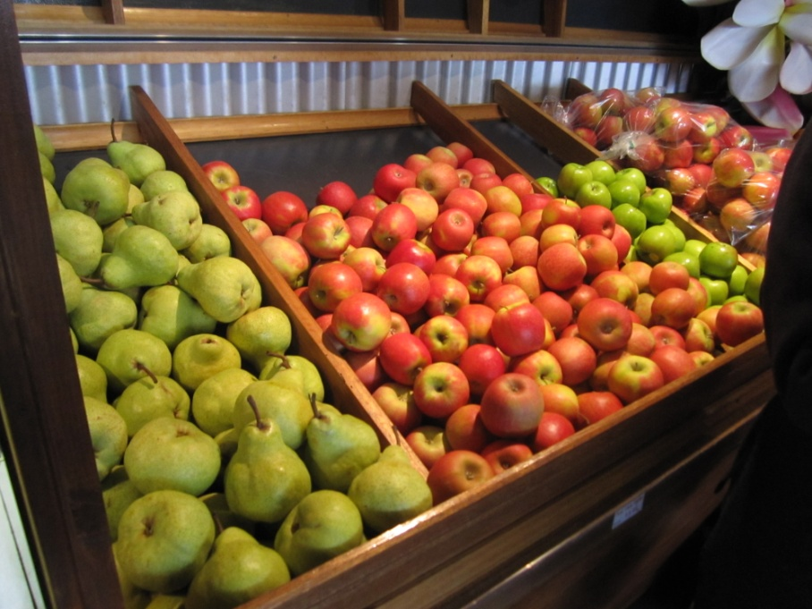
Fruit and Vegetable Retailer
Sales Assistant
Fruit and Vegetable Retailing
Sales Assistant
Dear Doctor: This form will take up to 5 minutes to complete. Please review each task the worker undertakes (both picture and written description) and tick whether or not the worker can complete this task. If modification required, please leave comments. Space at the end of this document is available for final comments and recommendations.
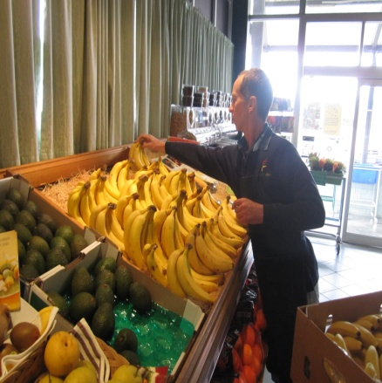 | Replenishing Shelves  - Performed as required  - Removing fruit (up to 20 kg) from pallet to trolley  - Pushing trolley on concrete floor  - Placing stock on shelving  - Stacking fruit from back to front | Doctor Approval  Yes No  Comments:
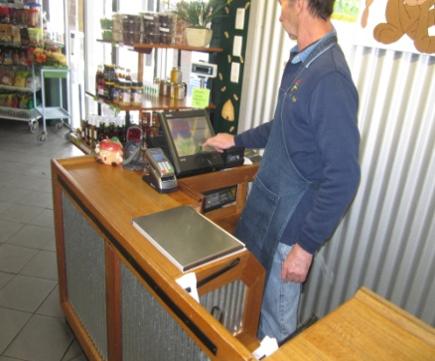 | Sales – Till  - Constant work flow undertaken standing at bench / till  - Customer places items on bench and worker scans and / weighs them and transfers them to a bag. Repetitive light lifting and grasping required.  - Occasionally worker assists elderly customers by lifting bags and transporting goods with trolley to customer’s vehicle | Doctor Approval  Yes No  Comments:
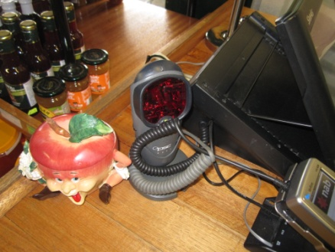  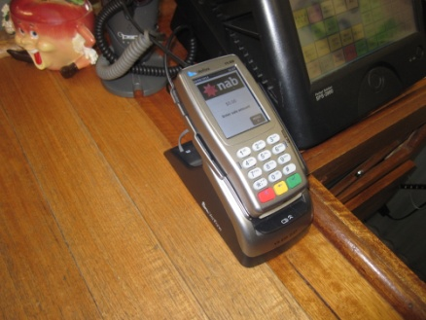 | Sales - POS  - Grasping of hand held scanner and use of Eftpos machine  - Low weight - some repetition involved | Doctor Approval  Yes No  Comments:
Work Capacity Form
Doctor Review (include final comments)

I confirm that in my view, subject to the above comments, the worker is able to perform certain duties detailed in this Early Medical Assessment.
These duties should be reassessed on: |  | Date:

Signature : |  | Date:

Employers Declaration:
I confirm that I/we have reviewed the Doctor’s recommendations and comments. I/we will make suitable changes to make allowances for the Doctor’s recommendations.
Signature : |  | Date:

Employees Declaration
My Doctor has discussed their recommendations with me. I have been given the opportunity to participate in this process.
Signature : |  | Date:
For information on completing this form, please contact Business SA on 08 8300 0000.
Disclaimer: This document is published by Business SA with funding from ReturnToWorkSA. All workplaces and circumstances are different and this document should be used as a guide only. It is not diagnostic and should not replace consultation, evaluation, or personal services including examination and an agreed course of action by a licensed practitioner. Business SA and ReturnToWorkSA and their affiliates and their respective agents do not accept any liability for injury, loss or damage arising from the use or reliance on this document. The copyright owner provides permission to reproduce and adapt this document for the purposes indicated and to tailor it (as intended) for individual circumstances. (C) 2016 ReturnToWorkSA.

