Early Medical Assessment

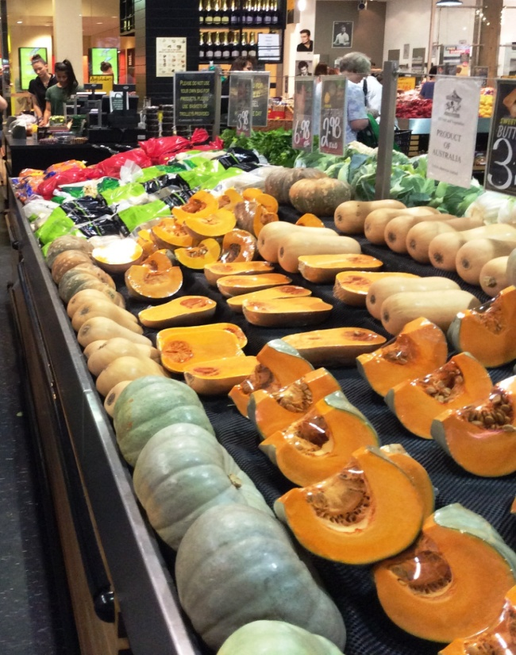

Fruit and Vegetable Retailer
Manager

Fruit and Vegetable Retailer
Manager
Dear Doctor: This form will take up to 5 minutes to complete. Please review each task the worker undertakes (both picture and written description) and tick whether or not the worker can complete this task. If modification required, please leave comments. Space at the end of this document is available for final comments and recommendations.
 | Customer Service  - Responding to customers’ enquiries/requests  - Handling goods (fetching products from the back of the shop) | Doctor Approval  Yes No  Comments:
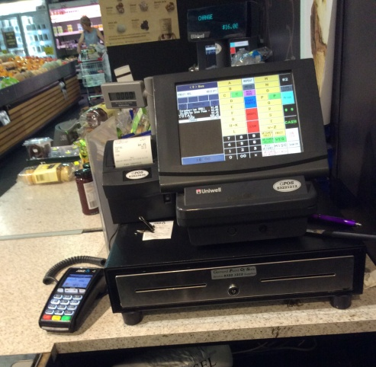 | Money Handling  - Standing behind the cash register and handling both goods and payment (cash and/or EFT) | Doctor Approval  Yes No  Comments:
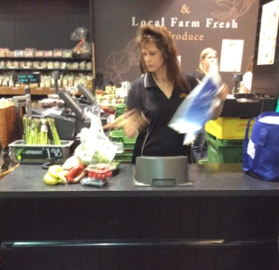 | Processing Transaction  - Removing items from shopping basket and placing each item on the electronic scale  - Recording price of weighted products on cash register  - Removing items from scale and placing in shopping bag  - Accepting payment by either cash or EFT  - Requires standing, repetitive reaching and lifting, turning the head and twisting the upper body. | Doctor Approval  Yes No  Comments:
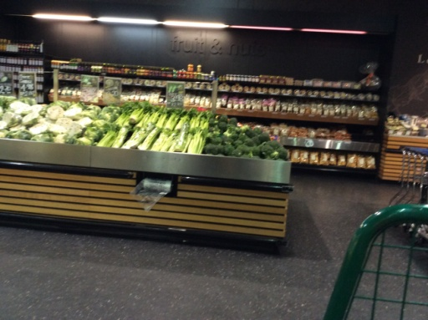 | Receiving Deliveries  - Purchasing fruit/veg at market daily (done by owners)  - Receiving deliveries ( driver delivers the purchased products and unloads them by using a forklift)  - Unpacking goods where appropriate (e.g. cool room/fridge/shelves)  - Involves repetitive bending, lifting and reaching. | Doctor Approval  Yes No  Comments:
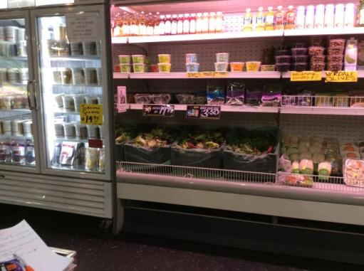 | Processing Bulk Stock (cold)  - Placing products in boxes then on trolley. Boxes generally weight under 15kg (approx.10% of boxes can weigh up to 20kg)  - Pushing trolley to cool room for storage and/or shop to stock shelves in either fridge or cold display (up to 1700mm). Reaching required to 700mm deep  - Involves repetitive bending, lifting and reaching. | Doctor Approval  Yes No  Comments:
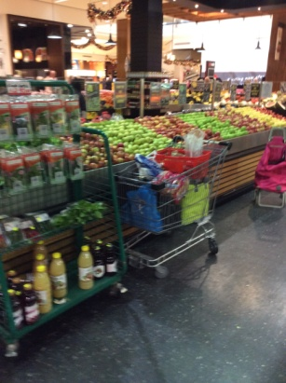 | Processing Bulk Stock  - Placing products in boxes then on trolley  - Pushing trolley to shop and stocking wall shelves(up to 1900mm) and display tables (1000mm high and 1000mm deep)  - Involves repetitive bending, lifting and reaching. | Doctor Approval  Yes No  Comments:
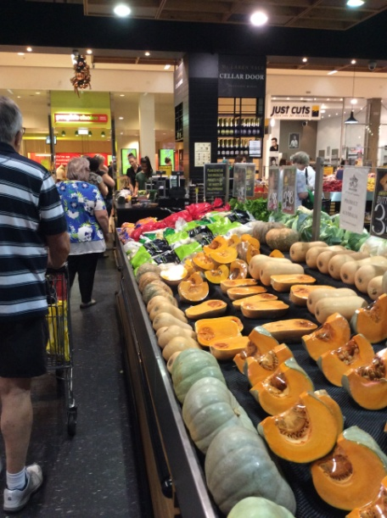 | Re-Merchandising  - Every night, approx. 50% of products are removed from displays and boxes wheeled on a trolley to the cool room  - Every morning, selected vegetables are cut/trimmed, covered and returned to shelves/display tables  - Each morning previously removed products are wheeled back in, and shelves/display tables are restocked  - The above involves repeated bending, lifting and reaching and using sharp implements for cutting. | Doctor Approval  Yes No  Comments:
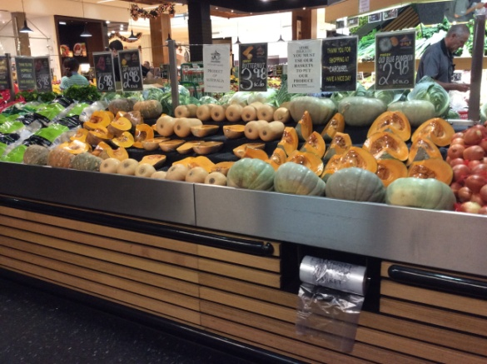 | Daily Tasks  - Sweeping and mopping the floors  - Cleaning glass and surfaces with cloth  - Cleaning shelves and display tables  - Administrative tasks (e.g. phone calls, paying bills etc), usually undertaken by the owner | Doctor Approval  Yes No  Comments:
Work Capacity Form
Doctor Review (include final comments)

I confirm that in my view, subject to the above comments, the worker is able to perform certain duties detailed in this Early Medical Assessment.
These duties should be reassessed on: |  | Date:

Signature : |  | Date:

Employers Declaration:
I confirm that I/we have reviewed the Doctor’s recommendations and comments. I/we will make suitable changes to make allowances for the Doctor’s recommendations.
Signature : |  | Date:

Employees Declaration
My Doctor has discussed their recommendations with me. I have been given the opportunity to participate in this process.
Signature : |  | Date:
For information on completing this form, please contact Business SA on 08 8300 0000.
Disclaimer: This document is published by Business SA with funding from ReturnToWorkSA. All workplaces and circumstances are different and this document should be used as a guide only. It is not diagnostic and should not replace consultation, evaluation, or personal services including examination and an agreed course of action by a licensed practitioner. Business SA and ReturnToWorkSA and their affiliates and their respective agents do not accept any liability for injury, loss or damage arising from the use or reliance on this document. The copyright owner provides permission to reproduce and adapt this document for the purposes indicated and to tailor it (as intended) for individual circumstances. (C) 2016 ReturnToWorkSA

