Early Medical Assessment

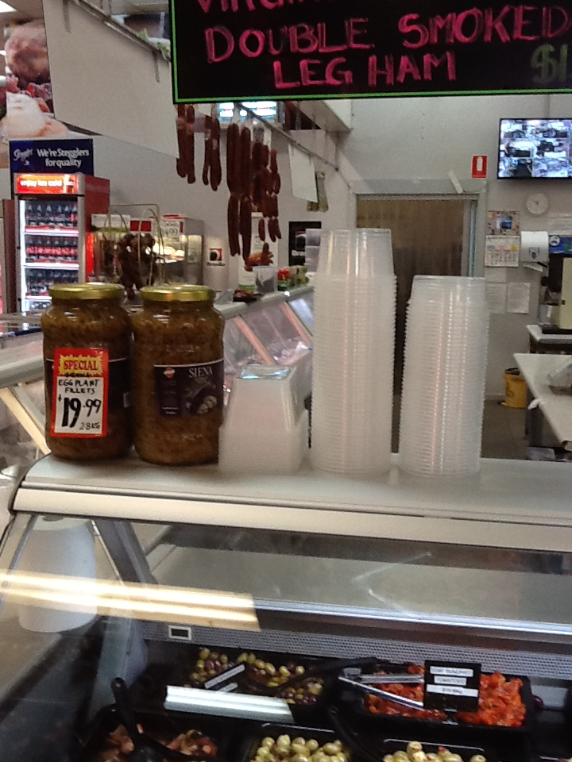

Fruit and Vegetable Retailer
Deli Staff

Fruit and Vegetable Retailer
Deli Staff
Dear Doctor: This form will take up to 5 minutes to complete. Please review each task the worker undertakes (both picture and written description) and tick whether or not the worker can complete this task. If modification required, please leave comments. Space at the end of this document is available for final comments and recommendations.
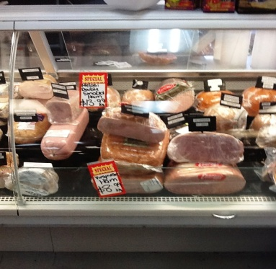  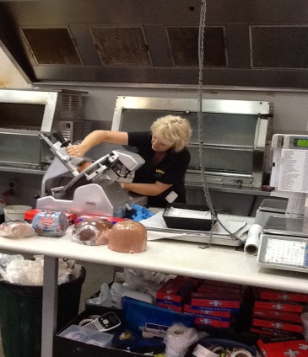 | Store Preparation  - Slicing meat as required using meat slicer. Bilateral reaching required, right arm pulling slicer back and forward (light force only), left arm to catch and place cut meats.  - Preparing chickens for rotisserie  - Spliting chickens with scissors when cooked and when required for customers | Doctor Approval  Yes No  Comments:
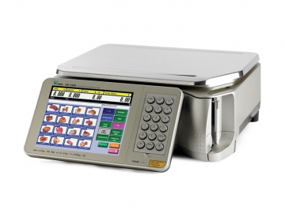 | Customer Service  - Standing and discussing produce with customers  - Weighing, wrapping and pricing items for customers using bilateral upper limbs and grasping.  - Accepting phone orders from customer and preparing goods | Doctor Approval  Yes No  Comments:
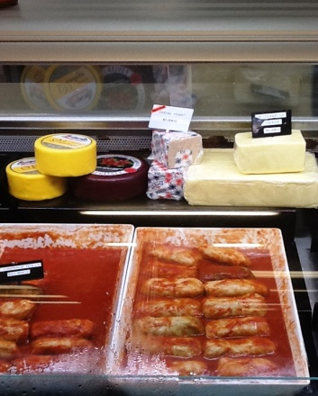 | Stock Replenishment  - Replenishing meats and cheese to display requiring lifting up to about 5kgs  - Occasionally walking to retrieve stock from coolroom. | Doctor Approval  Yes No  Comments:
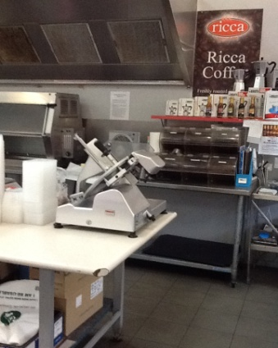  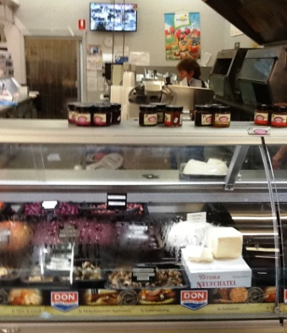 | Cleaning  - Cleaning slicing machines thoroughly  - Keeping rotisserie clean, by wiping  - Display cabinets to be cleaned thoroughly daily involving bending and reaching in to wipe inside glass and removing all product to wipe over shelving. | Doctor Approval  Yes No  Comments:
Work Capacity Form
Doctor Review (include final comments)

I confirm that in my view, subject to the above comments, the worker is able to perform certain duties detailed in this Early Medical Assessment.
These duties should be reassessed on: |  | Date:

Signature : |  | Date:

Employers Declaration:
I confirm that I/we have reviewed the Doctor’s recommendations and comments. I/we will make suitable changes to make allowances for the Doctor’s recommendations.
Signature : |  | Date:

Employees Declaration
My Doctor has discussed their recommendations with me. I have been given the opportunity to participate in this process.
Signature : |  | Date:
For information on completing this form, please contact Business SA on 08 8300 0000.
Disclaimer: This document is published by Business SA with funding from ReturnToWorkSA. All workplaces and circumstances are different and this document should be used as a guide only. It is not diagnostic and should not replace consultation, evaluation, or personal services including examination and an agreed course of action by a licensed practitioner. Business SA and ReturnToWorkSA and their affiliates and their respective agents do not accept any liability for injury, loss or damage arising from the use or reliance on this document. The copyright owner provides permission to reproduce and adapt this document for the purposes indicated and to tailor it (as intended) for individual circumstances. (C) 2016 ReturnToWorkSA

