Early Medical Assessment

Fruit and Vegetable Retailing
Stock Replenishment

Insert Job Title
Dear Doctor: This form will take up to 5 minutes to complete. Please review each task the worker undertakes (both picture and written description) and tick whether or not the worker can complete this task. If modification required, please leave comments. Space at the end of this document is available for final comments and recommendations.
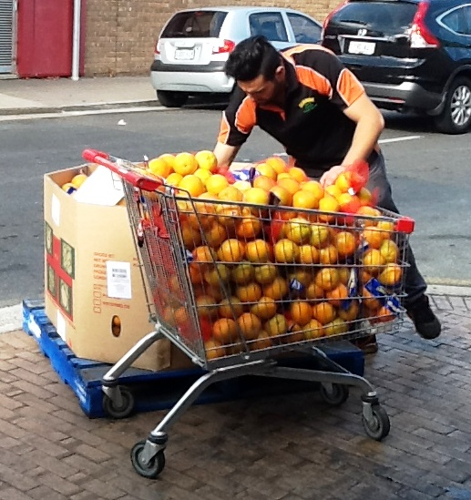  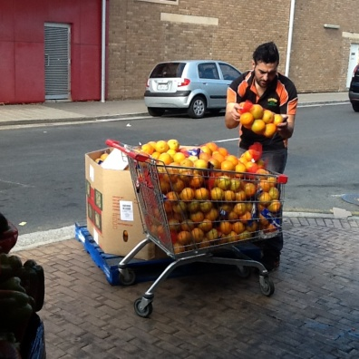  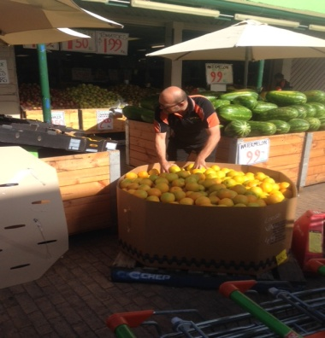  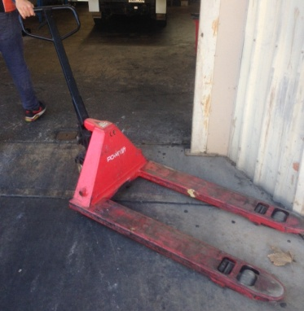 | Restocking Outside Fruit Bins Each Morning  - Moving display bins to front (outside) of store using pallet jacks  - Accessing and stacking crates from floor level requiring squatting, twisting, bending  - Goods also moved in shopping trolleys (up to 100kg load)  - Loading and unpacking trolleys with 5kg bags  Bringing Stock In Each Evening  - Moving display bins into  - store using pallet jacks  - Goods also moved back in shopping trolleys | Doctor Approval  Yes No  Comments:
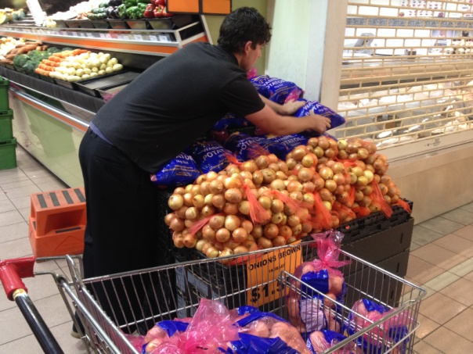  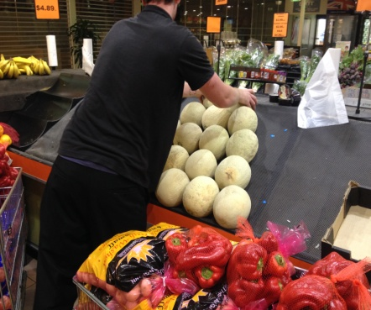  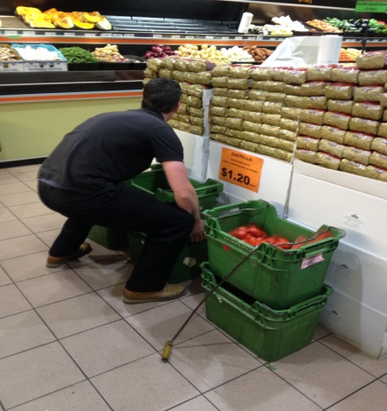 | Stock Replenishment  - Unpacking of stock for purchase. Requiring occasional bending, reaching and leaning with loads of up to 5kg, bilateral gross claw and flat palmer grasping as well as some lumbar twisting.  - Frequent accessing of items from floor to chest height, requiring squatting/kneeling, lumbar stooping and overhead reaching with shoulders flexed to greater than 90°.  - Frequent stocking of shelves requiring overhead reaching with shoulders flexed to greater than 90°. Step stool available.  - Using a knife to cut up watermelons and pumpkins for display. | Doctor Approval  Yes No  Comments:  :
Work Capacity Form
Doctor Review (include final comments)

I confirm that in my view, subject to the above comments, the worker is able to perform certain duties detailed in this Early Medical Assessment.
These duties should be reassessed on: |  | Date:

Signature : |  | Date:

Employers Declaration:
I confirm that I/we have reviewed the Doctor’s recommendations and comments. I/we will make suitable changes to make allowances for the Doctor’s recommendations.
Signature : |  | Date:

Employees Declaration
My Doctor has discussed their recommendations with me. I have been given the opportunity to participate in this process.
Signature : |  | Date:
For information on completing this form, please contact Business SA on 08 8300 0000.
Disclaimer: This document is published by Business SA with funding from ReturnToWorkSA. All workplaces and circumstances are different and this document should be used as a guide only. It is not diagnostic and should not replace consultation, evaluation, or personal services including examination and an agreed course of action by a licensed practitioner. Business SA and ReturnToWorkSA and their affiliates and their respective agents do not accept any liability for injury, loss or damage arising from the use or reliance on this document. The copyright owner provides permission to reproduce and adapt this document for the purposes indicated and to tailor it (as intended) for individual circumstances. (C) 2016 ReturnToWorkSA

