Early Medical Assessment

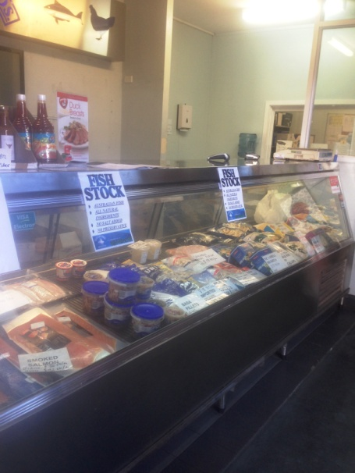

Fish and Takeaway Retailing
Dispatch

Fish and Takeaway Retailing
Dispatch
Dear Doctor: This form will take up to 5 minutes to complete. Please review each task the worker undertakes (both picture and written description) and tick whether or not the worker can complete this task. If modification required, please leave comments. Space at the end of this document is available for final comments and recommendations.
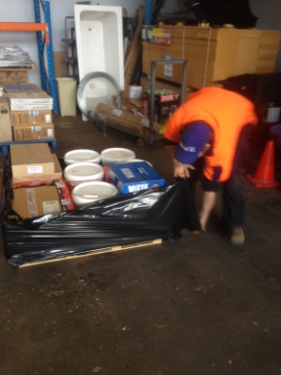 | Wrapping Pallets  - Bending and twisting to reach pallet on floor to start wrapping. Bilateral hold on roll of plastic whilst walking in crouch position around pallet.  - Pallets are moved by hand driven forklift. | Doctor Approval  Yes No  Comments:
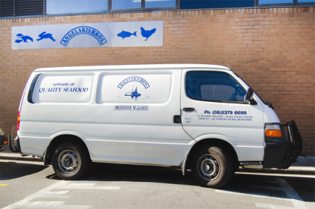 | Loading Vans  - Vans are loaded by hand ie lifting from pallet and carrying / placing inside van. Boxes mainly 5kg or 10kg. Infrequently a box up to 20kg may be lifted.  - Offsite trucks are loaded using the forklift. | Doctor Approval  Yes No  Comments:
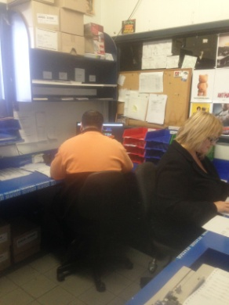 | Dispatch Paperwork  - Paperwork completed in office whilst seated at a desk. Computers used as required. | Doctor Approval  Yes No  Comments:
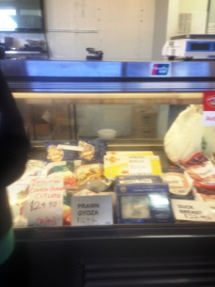 | Wholesale Counter  - Customer service for walk in customers as required.  - Counter requires reaching and forward bending to access frozen items at the front.  - Till located on bench.  - Upright freezer with shelving between floor and shoulder height for additional items.  - Occasionally orders are phoned in and may require fresh fish and poultry to be added. Fresh fish factory is across the road so worker must walk across road to collect and carry or push on trolley back to dispatch. | Doctor Approval  Yes No  Comments:
Work Capacity Form
Doctor Review (include final comments)

I confirm that in my view, subject to the above comments, the worker is able to perform certain duties detailed in this Early Medical Assessment.
These duties should be reassessed on: |  | Date:

Signature : |  | Date:

Employers Declaration:
I confirm that I/we have reviewed the Doctor’s recommendations and comments. I/we will make suitable changes to make allowances for the Dr’s recommendations.
Signature : |  | Date:

Employees Declaration
My Doctor has discussed their recommendations with me. I have been given the opportunity to participate in this process.
Signature : |  | Date:
For information on completing this form, please contact Business SA on 08 8300 0000.
Disclaimer: This document is published by Business SA with funding from ReturnToWorkSA. All workplaces and circumstances are different and this document should be used as a guide only. It is not diagnostic and should not replace consultation, evaluation, or personal services including examination and an agreed course of action by a licensed practitioner. Business SA and ReturnToWorkSA and their affiliates and their respective agents do not accept any liability for injury, loss or damage arising from the use or reliance on this document. The copyright owner provides permission to reproduce and adapt this document for the purposes indicated and to tailor it (as intended) for individual circumstances. (C) 2016 ReturnToWorkSA

