Early Medical Assessment

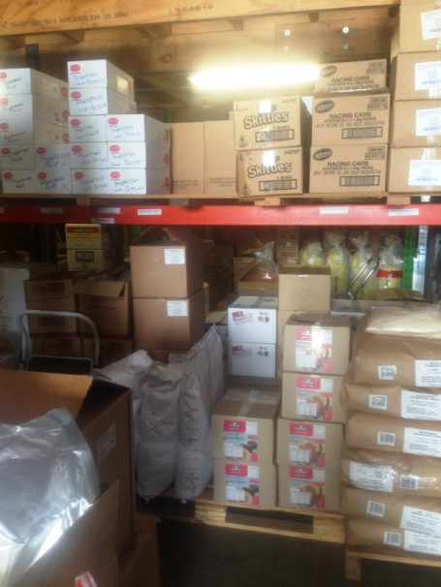
\
Fish and Takeaway Retailing
Storeperson

Fish and Takeaway Retailing
Storeperson
Dear Doctor: This form will take up to 5 minutes to complete. Please review each task the worker undertakes (both picture and written description) and tick whether or not the worker can complete this task. If modification required, please leave comments. Space at the end of this document is available for final comments and recommendations.
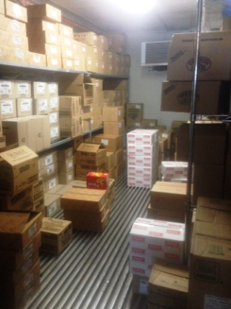  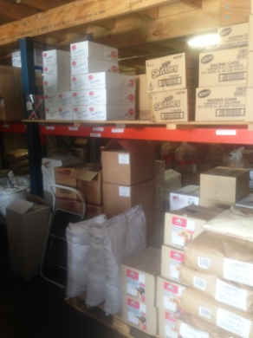  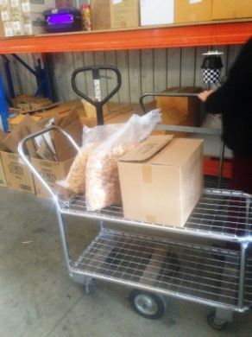  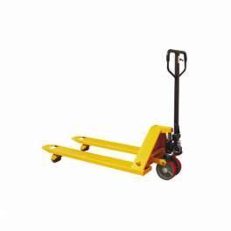 | Deliveries  - Deliveries arrive on wrapped pallets via truck. Unloading occurs using hand operated forklift.  - Unwrapping pallet and shelving product one at a time. Max 25kg bag or box. Repetitive lifting of these items from pallet on floor to shelf. Heaviest items placed on lower shelves.  - Bending and some twisting whilst holding weight required to access low shelves due to upper shelf placement.  - Pallet jack and flatbed trolley available to move produce if required. | Doctor Approval  Yes No  Comments:
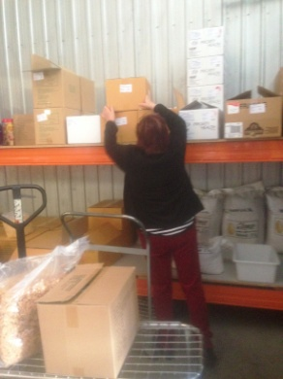  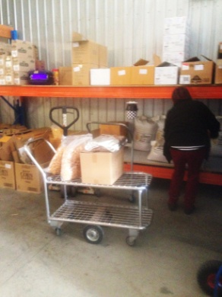 | Stock Rotation  - While shelving stock, stock is rotated which requires all old stock to be lifted off shelf and placed on floor. New stock is lifted onto shelves and old stock is then replaced on top/in front of new stock.  - Requires repetitive lifting and handling of stock up to 25kg. Can be boxes or large bags of flour and the like. | Doctor Approval  Yes No  Comments:
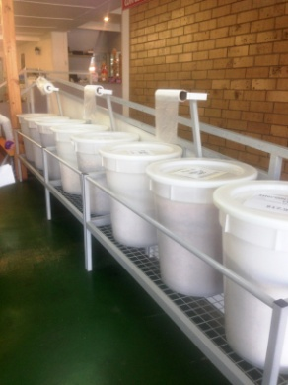  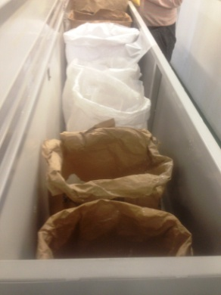  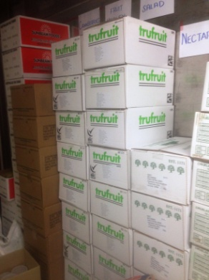 | Refilling Floor Stock  - During the day if stock in the shop runs low the customer service staff will let the stock person know to replace larger items such as bags of flour or cereal.  - Involves lifting out empty bag and replacing with a new one, then opening it. Shelf is designed to drop down to reduce distance of lift.  - Trolley available to reduce lifting and carrying. | Doctor Approval  Yes No  Comments:
Work Capacity Form
Doctor Review (include final comments)

I confirm that in my view, subject to the above comments, the worker is able to perform certain duties detailed in this Early Medical Assessment.
These duties should be reassessed on: |  | Date:

Signature : |  | Date:

Employers Declaration:
I confirm that I/we have reviewed the Doctor’s recommendations and comments. I/we will make suitable changes to make allowances for the Dr’s recommendations.
Signature : |  | Date:

Employees Declaration
My Doctor has discussed their recommendations with me. I have been given the opportunity to participate in this process.
Signature : |  | Date:
For information on completing this form, please contact Business SA on 08 8300 0000.
Disclaimer: This document is published by Business SA with funding from ReturnToWorkSA. All workplaces and circumstances are different and this document should be used as a guide only. It is not diagnostic and should not replace consultation, evaluation, or personal services including examination and an agreed course of action by a licensed practitioner. Business SA and ReturnToWorkSA and their affiliates and their respective agents do not accept any liability for injury, loss or damage arising from the use or reliance on this document. The copyright owner provides permission to reproduce and adapt this document for the purposes indicated and to tailor it (as intended) for individual circumstances. (C) 2016 ReturnToWorkSA

