Early Medical Assessment

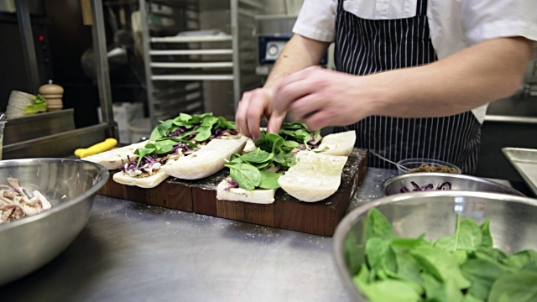

Fish and Takeaway Retailing
Sandwich Maker

Fish and Takeaway Retailing
Sandwich Maker
Dear Doctor: This form will take up to 5 minutes to complete. Please review each task the worker undertakes (both picture and written description) and tick whether or not the worker can complete this task. If modification required, please leave comments. Space at the end of this document is available for final comments and recommendations.
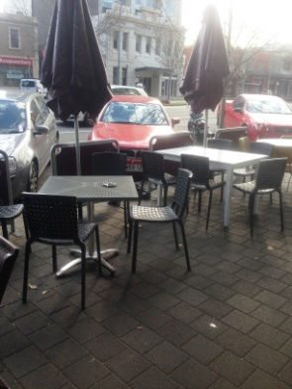  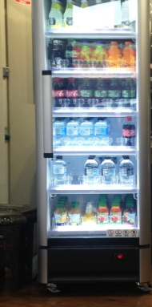  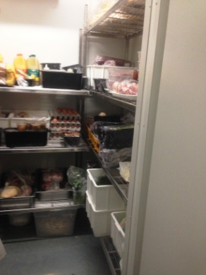 | Set Up  - Each morning take outside 4 tables and accompanying chairs. Carrying / pulling required. These need to be brought in at the end of the day also.  - Stocking drinks fridge requiring grasping and reaching between floor and overhead height. Task performed as required.  - Preparing food area by taking fillings out of cool room in trays and carrying to display cabinet. Filling display cabinet requires some bending, reaching, and grasping. Reverse done at end of day.  - Receiving deliveries, brought into store by delivery driver. Worker helps to put items in correct area eg bread. | Doctor Approval  Yes No  Comments:
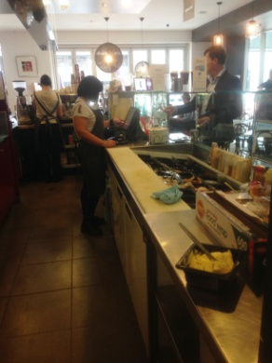  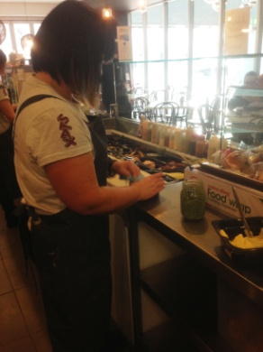  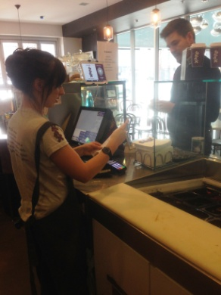  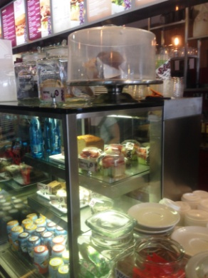  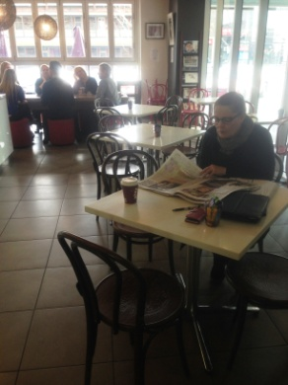 | Customer Service and Sandwich Making  - Touch screen POS, cash handling. Forward reaching over counter.  - Sandwiches made to order whilst standing at counter behind display cabinet with fillings inside. Use of tongs and knives requiring repetitive grasping. Repetitive forward reaching into cabinet to acquire fillings as ordered. Meats and cheese are pre-sliced.  - Toastie machine on bench, microwave above toasties requiring 90º shoulder flexion to reach.  - Table service; carrying plates and cups to customers sitting at tables.  - Constant standing and walking for the entire shift. Repetitive forward reaching at bench height and occasional reaching to head height to access equipment. Constant use of hands for handling money, preparing food and waiting. | Doctor Approval  Yes No  Comments:
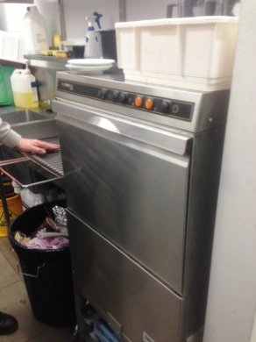 | Cleaning  - Wiping over tables as customers leave.  - Sweeping and mopping floors daily.  - Clearing dishes from tables and placing in dish washer in back kitchen or cleaning in sink.  - Cleaning benches; wiping over.  - Cleaning out display cabinets as required, removing plates, wiping trays and glass inside and out.  - Pulling bin to common area for emptying.  - Constant standing, constant forward reaching, occasional bending, constant handling, occasional pushing and carrying light loads. | Doctor Approval  Yes No  Comments:
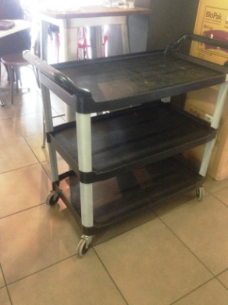 | Deliveries  - Catering for offices nearby.  - Placing trays of made sandwiches and possibly coffees on a three tiered trolley and pushing to offices.  - Many are in the same building as the café and an elevator is used.  - If it is a small order it may be carried instead of using the trolley. | Doctor Approval  Yes No  Comments:
Work Capacity Form
Doctor Review (include final comments)

I confirm that in my view, subject to the above comments, the worker is able to perform certain duties detailed in this Early Medical Assessment.
These duties should be reassessed on: |  | Date:

Signature : |  | Date:

Employers Declaration:
I confirm that I/we have reviewed the Doctor’s recommendations and comments. I/we will make suitable changes to make allowances for the Dr’s recommendations.
Signature : |  | Date:

Employees Declaration
My Doctor has discussed their recommendations with me. I have been given the opportunity to participate in this process.
Signature : |  | Date:
For information on completing this form, please contact Business SA on 08 8300 0000.
Disclaimer: This document is published by Business SA with funding from ReturnToWorkSA. All workplaces and circumstances are different and this document should be used as a guide only. It is not diagnostic and should not replace consultation, evaluation, or personal services including examination and an agreed course of action by a licensed practitioner. Business SA and ReturnToWorkSA and their affiliates and their respective agents do not accept any liability for injury, loss or damage arising from the use or reliance on this document. The copyright owner provides permission to reproduce and adapt this document for the purposes indicated and to tailor it (as intended) for individual circumstances. (C) 2016 ReturnToWorkSA

