Early Medical
Assessment

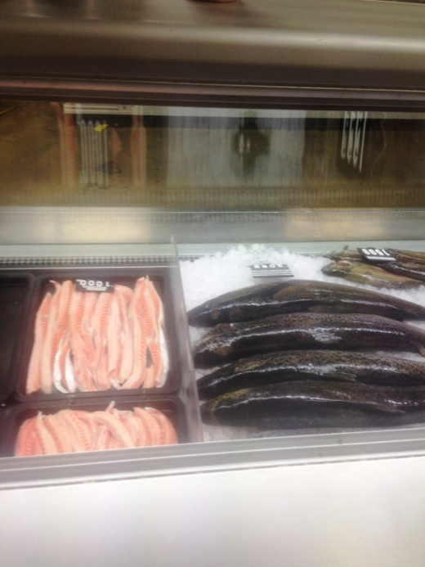

Fish and Takeaway Retailing
Retail Assistant

Fish and Takeaway Retailing
Retail Assistant
Dear Doctor: This form will take up to 5 minutes to complete. Please review each task the worker undertakes (both picture and written description) and tick whether or not the worker can complete this task. If modification required, please leave comments. Space at the end of this document is available for final comments and recommendations.
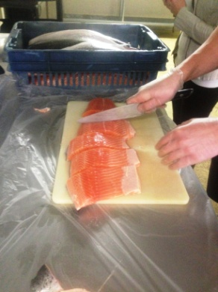  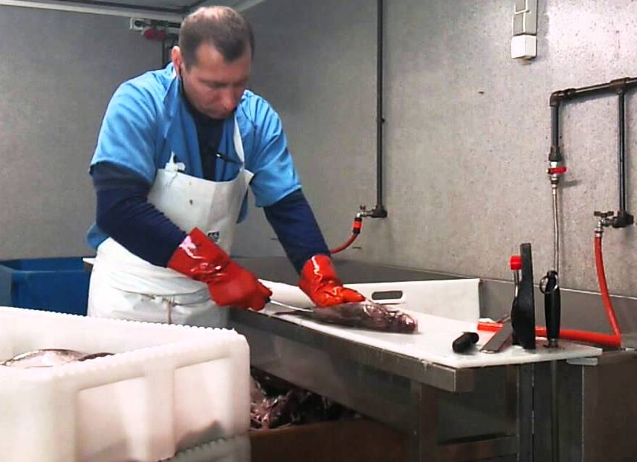 | Preparing Fresh Fish  - Constant standing and walking whilst undertaking duties.  - Receiving fish from filleters.  - Cutting fish into fillets for putting in display cabinet for sale.  - Cleaning and scaling ‘special order’ fish for customers; bilateral handling.  - Placing fish onto trays and placing in display cabinet (bending to reach into front). | Doctor Approval  Yes No  Comments:
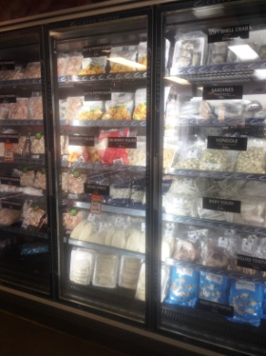  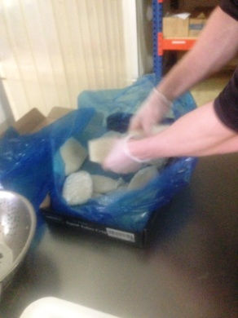 | Frozen Fish  - Frozen deliveries arrive daily and are brought in by trolley.  - Unloading trolley into either upright freezer (shelves floor to overhead height requiring full range of reaching) or chest freezers (bending required) - repetitive action.  - Some frozen fish boxes are opened and fish bagged separately. Handling of separate pieces and placing in a bag to place in cryovac (pulling lid down to operate).  - Printing price sticker, attach to package and place in freezer. | Doctor Approval  Yes No  Comments:
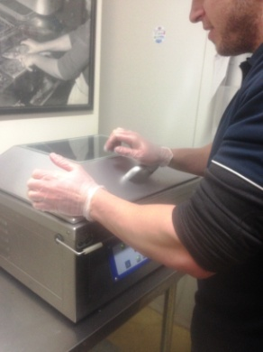
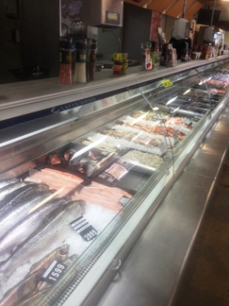  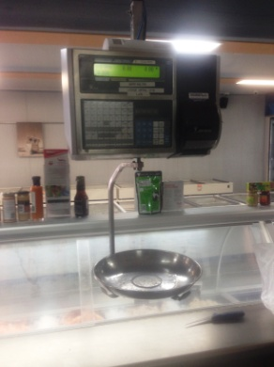 | Customer Service  - Standing to serve walk in customers as required. Bending required to access fish from display counter.  - Weighing fish on suspended scales.  - Wrapping order at counter (bilateral folding of paper and sticking with price tag) in paper and passing over counter to customer requiring reaching. | Doctor Approval  Yes No  Comments:
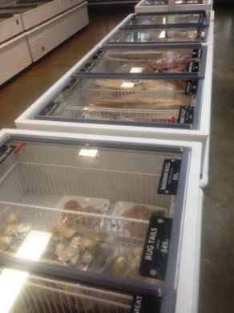 | Cleaning  - Sweeping and mopping floor as required throughout the day. Wiping of display cabinet glass on customer side.  - Once per week cleaning out display cabinet by lifting out trays and a 30kg stainless steel tray and wiping over inside and glass. Bending and reaching inside to wipe inside of glass and cabinet.  - Once per week clearing out a chest freezer and defrosting it to clean and sanitize inside, requiring bending and reaching to wipe inside. Involves lifting all product out and placing in large upright freezer whilst defrosting taking place. Repacking when finished. | Doctor Approval  Yes No  Comments:
Work Capacity Form
Doctor Review (include final comments)

I confirm that in my view, subject to the above comments, the worker is able to perform certain duties detailed in this Early Medical Assessment.
These duties should be reassessed on: |  | Date:

Signature : |  | Date:

Employers Declaration:
I confirm that I/we have reviewed the Doctor’s recommendations and comments. I/we will make suitable changes to make allowances for the Dr’s recommendations.
Signature : |  | Date:

Employees Declaration
My Doctor has discussed their recommendations with me. I have been given the opportunity to participate in this process.
Signature : |  | Date:
For information on completing this form, please contact Business SA on 08 8300 0000.
Disclaimer: This document is published by Business SA with funding from ReturnToWorkSA. All workplaces and circumstances are different and this document should be used as a guide only. It is not diagnostic and should not replace consultation, evaluation, or personal services including examination and an agreed course of action by a licensed practitioner. Business SA and ReturnToWorkSA and their affiliates and their respective agents do not accept any liability for injury, loss or damage arising from the use or reliance on this document. The copyright owner provides permission to reproduce and adapt this document for the purposes indicated and to tailor it (as intended) for individual circumstances. (C) 2016 ReturnToWorkSA

