Early Medical Assessment

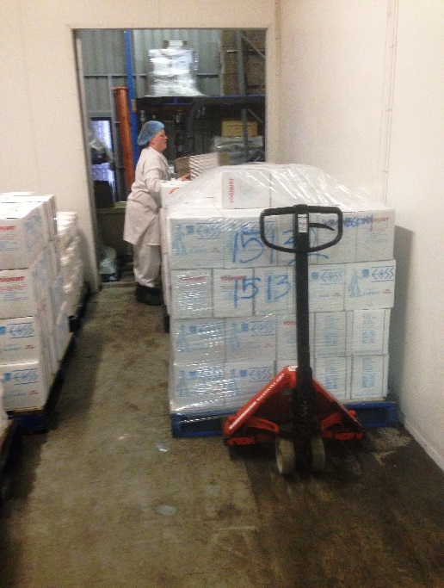

Fish and Takeaway Retailing
Packing - Yoghurt

Fish and Takeaway Retailing
Packing
Dear Doctor: This form will take up to 5 minutes to complete. Please review each task the worker undertakes (both picture and written description) and tick whether or not the worker can complete this task. If modification required, please leave comments. Space at the end of this document is available for final comments and recommendations.
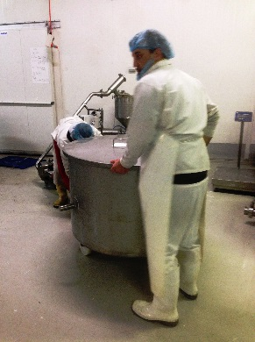  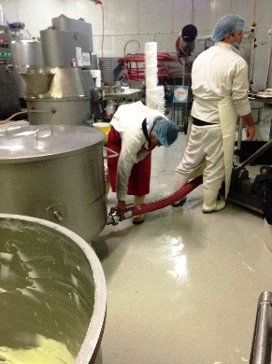  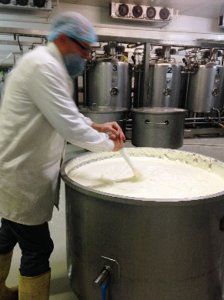 | Mixed Yoghurt  - Pushing / pulling vat of yoghurt out of mixer (medium force).  - Connecting mixed yoghurt vat with hose (bending and gripping).  - Scraping of side of the bowl manually is required when vat nearly empty using long handled ‘paddle’. Medium to heavy force required as yoghurt is thick. | Doctor Approval  Yes No  Comments:
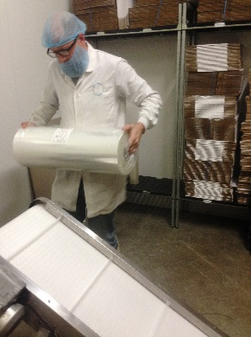  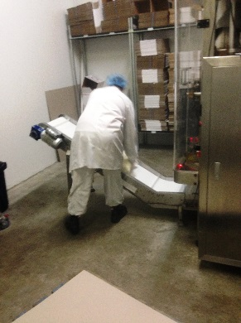  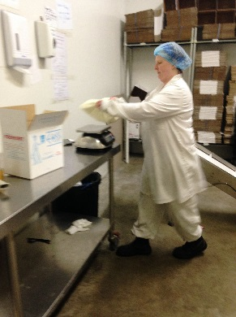  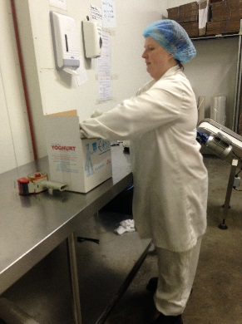  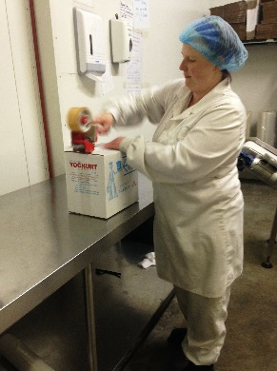 | Packaging  - Yoghurt is packaged automatically by machine.  - Machine film rolls changed occasionally 26kg roll, 2 person lift.  - Two workers undertake packing task. One makes boxes and one fills boxes.  - Forming box using both hands to fold flaps down. Repetitive bilateral gripping, pronation / supination, forward reaching to work at bench height.  - Constant lifting 5kg bag from conveyor belt and placing on bench.  - Weighing bag and placing 2 per box (ie forming 10kg box).  - Sticky taping box with tape gun (hammer grip).  - Repetitive lifting 10kg box from bench to pallet on floor.  - Up to 4 pallets are filled per day. 100 boxes per pallet.  - Pallet is wrapped by bilaterally holding roll of plastic and walking around pallet whilst slowly raising roll to cover entire pallet. Bending required for low areas.  - Pallet jack pushed (heavy force) to move full pallet to cool room. | Doctor Approval  Yes No  Comments:
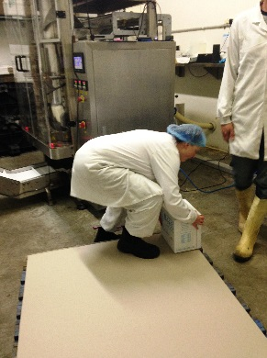
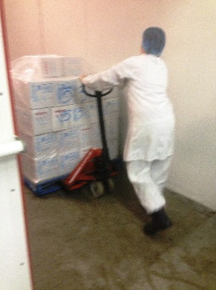
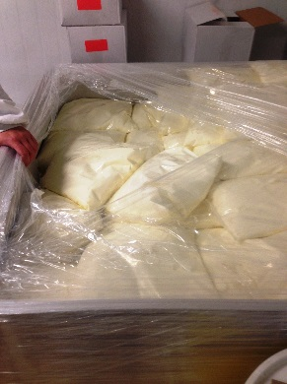  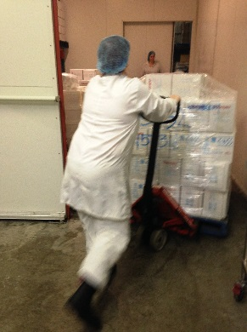 | Mega Bins  - For wholesale, 5kg yoghurt bags are lifted into a large vat/bin which is on a pallet (no boxing required).  - Pallet moved by pushing pallet jack. | Doctor Approval  Yes No  Comments:
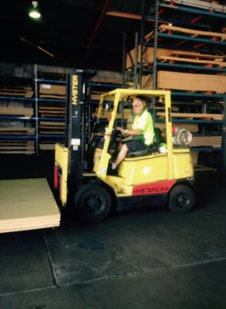 | Forklift  - Pallets are loaded into truck using forklift.  - Climbing in / out of forklift infrequently.  - Forward reaching and gripping required to use steering wheel and gear stick.  - Rotation of neck and spine required for driving and reversing. | Doctor Approval  Yes No  Comments:
Work Capacity Form
Doctor Review (include final comments)

I confirm that in my view, subject to the above comments, the worker is able to perform certain duties detailed in this Early Medical Assessment.
These duties should be reassessed on: |  | Date:

Signature : |  | Date:

Employers Declaration:
I confirm that I/we have reviewed the Doctor’s recommendations and comments. I/we will make suitable changes to make allowances for the Dr’s recommendations.
Signature : |  | Date:

Employees Declaration
My Doctor has discussed their recommendations with me. I have been given the opportunity to participate in this process.
Signature : |  | Date:
For information on completing this form, please contact Business SA on 08 8300 0000.
Disclaimer: This document is published by Business SA with funding from ReturnToWorkSA. All workplaces and circumstances are different and this document should be used as a guide only. It is not diagnostic and should not replace consultation, evaluation, or personal services including examination and an agreed course of action by a licensed practitioner. Business SA and ReturnToWorkSA and their affiliates and their respective agents do not accept any liability for injury, loss or damage arising from the use or reliance on this document. The copyright owner provides permission to reproduce and adapt this document for the purposes indicated and to tailor it (as intended) for individual circumstances. (C) 2016 ReturnToWorkSA

