Early Medical Assessment

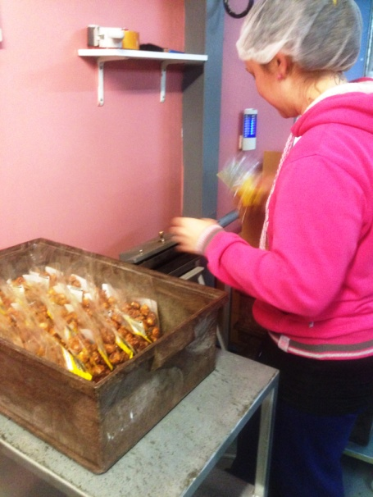

Fish and Takeaway Retailing
Packing – Nuts

Fish and Takeaway Retailing
Packing
Dear Doctor: This form will take up to 5 minutes to complete. Please review each task the worker undertakes (both picture and written description) and tick whether or not the worker can complete this task. If modification required, please leave comments. Space at the end of this document is available for final comments and recommendations.
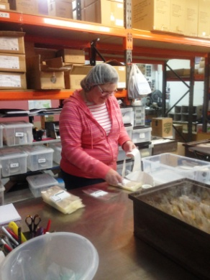 | Labelling  - Peeling labels from roll of stickers and placing on cellophane bags on the bench.  - Constant standing, repetitive pinching to peel sticker, constant neck flexion to look down to bench, bilateral hand use. | Doctor Approval  Yes No  Comments:
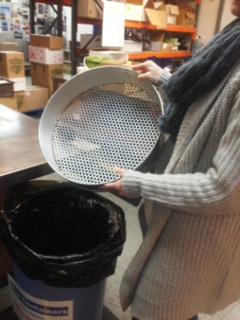  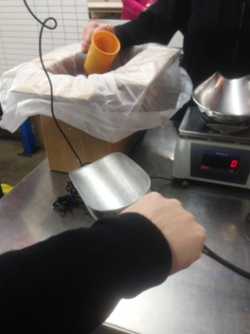  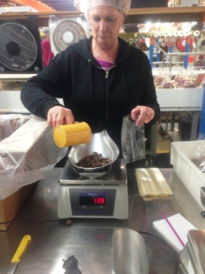 | Weighing  - Constant standing at bench. Constant bilateral hand use and forward reaching with close range.  - Sieving nuts – shaking over a bin and tipping into a box ready to be packaged.  - Opening cellophane bag in preparation.  - Scooping nuts into cellophane bag on scales using scoop or cup.  - Lifting bag off scales and placing in box on bench.  - Carrying box to sealer. | Doctor Approval  Yes No  Comments:
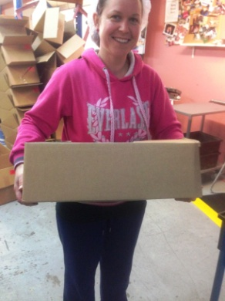
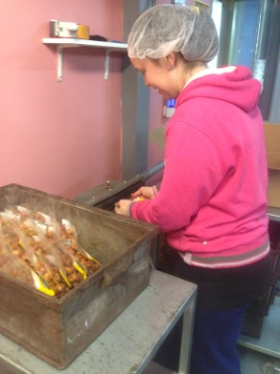 | Sealing  - Standing and using foot pedal to seal individual bags of product. Holding bag shut with both hands whilst sealing occurs.  - Placing sealed bag into box. | Doctor Approval  Yes No  Comments:
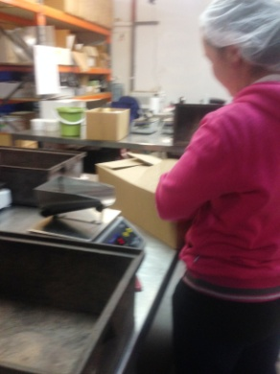  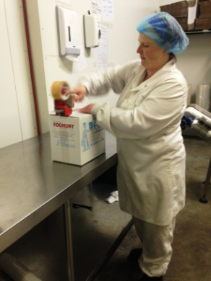 | Boxing  - Occasional folding of box using both arms and grasping.  - Taping box shut using tape gun (hammer grip). | Doctor Approval  Yes No  Comments:
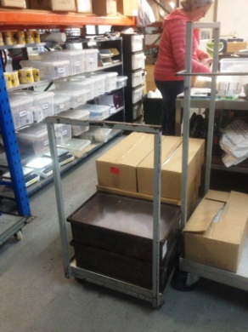 | Collecting Product  - Infrequently pushing empty trolley to cool room to collect boxes of product for packing. | Doctor Approval  Yes No  Comments:
Work Capacity Form
Doctor Review (include final comments)

I confirm that in my view, subject to the above comments, the worker is able to perform certain duties detailed in this Early Medical Assessment.
These duties should be reassessed on: |  | Date:

Signature : |  | Date:

Employers Declaration:
I confirm that I/we have reviewed the Doctor’s recommendations and comments. I/we will make suitable changes to make allowances for the Dr’s recommendations.
Signature : |  | Date:

Employees Declaration
My Doctor has discussed their recommendations with me. I have been given the opportunity to participate in this process.
Signature : |  | Date:
For information on completing this form, please contact Business SA on 08 8300 0000.
Disclaimer: This document is published by Business SA with funding from ReturnToWorkSA. All workplaces and circumstances are different and this document should be used as a guide only. It is not diagnostic and should not replace consultation, evaluation, or personal services including examination and an agreed course of action by a licensed practitioner. Business SA and ReturnToWorkSA and their affiliates and their respective agents do not accept any liability for injury, loss or damage arising from the use or reliance on this document. The copyright owner provides permission to reproduce and adapt this document for the purposes indicated and to tailor it (as intended) for individual circumstances. (C) 2016 ReturnToWorkSA

