Early Medical Assessment

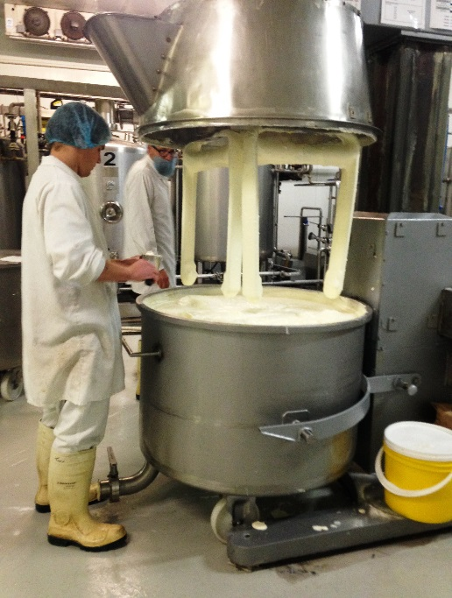

Fish and Takeaway Retailing
Yoghurt Making

Fish and Takeaway Retailing
Yoghurt Making
Dear Doctor: This form will take up to 5 minutes to complete. Please review each task the worker undertakes (both picture and written description) and tick whether or not the worker can complete this task. If modification required, please leave comments. Space at the end of this document is available for final comments and recommendations.
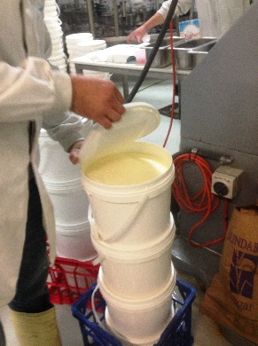 | Pot Set Yoghurt  - Four workers involved in this process  - Two holding hoses (8kg) and ‘pouring’ 10L of yoghurt into each bucket (static holding and moving hose);  - One placing lids on buckets (frequent gripping and pushing);  - One stacking buckets on top of each other (frequent lifting 10kg buckets).  - Move with pallet jack. | Doctor Approval  Yes No  Comments:
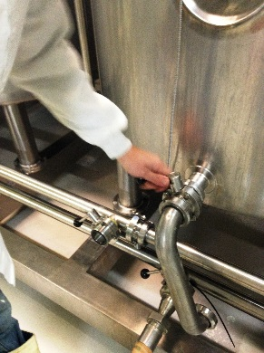  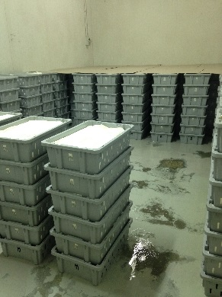  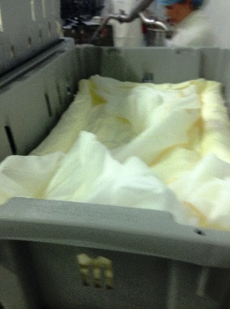  30  1176  36 | Strained Yoghurt  - Occasional use of levers to set up vats for pouring, gripping and pulling force.  - Three workers involved in this process  - putting crate in place (1kg);  - holding yoghurt hose (8kg full);  - folding cloth into crate .  - Once poured tubs are left for 24 hours in cold room to strain.  - Lifting 12kg strained tubs onto pallet on floor to be moved to mixing room.  - Occasional pushing pallet mover with medium force.  - Infrequent lifting of 25kg bags of skim powder (10 bags lifted twice per week). First worker lifting from pallet to bench, second worker opens bags and pours into rapper. | Doctor Approval  Yes No  Comments:
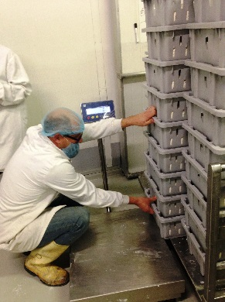  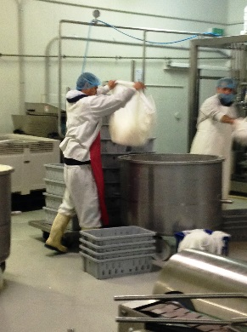  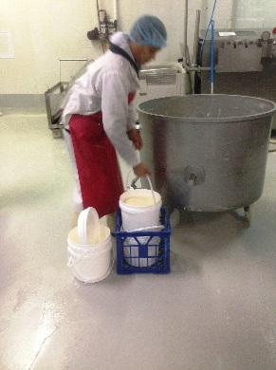  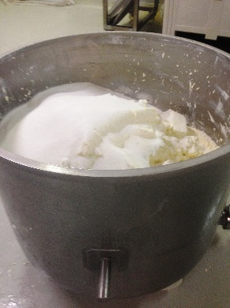  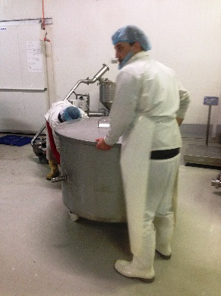  1794  1849  1773 | Mixing Yoghurt  - Tower of stained yoghurt pulled onto scales whilst in crouching position.  - Crated strained yoghurt is lifted out of the tub using the cloth (8kg) and put in mixing vat.  - Pot set yoghurt buckets (10kg) are lifted and poured into mixing vat.  - Sugar lifted (15kg bags) and poured into vat.  - Mixing vat pushed/pulled into place for automatic mixing (medium force). | Doctor Approval  Yes No  Comments:
Work Capacity Form
Doctor Review (include final comments)

I confirm that in my view, subject to the above comments, the worker is able to perform certain duties detailed in this Early Medical Assessment.
These duties should be reassessed on: |  | Date:

Signature : |  | Date:

Employers Declaration:
I confirm that I/we have reviewed the Doctor’s recommendations and comments. I/we will make suitable changes to make allowances for the Dr’s recommendations.
Signature : |  | Date:

Employees Declaration
My Doctor has discussed their recommendations with me. I have been given the opportunity to participate in this process.
Signature : |  | Date:
For information on completing this form, please contact Business SA on 08 8300 0000.
Disclaimer: This document is published by Business SA with funding from ReturnToWorkSA. All workplaces and circumstances are different and this document should be used as a guide only. It is not diagnostic and should not replace consultation, evaluation, or personal services including examination and an agreed course of action by a licensed practitioner. Business SA and ReturnToWorkSA and their affiliates and their respective agents do not accept any liability for injury, loss or damage arising from the use or reliance on this document. The copyright owner provides permission to reproduce and adapt this document for the purposes indicated and to tailor it (as intended) for individual circumstances. (C) 2016 ReturnToWorkSA

