Early Medical Assessment
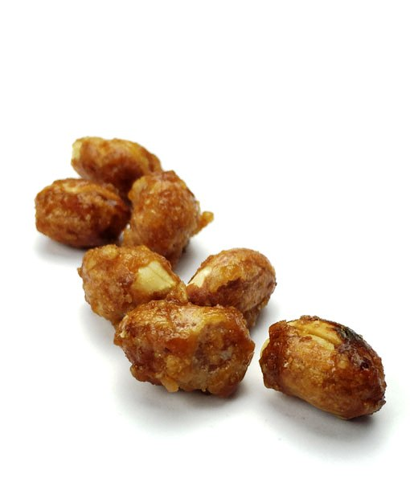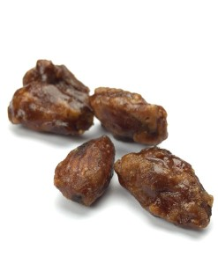

Fish and Takeaway Retailing
Glazing

Fish and Takeaway Retailing
Glazing
Dear Doctor: This form will take up to 5 minutes to complete. Please review each task the worker undertakes (both picture and written description) and tick whether or not the worker can complete this task. If modification required, please leave comments. Space at the end of this document is available for final comments and recommendations.
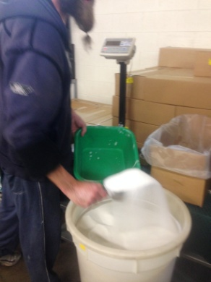 | Preparation  - Sugar and peanuts are delivered in 25kg bags on a pallet.  - Pouring 25kg bag into large bucket on wheels to push to glazing area (light push force with some bending required). If worker finds difficult, two people can pour.  - Scooping 2.6kg sugar out of large bucket onto scales and then carrying the 2.6kg to the copper pot.  - Carrying bucket of water infrequently to copper pot to be used for multiple toffees. Scooped out each time.  - Team of three workers per two pots. Constant standing and moving around glazing area throughout shift. | Doctor Approval  Yes No  Comments:
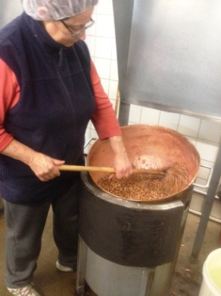  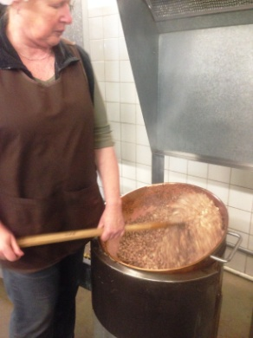 | Stirring and Tipping  - 5kg of nuts are glazed at a time in the copper pot.  - Stirring toffee and nuts in pot for 20 minutes constantly using large wooden spoon (up to 1m and length can vary according to workers height). One hand grips the top of the spoon and the other hand directing using a power grip.  - As the toffee changes it becomes harder to stir and the stirring motion becomes more of a digging motion. Bilateral shoulder rotation and elbow flexion/extension occurs constantly.  - Two workers lift and tip copper pot onto bench using a swinging motion. Wearing gloves, gripping a handle each, swinging forward then back and over the shoulder requiring shoulder rotation. | Doctor Approval  Yes No  Comments:
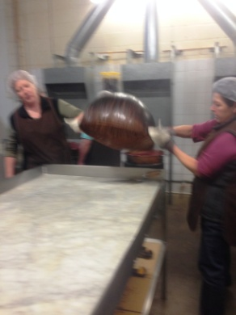
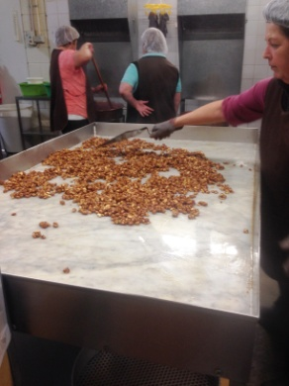  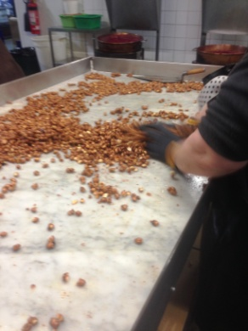  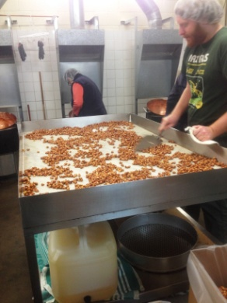  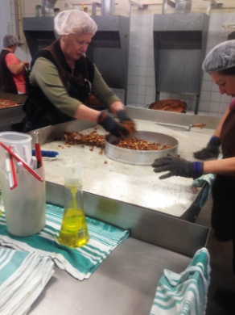 | On The Table  - Marble bench top with surrounding edging.  - Spreading nuts and toffee over bench using trowel in dominant hand. Bench is deep and requires extended reach and bending to reach opposite side. Most of the time two workers are working on either side of the bench to reduce the reaching but it does happen occasionally when cleaning / breaking and sieving.  - Allowing toffee to set.  - Breaking up ‘set’ toffee and nuts with hands. NB. Bilateral activity. Sweeping motion into the middle with extended arms and gripping to break toffee.  - NB. Almonds and Macadamia nuts are harder to break apart than peanuts and require ‘snapping’ - a downwards motion with the thumbs whilst gripping with some force to break toffee.  - Grasping nuts off table and placing in sieve.  - Sieving of 2.5kg of toffee nuts at a time holding a round sieve and shaking.  - Pouring sieved nuts into empty box.  - Cleaning bench down with trowel and pouring and spreading oil for next batch. | Doctor Approval  Yes No  Comments:
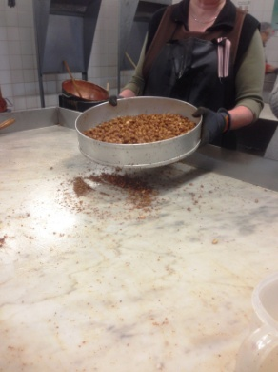
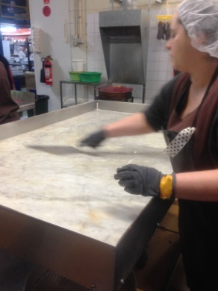
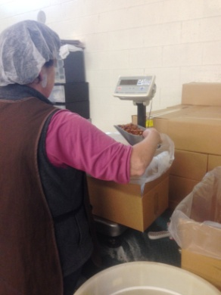  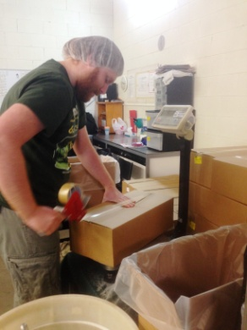 | Packing  - Carrying box to scales and adjusting weight to 10kg using scoop.  - Folding down flaps and taping box shut with tape gun. Power grip dominant hand.  - Lifting and carrying box (10kg) to pallet. | Doctor Approval  Yes No  Comments:
Work Capacity Form
Doctor Review (include final comments)

I confirm that in my view, subject to the above comments, the worker is able to perform certain duties detailed in this Early Medical Assessment.
These duties should be reassessed on: |  | Date:

Signature : |  | Date:

Employers Declaration:
I confirm that I/we have reviewed the Doctor’s recommendations and comments. I/we will make suitable changes to make allowances for the Dr’s recommendations.
Signature : |  | Date:

Employees Declaration
My Doctor has discussed their recommendations with me. I have been given the opportunity to participate in this process.
Signature : |  | Date:
For information on completing this form, please contact Business SA on 08 8300 0000.
Disclaimer: This document is published by Business SA with funding from ReturnToWorkSA. All workplaces and circumstances are different and this document should be used as a guide only. It is not diagnostic and should not replace consultation, evaluation, or personal services including examination and an agreed course of action by a licensed practitioner. Business SA and ReturnToWorkSA and their affiliates and their respective agents do not accept any liability for injury, loss or damage arising from the use or reliance on this document. The copyright owner provides permission to reproduce and adapt this document for the purposes indicated and to tailor it (as intended) for individual circumstances. (C) 2016 ReturnToWorkSA

