Early Medical Assessment

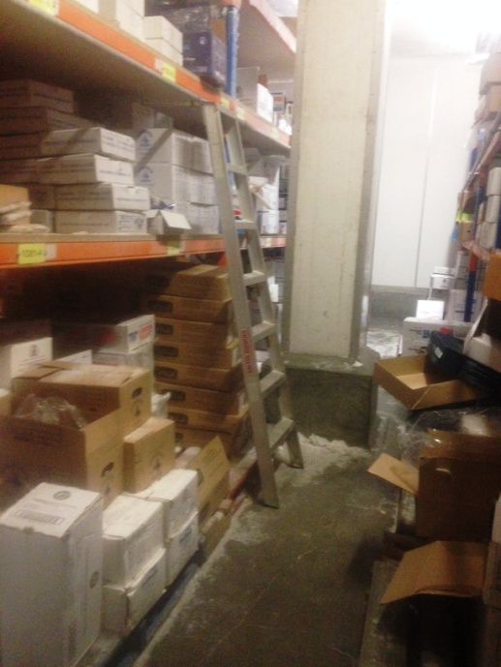

Fish and Takeaway Retailing
Freezer

Fish and Takeaway Retailing
Freezer
Dear Doctor: This form will take up to 5 minutes to complete. Please review each task the worker undertakes (both picture and written description) and tick whether or not the worker can complete this task. If modification required, please leave comments. Space at the end of this document is available for final comments and recommendations.
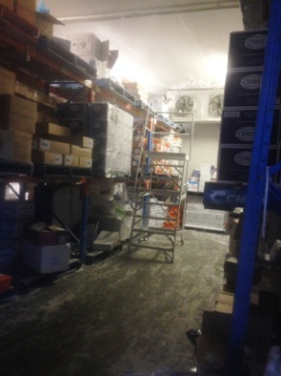  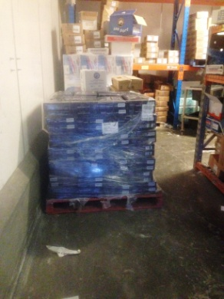 | Stores  - Freezer workers wear thermal pants and jacket to protect against -20º temperatures. Entrance to freezer can be slippery with ice.  - Constant standing and walking required to carry out duties.  - Use hand driven forklift to place pallets on shelving.  - Upper levels are unpacked by hand whilst climbing and standing on a platform ladder. Repetitive task whilst shelving product.  - Boxes handled are mostly 5kg or 10kg. Infrequently boxes of 15-20kg are lifted.  - Deliveries on pallets are unwrapped from plastic and boxes re-shelved. Lifting from pallet on floor and carrying to correct area within freezer. | Doctor Approval  Yes No  Comments:
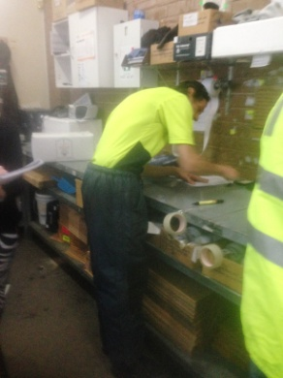  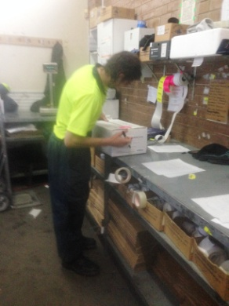 | Picking Order  - Paperwork done at bench.  - Picking order in freezer using sack truck to transport boxes. Lifting boxes onto sack truck required. Some low level postures for low lifting.  - Pushing sack truck outside of freezer and palletizing order (pallet on the floor).  - Labeling boxes at bench height and taping.  - Using hand driven forklift to move pallet to dispatch. | Doctor Approval  Yes No  Comments:
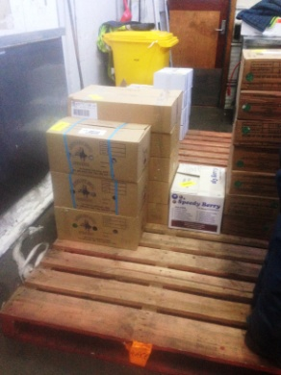
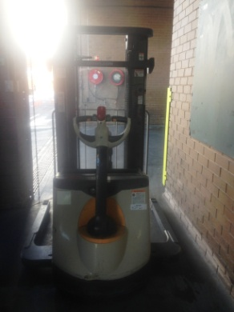
Work Capacity Form
Doctor Review (include final comments)

I confirm that in my view, subject to the above comments, the worker is able to perform certain duties detailed in this Early Medical Assessment.
These duties should be reassessed on: |  | Date:

Signature : |  | Date:

Employers Declaration:
I confirm that I/we have reviewed the Doctor’s recommendations and comments. I/we will make suitable changes to make allowances for the Dr’s recommendations.
Signature : |  | Date:

Employees Declaration
My Doctor has discussed their recommendations with me. I have been given the opportunity to participate in this process.
Signature : |  | Date:
For information on completing this form, please contact Business SA on 08 8300 0000.
Disclaimer: This document is published by Business SA with funding from ReturnToWorkSA. All workplaces and circumstances are different and this document should be used as a guide only. It is not diagnostic and should not replace consultation, evaluation, or personal services including examination and an agreed course of action by a licensed practitioner. Business SA and ReturnToWorkSA and their affiliates and their respective agents do not accept any liability for injury, loss or damage arising from the use or reliance on this document. The copyright owner provides permission to reproduce and adapt this document for the purposes indicated and to tailor it (as intended) for individual circumstances. (C) 2016 ReturnToWorkSA

