Early Medical Assessment

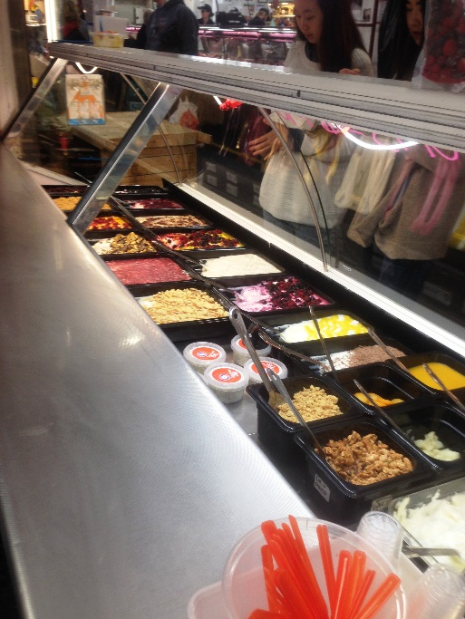

Fish and Takeaway Retailing
Customer Service – Yoghurt Retail

Fish and Takeaway Retailing
Customer Service
Dear Doctor: This form will take up to 5 minutes to complete. Please review each task the worker undertakes (both picture and written description) and tick whether or not the worker can complete this task. If modification required, please leave comments. Space at the end of this document is available for final comments and recommendations.
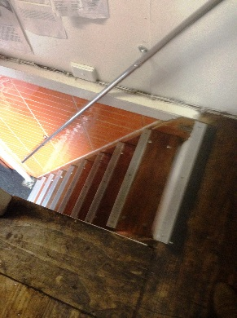  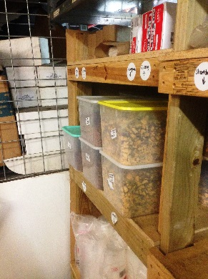 | Preparation  - Driver delivers items to cool room using forklift on Monday and unpacks into coolroom.  - Storage area located upstairs. Occasional stair climbing throughout day. Yoghurt, packaging and toppings stored upstairs.  - Carrying 10kg boxes of yoghurt downstairs as required.  - Tubs of dry toppings are kept in shelving upstairs. Wednesday is preparation day and these boxes are carried downstairs to fill plastic tubs for the week. Plastic tubs located at the side of the prep bench for easy access.  - All preparation work done on middle bench.  - Flavours are put in squeezy bottles.  - Presenting yoghurt for display involves squeezing bag into 2.5L display tub. Squeezing flavouring on top by weight.  - Lifting and placing yoghurt tub in display cabinet.  - Presentation of yoghurt in display tubs is ongoing throughout day. Lifting tubs out, refilling as required and re-doing toppings. Smoothing icecream tops and making them look attractive. | Doctor Approval  Yes No  Comments:
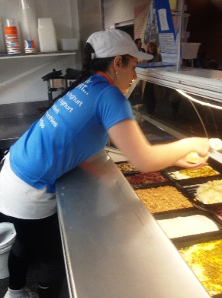  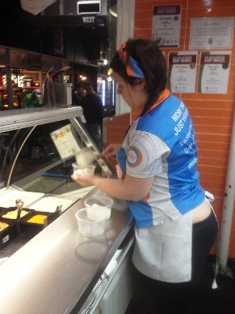  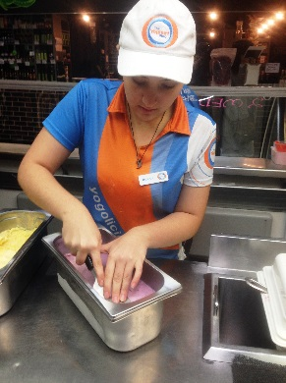  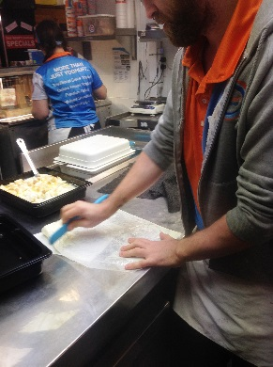  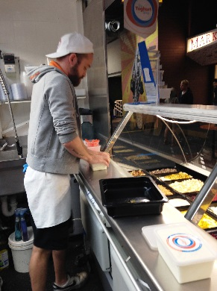 | Customer Service  - Cash handling and EFTPOS. Computer touch screen used.  - Service customer’s yoghurt orders. Repetitive bending and reaching into display cabinet to scoop yoghurt into take away tub using dominant hand.  - Pressing lid onto takeaway container.  - Frequent reaching over counter to pass yoghurt to customer and take payment. | Doctor Approval  Yes No  Comments:
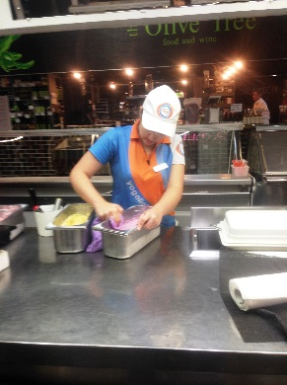 | Cleaning  - Glad wrapping (bilateral task) all left over yoghurt for overnight storage. Placing in fridges under display cabinets. Squatting required.  - Removing glass doors from display cabinets (bilateral activity).  - Cleaning cabinet by lifting out large metal plate and wiping over.  - Wiping front glass (reaching in 800mm) using dominant arm.  - Saturdays, frozen yoghurt is carried upstairs for storage. | Doctor Approval  Yes No  Comments:
Work Capacity Form
Doctor Review (include final comments)

I confirm that in my view, subject to the above comments, the worker is able to perform certain duties detailed in this Early Medical Assessment.
These duties should be reassessed on: |  | Date:

Signature : |  | Date:

Employers Declaration:
I confirm that I/we have reviewed the Doctor’s recommendations and comments. I/we will make suitable changes to make allowances for the Dr’s recommendations.
Signature : |  | Date:

Employees Declaration
My Doctor has discussed their recommendations with me. I have been given the opportunity to participate in this process.
Signature : |  | Date:
For information on completing this form, please contact Business SA on 08 8300 0000.
Disclaimer: This document is published by Business SA with funding from ReturnToWorkSA. All workplaces and circumstances are different and this document should be used as a guide only. It is not diagnostic and should not replace consultation, evaluation, or personal services including examination and an agreed course of action by a licensed practitioner. Business SA and ReturnToWorkSA and their affiliates and their respective agents do not accept any liability for injury, loss or damage arising from the use or reliance on this document. The copyright owner provides permission to reproduce and adapt this document for the purposes indicated and to tailor it (as intended) for individual circumstances. (C) 2016 ReturnToWorkSA

