Early Medical Assessment

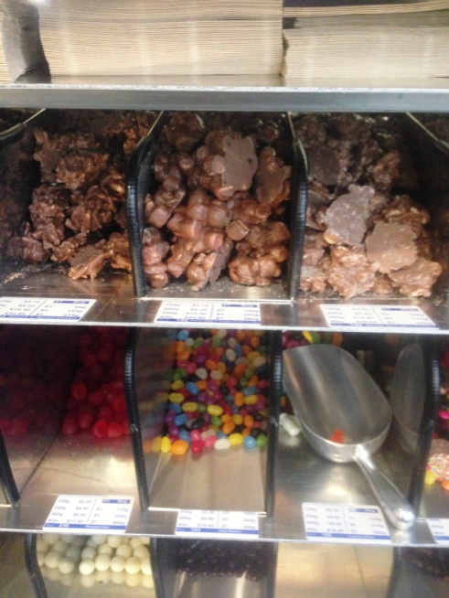

Fish and Takeaway Retailing
Customer Service – Nut Retail

Fish and Takeaway Retailing
Customer Service
Dear Doctor: This form will take up to 5 minutes to complete. Please review each task the worker undertakes (both picture and written description) and tick whether or not the worker can complete this task. If modification required, please leave comments. Space at the end of this document is available for final comments and recommendations.
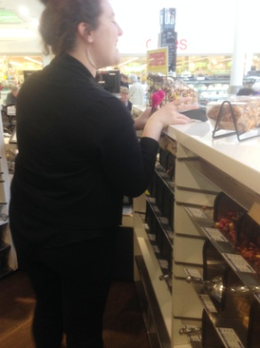  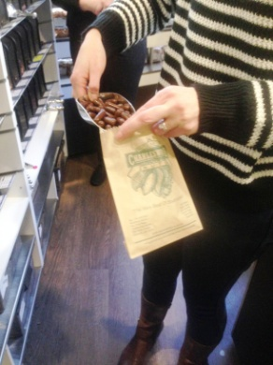  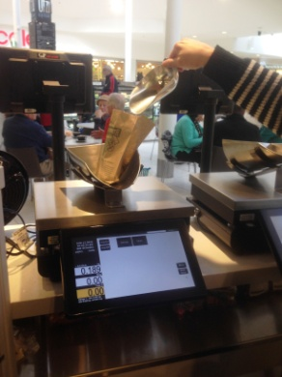  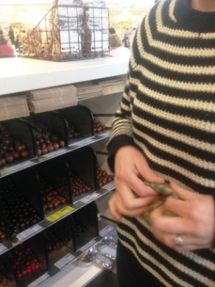 | Customer Service  - Scooping product into bags for customers as requested. Bending and reaching required due to counter height and depth.  - Low level postures required to access lower shelving.  - Touch screen till on bench top, frequent reaching over bench to handle money and pass product.  - Scoop or tongs used to handle product. Grasping and gripping repetitively.  - Placing bag on scales (on counter) to weigh and adding or taking product out as required. Folding top of bag over and handing to customer. | Doctor Approval  Yes No  Comments:
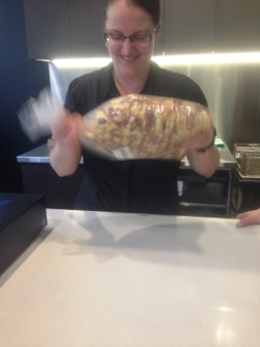  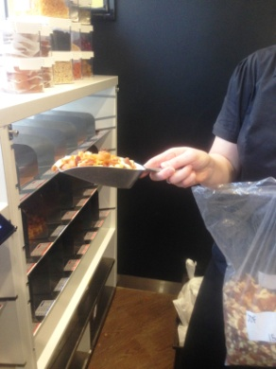  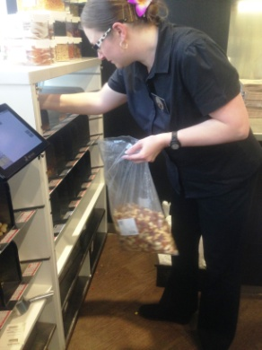  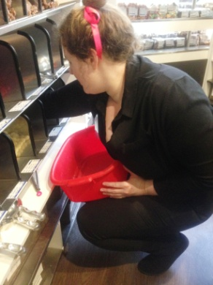 | Stock Rotation  - One section of the shop rotated each day.  - Pulling product out of shelving into tub with scoop or gloved hands. Squatting required for lower shelves (max of 6kg handled). Bending for higher shelves (max of 3kg handled).  - Collecting bag of dried fruit or nuts from store room.  - Dropping bag on counter repetitively to loosen fruit .  - Using scoop to place new product in correct shelf.  - Replacing previously removed product into shelf.  - Refilling of shelves occurs daily as required.  - Constant standing, gripping and bilateral hand use. Constant forward reaching. | Doctor Approval  Yes No  Comments:
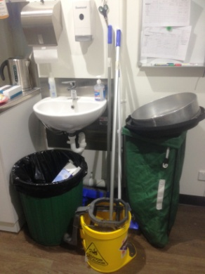 | Cleaning  - Sweeping and mopping daily as required.  - Wiping over benches throughout the day.  - During stock rotation, removal of shelves and washing in sink located in storeroom. Wiping of inside of glass and display shelving requiring forward reaching and bending. | Doctor Approval  Yes No  Comments:
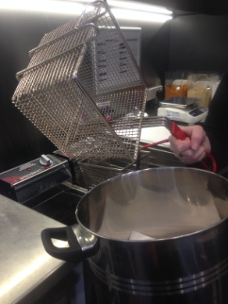  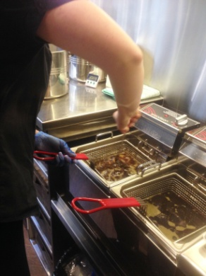  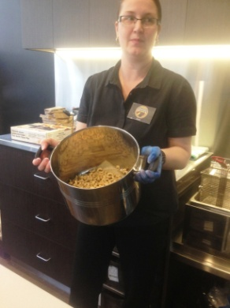 | Cooking Nuts  - Scooping raw nuts from box into frying basket.  - Lifting basket (two hands) into hot oil .  - Lifting basket of cooked nuts out of oil and pouring sideways into waiting pot on bench. Gripping and shoulder and forearm rotation to tip.  - Placing seasoning in pot with cooked nuts and shaking to coat product. Bilateral tossing movement to move nuts around in pot.  - Using scoop to place cooked nuts into shelving. | Doctor Approval  Yes No  Comments:
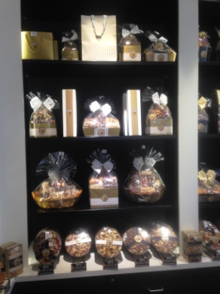  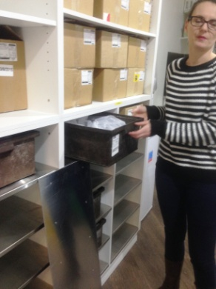 | Deliveries  - Twice per week or daily during the Christmas period.  - Driver brings all deliveries into the shop.  - Lifting tote boxes into shelving between floor and overhead height.  - Climbing step ladder to place pre-made baskets on display shelving. | Doctor Approval  Yes No  Comments:
Work Capacity Form
Doctor Review (include final comments)

I confirm that in my view, subject to the above comments, the worker is able to perform certain duties detailed in this Early Medical Assessment.
These duties should be reassessed on: |  | Date:

Signature : |  | Date:

Employers Declaration:
I confirm that I/we have reviewed the Doctor’s recommendations and comments. I/we will make suitable changes to make allowances for the Dr’s recommendations.
Signature : |  | Date:

Employees Declaration
My Doctor has discussed their recommendations with me. I have been given the opportunity to participate in this process.
Signature : |  | Date:
For information on completing this form, please contact Business SA on 08 8300 0000.
Disclaimer: This document is published by Business SA with funding from ReturnToWorkSA. All workplaces and circumstances are different and this document should be used as a guide only. It is not diagnostic and should not replace consultation, evaluation, or personal services including examination and an agreed course of action by a licensed practitioner. Business SA and ReturnToWorkSA and their affiliates and their respective agents do not accept any liability for injury, loss or damage arising from the use or reliance on this document. The copyright owner provides permission to reproduce and adapt this document for the purposes indicated and to tailor it (as intended) for individual circumstances. (C) 2016 ReturnToWorkSA

