Early Medical Assessment

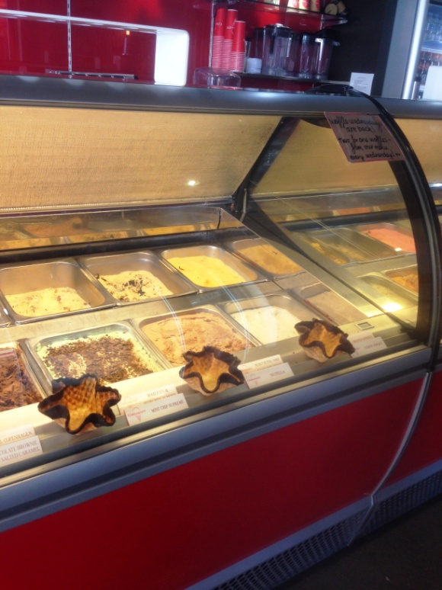

Fish and Takeaway Retailing
Customer Service – Ice-cream Retail

Fish and Takeaway Retailing
Customer Service
Dear Doctor: This form will take up to 5 minutes to complete. Please review each task the worker undertakes (both picture and written description) and tick whether or not the worker can complete this task. If modification required, please leave comments. Space at the end of this document is available for final comments and recommendations.
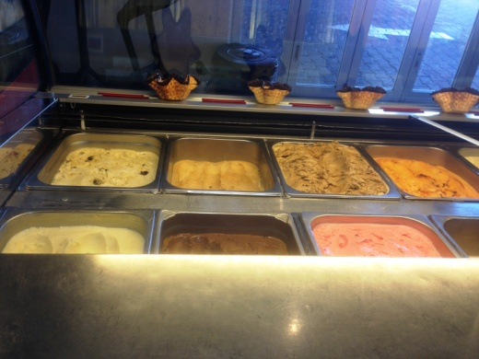  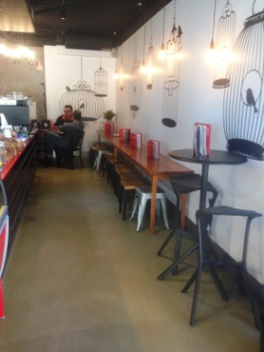 | Opening Store  - Setting up outdoor furniture (lightweight metal chairs).  - Unstacking indoor chairs from tables.  - Setting up cake display on counter ie retrieving from kitchen (in back of shop) and placing on bench.  - Placing ice-cream in cabinet (each tub <5kg).  - Cleaning cabinet by wiping out inside and glass, involves bending and extended reaching to reach the inside of the cabinet. | Doctor Approval  Yes No  Comments:
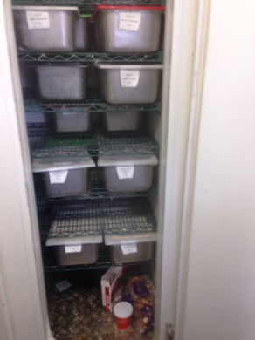 | Closing Store  - Stacking chairs onto tables.  - Bring in (lifting and carrying) outdoor chairs.  - Emptying ice-cream cabinet and carrying tubs to freezer in kitchen (shelving floor to overhead height).  - Cleaning floor (sweeping and mopping) and wiping tables. | Doctor Approval  Yes No  Comments:
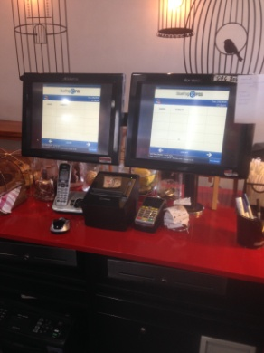  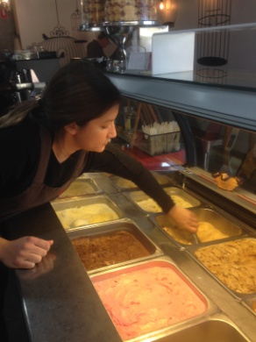  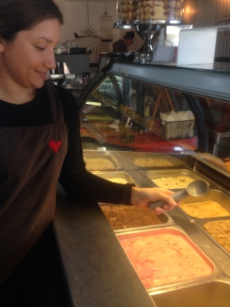  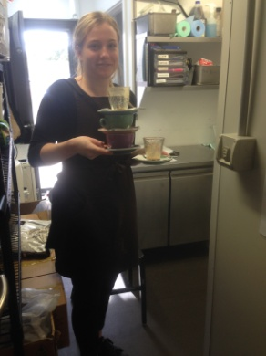 | Serving Customers  - Constant standing whilst taking customer orders.  - Scooping ice-cream repetitively. Forward bending and reaching to reach front tubs. Scoop held in dominant hand.  - Scoop is replaced in water to make scooping process easier.  - Clearing tables and dishes as required. Carrying dishes to kitchen, loading under bench dishwasher requiring bending.  - Touch screen POS on bench.  - Forward reaching requiring up to 100 degrees shoulder flexion required to reach over counter to hand ice-cream to customer. Lower area available by till.  - Stocking drink fridges and ice-cream cups - shelving between floor and overhead height. | Doctor Approval  Yes No  Comments:
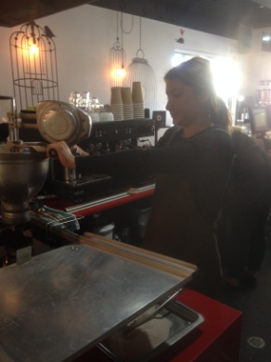  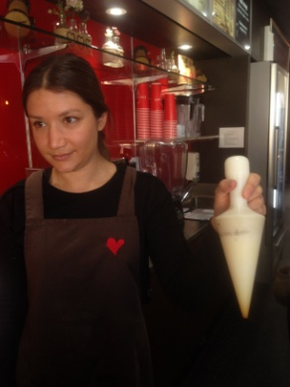  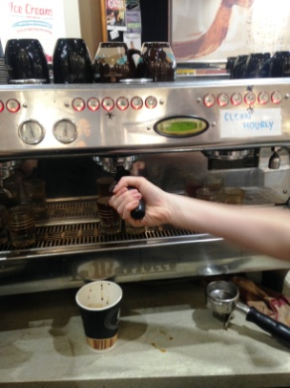 | Making Waffle Cones, Donuts and Coffee  - Constant standing and moving behind bench.  - Made to order. Pulling donut maker across oil and filling with mixture. Operating donut machine with both hands to make donuts. Scooping out when cooked.  - Scooping cooled oil out to empty deep fryer with a jug.  - Waffle mixture is pre-measured. When cooked, waffle is wrapped around cylindrical shape to make cone. Bilateral activity.  - Making coffees as ordered - coffee machine on bench.  - Wrist supination and lateral flexion whilst gripping to place coffee grounds in machine.  - Tamping grind, downwards pressing motion with dominant hand whilst gripping tamper.  - Holding milk jug to steamer and turning knob (approx chest height) with dominant hand to operate steam.  - Pouring heated milk into cup.  - Wrist pronation to tip out used grounds. Can require banging portafilter to remove wet grounds. | Doctor Approval  Yes No  Comments:
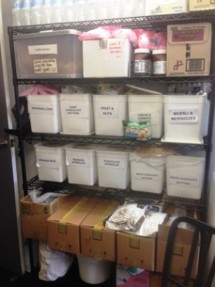 | Deliveries  - Once / twice per week. Delivery driver unloads into kitchen.  - Shelving of ice-cream in freezer requiring reaching between floor and overhead height.  - Placing cakes in under bench fridges requiring low level postures to access. | Doctor Approval  Yes No  Comments:
Work Capacity Form
Doctor Review (include final comments)

I confirm that in my view, subject to the above comments, the worker is able to perform certain duties detailed in this Early Medical Assessment.
These duties should be reassessed on: |  | Date:

Signature : |  | Date:

Employers Declaration:
I confirm that I/we have reviewed the Doctor’s recommendations and comments. I/we will make suitable changes to make allowances for the Dr’s recommendations.
Signature : |  | Date:

Employees Declaration
My Doctor has discussed their recommendations with me. I have been given the opportunity to participate in this process.
Signature : |  | Date:
For information on completing this form, please contact Business SA on 08 8300 0000.
Disclaimer: This document is published by Business SA with funding from ReturnToWorkSA. All workplaces and circumstances are different and this document should be used as a guide only. It is not diagnostic and should not replace consultation, evaluation, or personal services including examination and an agreed course of action by a licensed practitioner. Business SA and ReturnToWorkSA and their affiliates and their respective agents do not accept any liability for injury, loss or damage arising from the use or reliance on this document. The copyright owner provides permission to reproduce and adapt this document for the purposes indicated and to tailor it (as intended) for individual circumstances. (C) 2016 ReturnToWorkSA

