Early Medical Assessment

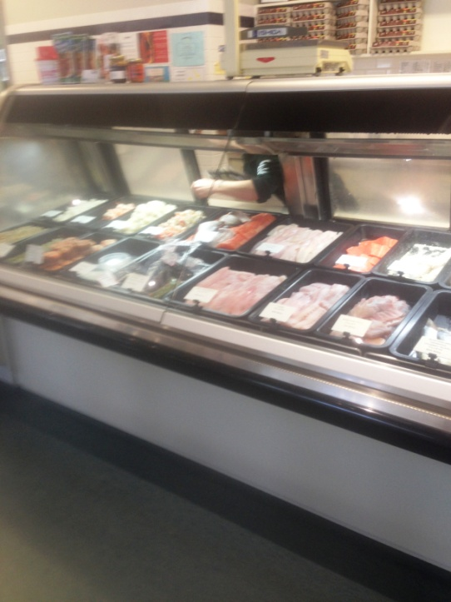

Fish and Takeaway Retailing
Customer Service – Fish Retail

Fish and Takeaway Retailing
Customer Service
Dear Doctor: This form will take up to 5 minutes to complete. Please review each task the worker undertakes (both picture and written description) and tick whether or not the worker can complete this task. If modification required, please leave comments. Space at the end of this document is available for final comments and recommendations.
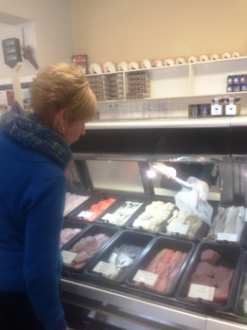  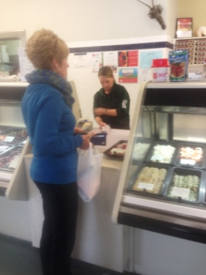  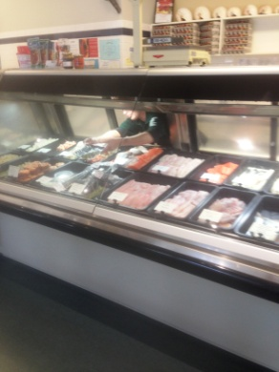 | Serving Customers  - Constant standing to serve customers fish and other products as requested.  - Front service counter requires above shoulder reaching for some.  - Cabinet requires bending to reach front tubs of fish. Sliding doors to fridges need to be pushed aside each time fish is accessed.  - Tongs used to handle fish / food products; repetitive gripping.  - There is a cut out in the counter to hand fish and collect money to reduce reaching.  - Wrapping fish in paper for customer and bagging if required. | Doctor Approval  Yes No  Comments:
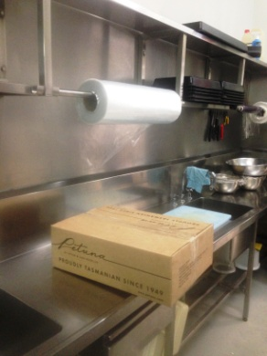  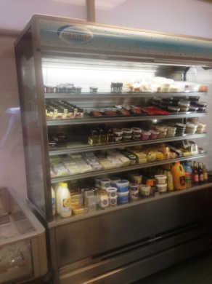  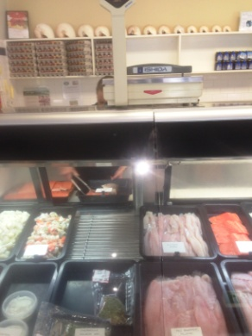 | Stock Handling  - Replacing fish in tubs as required for presentation.  - Wrapping tubs at bench. Both hands required to pull down plastic from roll to wrap around tub.  - Placing tubs in display cabinet or coolroom between floor and overhead height.  - Replacing dry or frozen stock including drinks as required throughout day. Shelving between floor and over shoulder height - can be handled individually or in boxes into store then placed on shelves. Low level postures required for accessing low shelving. | Doctor Approval  Yes No  Comments:
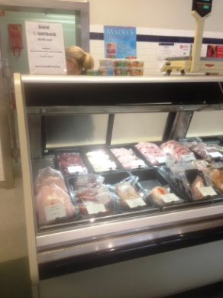  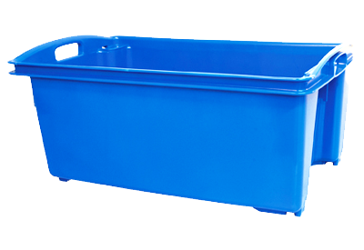 | Cleaning  - Wiping cabinet and glass requiring forward reaching and bending into cabinet.  - Removing tubs of fish and hosing cabinet daily (plumbed to sewer).  - Removing all fish in tubs on Saturday and placing in coolroom and fully cleaning cabinet using hose and wiping.  - Sweeping and mopping floors. | Doctor Approval  Yes No  Comments:
Work Capacity Form
Doctor Review (include final comments)

I confirm that in my view, subject to the above comments, the worker is able to perform certain duties detailed in this Early Medical Assessment.
These duties should be reassessed on: |  | Date:

Signature : |  | Date:

Employers Declaration:
I confirm that I/we have reviewed the Doctor’s recommendations and comments. I/we will make suitable changes to make allowances for the Dr’s recommendations.
Signature : |  | Date:

Employees Declaration
My Doctor has discussed their recommendations with me. I have been given the opportunity to participate in this process.
Signature : |  | Date:
For information on completing this form, please contact Business SA on 08 8300 0000.
Disclaimer: This document is published by Business SA with funding from ReturnToWorkSA. All workplaces and circumstances are different and this document should be used as a guide only. It is not diagnostic and should not replace consultation, evaluation, or personal services including examination and an agreed course of action by a licensed practitioner. Business SA and ReturnToWorkSA and their affiliates and their respective agents do not accept any liability for injury, loss or damage arising from the use or reliance on this document. The copyright owner provides permission to reproduce and adapt this document for the purposes indicated and to tailor it (as intended) for individual circumstances. (C) 2016 ReturnToWorkSA

