Early Medical Assessment

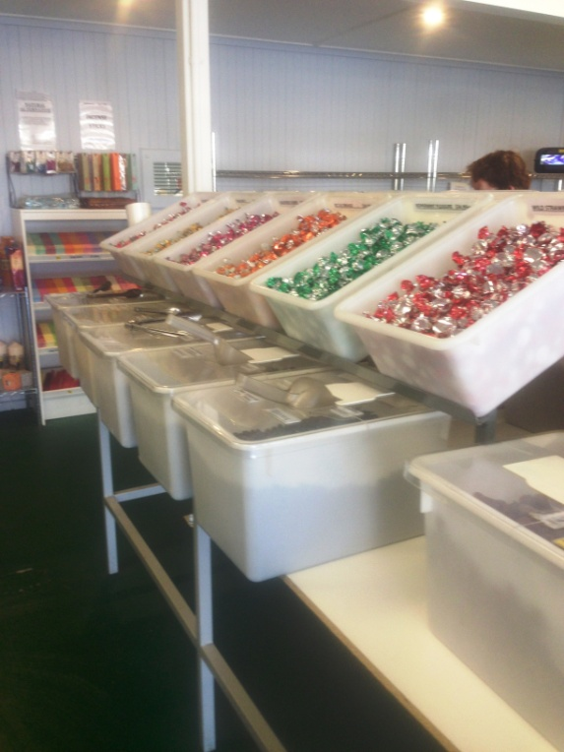

Fish and Takeaway Retailing
Customer Service – Confectionary Retail

Fish and Takeaway Retailing
Customer Service
Dear Doctor: This form will take up to 5 minutes to complete. Please review each task the worker undertakes (both picture and written description) and tick whether or not the worker can complete this task. If modification required, please leave comments. Space at the end of this document is available for final comments and recommendations.
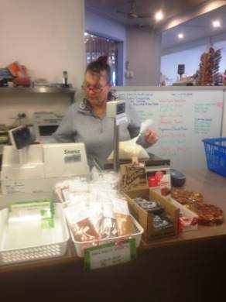  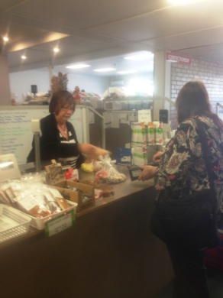 | Serving Customers  - Using scales and till at bench height. Bagging items for customer to take away.  - Constant standing, repetitive forward reaching to use till and scales, repetitive grasping of items and money.  - Bagging up small amounts in bags, placing tie on it and labelling eg 1kg bag of flour. Using scoop with dominant hand and holding bag with second hand. | Doctor Approval  Yes No  Comments:
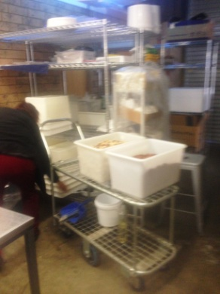  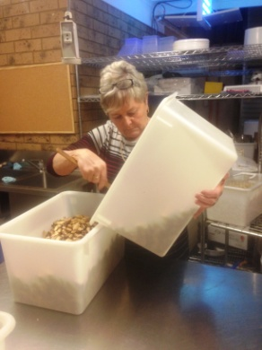 | Rotation  - Removing tub from shop and carrying or pushing on trolley to bench.  - Pouring contents of tub into a different tub. Bilateral gripping and lifting to pour from one side.  - Filling tub with new product obtained from box in storeroom.  - Filling the top of the tub with the remaining product from the old tub.  - Lifting and pouring tub or using a scoop in dominant hand to pull product out whilst holding tub with the second hand.  - Washing dirty tubs at sink and sanitizing. Bending to place under bench on a shelf to dry. | Doctor Approval  Yes No  Comments:
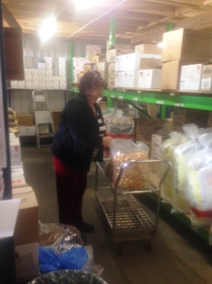  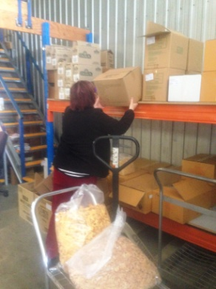  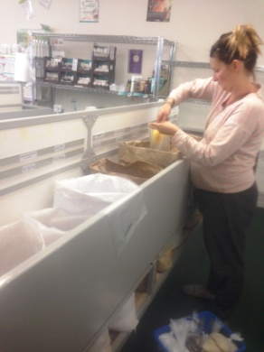  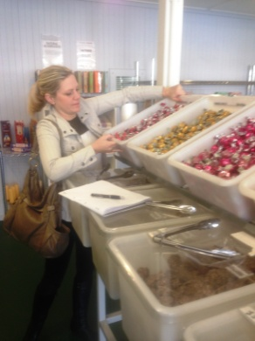  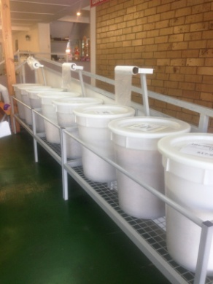 | Refilling  - During day as required, constant standing and walking to refill tubs as they become low.  - Carrying box out to shop and pouring/scooping into tub.  - Some items such as flour require the whole bag to be carried or pushed on trolley out to shop and lifted into stand.  - Replacing tub in position in shop (full tub up to 15kg).  - Confectionary tubs are tilted; can be awkward to lift into place.  - Large cereal/grain tubs can take a 25kg bag to fill. | Doctor Approval  Yes No  Comments:
 | Cleaning  - Sweeping and mopping floors.  - Wiping over benches. | Doctor Approval  Yes No  Comments:
Work Capacity Form
Doctor Review (include final comments)

I confirm that in my view, subject to the above comments, the worker is able to perform certain duties detailed in this Early Medical Assessment.
These duties should be reassessed on: |  | Date:

Signature : |  | Date:

Employers Declaration:
I confirm that I/we have reviewed the Doctor’s recommendations and comments. I/we will make suitable changes to make allowances for the Dr’s recommendations.
Signature : |  | Date:

Employees Declaration
My Doctor has discussed their recommendations with me. I have been given the opportunity to participate in this process.
Signature : |  | Date:
For information on completing this form, please contact Business SA on 08 8300 0000.
Disclaimer: This document is published by Business SA with funding from ReturnToWorkSA. All workplaces and circumstances are different and this document should be used as a guide only. It is not diagnostic and should not replace consultation, evaluation, or personal services including examination and an agreed course of action by a licensed practitioner. Business SA and ReturnToWorkSA and their affiliates and their respective agents do not accept any liability for injury, loss or damage arising from the use or reliance on this document. The copyright owner provides permission to reproduce and adapt this document for the purposes indicated and to tailor it (as intended) for individual circumstances. (C) 2016 ReturnToWorkSA

