Early Medical Assessment
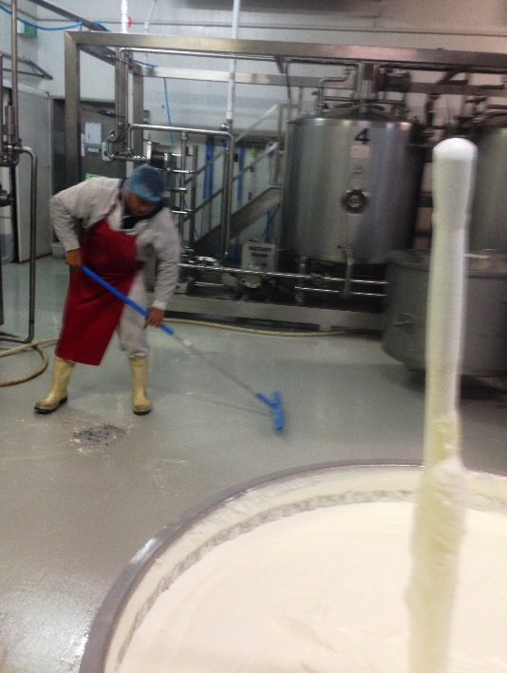

Fish and Takeaway Retailing
Cleaning

Fish and Takeaway Retailing
Cleaning
Dear Doctor: This form will take up to 5 minutes to complete. Please review each task the worker undertakes (both picture and written description) and tick whether or not the worker can complete this task. If modification required, please leave comments. Space at the end of this document is available for final comments and recommendations.
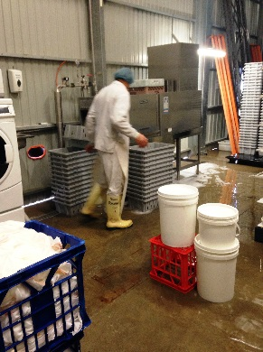  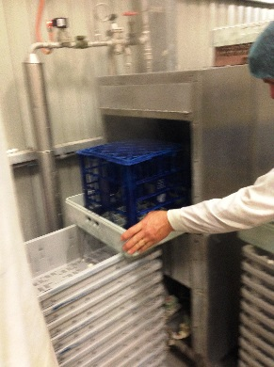  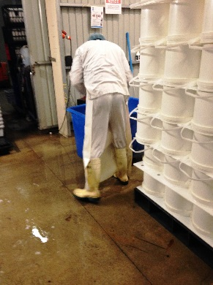  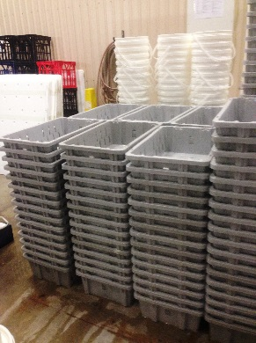  1844  1840 | Rising Buckets and Crates  - Rinsing buckets and crates in a sink at waist height and stacking on a pallet to be transferred to cleaning room.  - Grasping bucket or crate and placing on rack and pushing though industrial dish washer at waist height.  - Collecting rack after cleaning, dipping in sanitiser and stacking on pallet. Repetitive gripping and forward reaching required. Frequent bending whilst dipping. | Doctor Approval  Yes No  Comments:
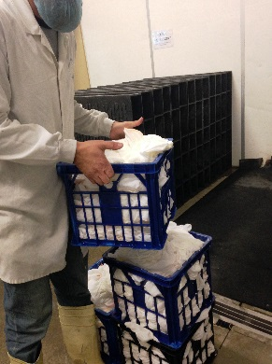  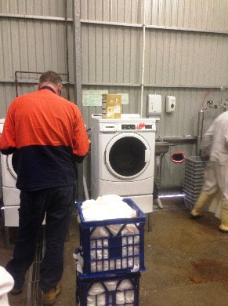 | Cleaning Cloths  - 10kg crate of cloths are placed next to industrial washing machine.  - Separating each cloth, shaking out and placing in washing machine.  - Constant standing, fine gripping and forward reaching into machine. | Doctor Approval  Yes No  Comments:
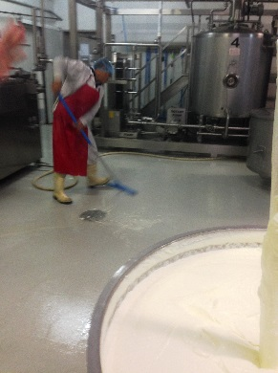 | Cleaning Room  - Holding hose to rinse floor.  - Foaming room with chemical agent (hose attachment).  - Manually scrubbing room using push/pull motion with broom.  - Rinsing with hose.  - Squeegee water off using pushing motion with rubber bladed broom. | Doctor Approval  Yes No  Comments:
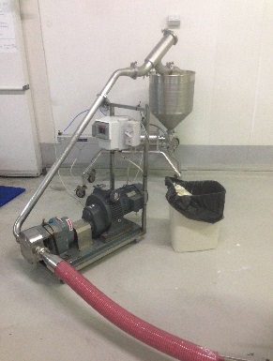 | Manual Cleaning of Equipment  - Daily all pumps and filling equipment are pulled apart and rinsed manually, scrubbed with soapy water and placed in sanitizer solution over night. | Doctor Approval  Yes No  Comments:
Work Capacity Form
Doctor Review (include final comments)

I confirm that in my view, subject to the above comments, the worker is able to perform certain duties detailed in this Early Medical Assessment.
These duties should be reassessed on: |  | Date:

Signature : |  | Date:

Employers Declaration:
I confirm that I/we have reviewed the Doctor’s recommendations and comments. I/we will make suitable changes to make allowances for the Dr’s recommendations.
Signature : |  | Date:

Employees Declaration
My Doctor has discussed their recommendations with me. I have been given the opportunity to participate in this process.
Signature : |  | Date:
For information on completing this form, please contact Business SA on 08 8300 0000.
Disclaimer: This document is published by Business SA with funding from ReturnToWorkSA. All workplaces and circumstances are different and this document should be used as a guide only. It is not diagnostic and should not replace consultation, evaluation, or personal services including examination and an agreed course of action by a licensed practitioner. Business SA and ReturnToWorkSA and their affiliates and their respective agents do not accept any liability for injury, loss or damage arising from the use or reliance on this document. The copyright owner provides permission to reproduce and adapt this document for the purposes indicated and to tailor it (as intended) for individual circumstances. (C) 2016 ReturnToWorkSA

