Early Medical Assessment

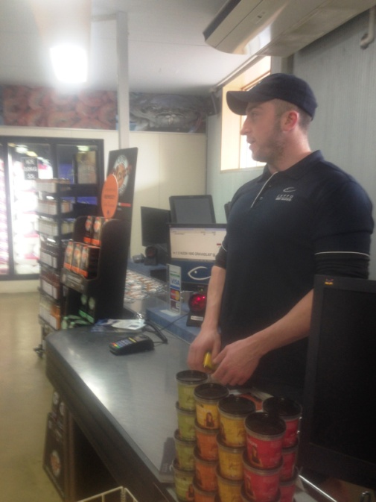

Fish and Takeaway Retailing
Checkout Operator

Fish and Takeaway Retailing
Checkout Operator
Dear Doctor: This form will take up to 5 minutes to complete. Please review each task the worker undertakes (both picture and written description) and tick whether or not the worker can complete this task. If modification required, please leave comments. Space at the end of this document is available for final comments and recommendations.
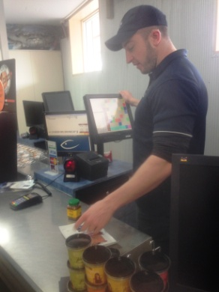  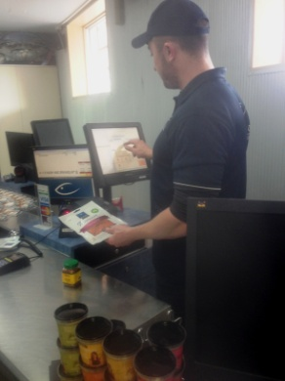 | Customer Service  - Constant standing to serve customers who have obtained their seafood and any other dry product or ice from counter or shop.  - Touch screen and laser scanning system (dominant hand swipes barcode near scanner.)  - Twisting required between screen and customer.  - Occasionally carrying order out to car if person elderly or disabled. Trolley available to use on ramp if many ice bags required. | Doctor Approval  Yes No  Comments:
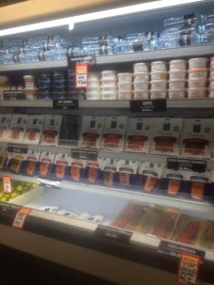  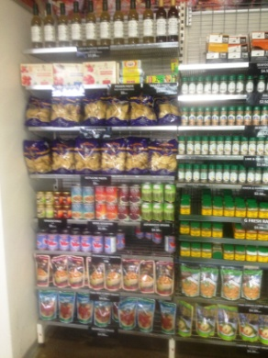 | Stock Replenishment  - Shelving requires reaching through all ranges.  - Dry ingredients on shelving, frozen fish in upright freezers or chest freezer. Fresh fish in front counter requiring bending and reaching to access furthest point. | Doctor Approval  Yes No  Comments:
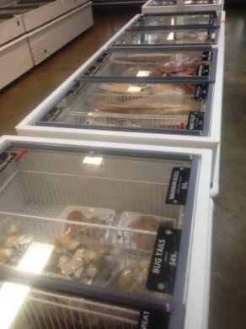 | Cleaning  - Sweeping and mopping floor as required thought-out day. Wiping of display cabinet glass on customer side.  - Once per week clean out display cabinet by lifting out trays and a 30kg stainless steel tray then wiping over inside and glass - bending and reaching inside required to wipe inside of glass and cabinet.  - Once per week clearing out a chest freezer and defrosting it to clean and sanitize inside, requiring bending and reaching to wipe inside. Involves lifting all products out and placing in large upright freezer whilst defrosting taking place. Repacking when finished. | Doctor Approval  Yes No  Comments:
Work Capacity Form
Doctor Review (include final comments)

I confirm that in my view, subject to the above comments, the worker is able to perform certain duties detailed in this Early Medical Assessment.
These duties should be reassessed on: |  | Date:

Signature : |  | Date:

Employers Declaration:
I confirm that I/we have reviewed the Doctor’s recommendations and comments. I/we will make suitable changes to make allowances for the Dr’s recommendations.
Signature : |  | Date:

Employees Declaration
My Doctor has discussed their recommendations with me. I have been given the opportunity to participate in this process.
Signature : |  | Date:
For information on completing this form, please contact Business SA on 08 8300 0000.
Disclaimer: This document is published by Business SA with funding from ReturnToWorkSA. All workplaces and circumstances are different and this document should be used as a guide only. It is not diagnostic and should not replace consultation, evaluation, or personal services including examination and an agreed course of action by a licensed practitioner. Business SA and ReturnToWorkSA and their affiliates and their respective agents do not accept any liability for injury, loss or damage arising from the use or reliance on this document. The copyright owner provides permission to reproduce and adapt this document for the purposes indicated and to tailor it (as intended) for individual circumstances. (C) 2016 ReturnToWorkSA

