Early Medical Assessment

Domestic Hardware and Homeware Retailing
Retail Sales Assistant Homewares

Domestic Hardware and Homeware Retailing
Retail Sales Assistant Homewares
Dear Doctor: This form will take up to 5 minutes to complete. Please review each task the worker undertakes (both picture and written description) and tick whether or not the worker can complete this task. If modification required, please leave comments. Space at the end of this document is available for final comments and recommendations.
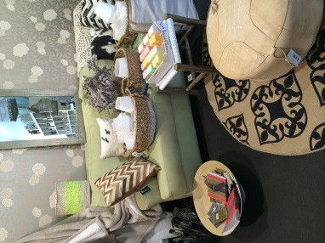 | Customer Service  - Standing / walking and discussing products with customer  - Handling and arranging items in-store to demonstrate product matching/ ideas (*Stock mostly lightweight e.g. cushions; figurines weighing ½- 5kg) | Doctor Approval  Yes No  Comments:
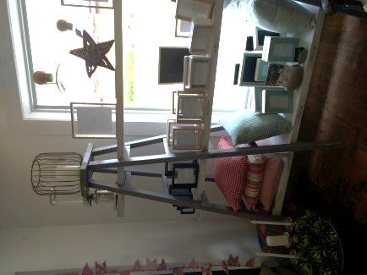 | Stock Handling  - Handing stock such as candles; picture frames; cushions (½ - 1kg) from between floor and 1820m m | Doctor Approval  Yes No  Comments:
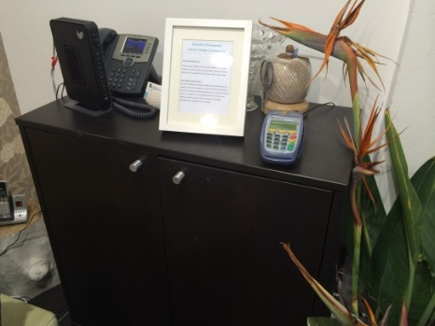 | Processing Transactions  - Walking, carrying items and standing at 900mm front counter  - Completing docket (hand written); wrapping and bagging items  - Handling cash from drawer or EFT on separate counter | Doctor Approval  Yes No  Comments:
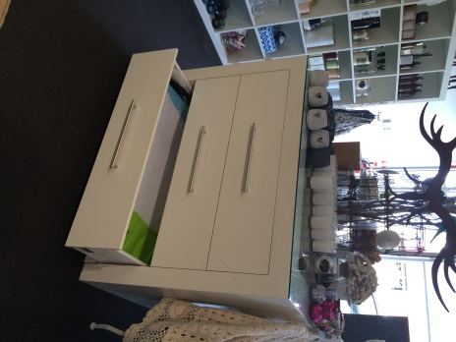 | Gift Wrapping  - Retrieving paper wrapping from low drawer  - Statically standing with neck flexed to giftwrap items and applying ribbon using fine finger dexterity.  - Assembling and wrapping contractual gifts | Doctor Approval  Yes No  Comments:
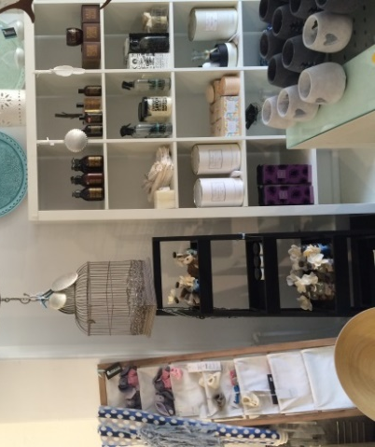 | Merchandising and Receiving  Stock  - Handling cartons of stock most weighing < 10kg.  - Presenting and facing up stock – handling items of ½ - 1kg weight; pulling forward on shelves. | Doctor Approval  Yes No  Comments:
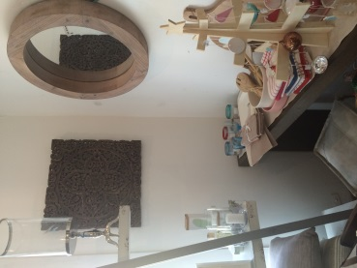 | Hanging Items  - Using stepladder to hang items from wall 1800mm or from hooks in roof.  - Carrying items while climbing ladder | Doctor Approval  Yes No  Comments:
 | Shop Display  Window display  - Pushing and moving furniture (medium force) within shop  - Grasping and arranging small items < 5kg for window display  - Grasping and arranging items 5kg-10kg for window display | Doctor Approval  Yes No  Comments:
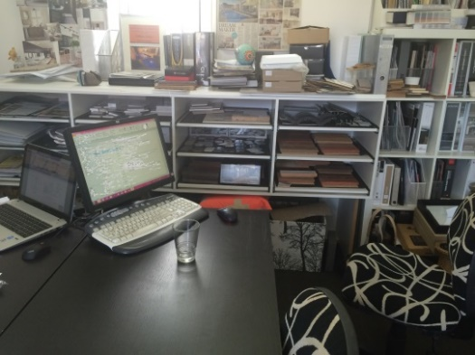 | Administrative Work  - Use of PC seated at desk with ergonomic chair.  - Duration up to 1 hour (quotes and ordering) if minimal customer interruptions | Doctor Approval  Yes No  Comments:
Work Capacity Form
Doctor Review (include final comments)

I confirm that in my view, subject to the above comments, the worker is able to perform certain duties detailed in this Early Medical Assessment.
These duties should be reassessed on: |  | Date:

Signature : |  | Date:

Employers Declaration:
I confirm that I/we have reviewed the Doctor’s recommendations and comments. I/we will make suitable changes to make allowances for the Doctor’s recommendations.
Signature : |  | Date:

Employees Declaration
My Doctor has discussed their recommendations with me. I have been given the opportunity to participate in this process.
Signature : |  | Date:
For information on completing this form, please contact Business SA on 08 8300 0000.
Disclaimer: This document is published by Business SA with funding from ReturnToWorkSA. All workplaces and circumstances are different and this document should be used as a guide only. It is not diagnostic and should not replace consultation, evaluation, or personal services including examination and an agreed course of action by a licensed practitioner. Business SA and ReturnToWorkSA and their affiliates and their respective agents do not accept any liability for injury, loss or damage arising from the use or reliance on this document. The copyright owner provides permission to reproduce and adapt this document for the purposes indicated and to tailor it (as intended) for individual circumstances. (C) 2016 ReturnToWorkSA

