Early Medical Assessment

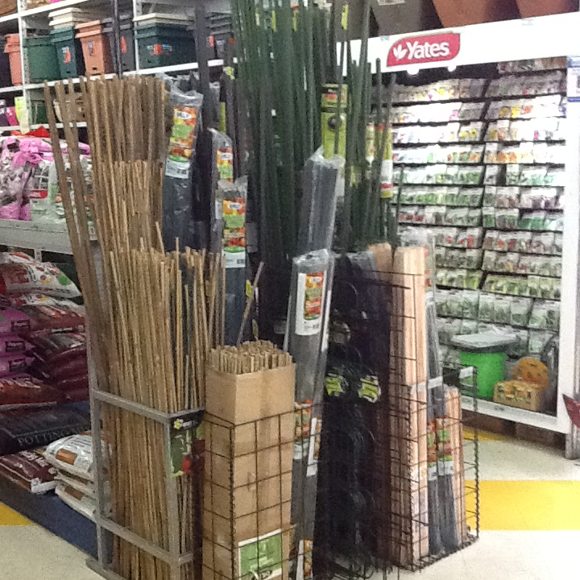

Domestic Hardware and Homeware Retailing
Manager

Domestic Hardware and Homeware Retailing
Manager
Dear Doctor: This form will take up to 5 minutes to complete. Please review each task the worker undertakes (both picture and written description) and tick whether or not the worker can complete this task. If modification required, please leave comments. Space at the end of this document is available for final comments and recommendations.
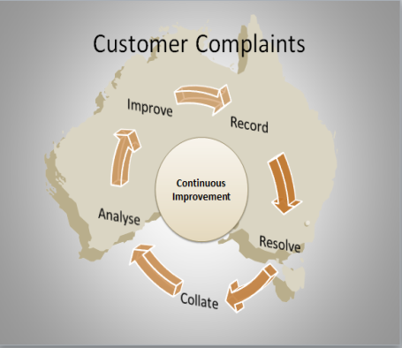 | Customer Responsibilities  - Overall responsibility for health and safety of all customers within the business  - Resolving customer complaints  - Providing appropriate training and development for staff | Doctor Approval  Yes No  Comments:
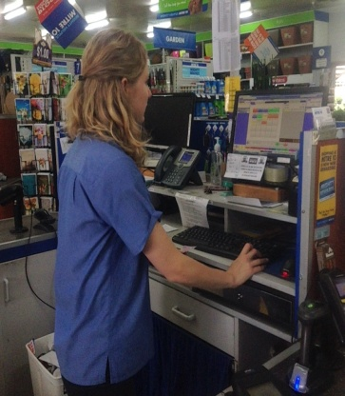 | Staff Responsibilities  - Overall responsibility of health and safety for all staff within the business  - Rostering staff  - Providing appropriate training and development for staff | Doctor Approval  Yes No  Comments:
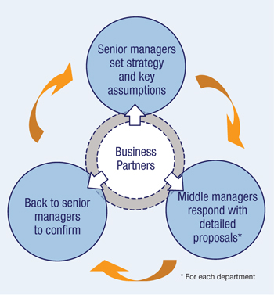   | Business Responsibilities  - Preparing and monitoring purchasing budget  - Preparing and monitoring sales budget and initiating corrective action where required  - Preparing and monitoring staff budget  - Providing leadership and direction to supervisors and staff aligning sales activities with the broader business plan  - Assisting with the marketing of promotional materials  - Ultimate responsibility for work, health and safety | Doctor Approval  Yes No  Comments:
Work Capacity Form
Doctor Review (include final comments)

I confirm that in my view, subject to the above comments, the worker is able to perform certain duties detailed in this Early Medical Assessment.
These duties should be reassessed on: |  | Date:

Signature : |  | Date:

Employers Declaration:
I confirm that I/we have reviewed the Doctor’s recommendations and comments. I/we will make suitable changes to make allowances for the Doctor’s recommendations.
Signature : |  | Date:

Employees Declaration
My Doctor has discussed their recommendations with me. I have been given the opportunity to participate in this process.
Signature : |  | Date:
For information on completing this form, please contact Business SA on 08 8300 0000.
Disclaimer: This document is published by Business SA with funding from ReturnToWorkSA. All workplaces and circumstances are different and this document should be used as a guide only. It is not diagnostic and should not replace consultation, evaluation, or personal services including examination and an agreed course of action by a licensed practitioner. Business SA and ReturnToWorkSA and their affiliates and their respective agents do not accept any liability for injury, loss or damage arising from the use or reliance on this document. The copyright owner provides permission to reproduce and adapt this document for the purposes indicated and to tailor it (as intended) for individual circumstances. (C) 2016 ReturnToWorkSA

