Early Medical Assessment

Domestic Hardware and Homeware Retailing
Homeware Sales Assistant

Domestic Hardware and Homeware Retailing
Homeware Sales Assistant
Dear Doctor: This form will take up to 5 minutes to complete. Please review each task the worker undertakes (both picture and written description) and tick whether or not the worker can complete this task. If modification required, please leave comments. Space at the end of this document is available for final comments and recommendations.
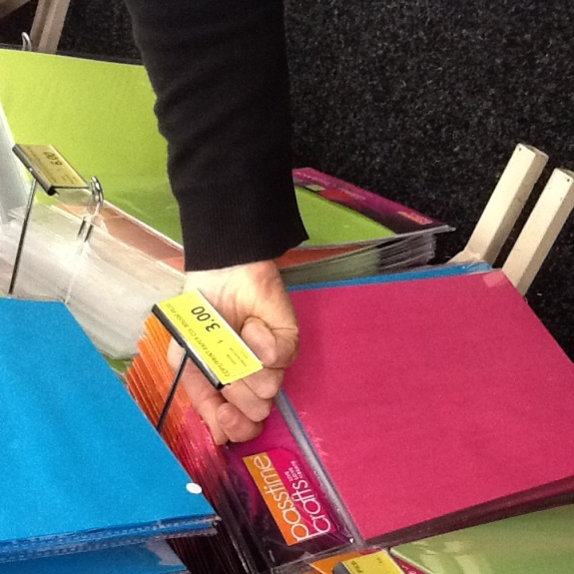 | Stock Handling  - Placing small stock items onto shelving at varying heights.  - Repeated squatting, bending and climbing steps/ladders in order to fetch and replenish stock.  - Wall hangers (various heights)  - Free-standing hangers (various heights)  (using step stool and ladder if required) | Doctor Approval  Yes No  Comments:
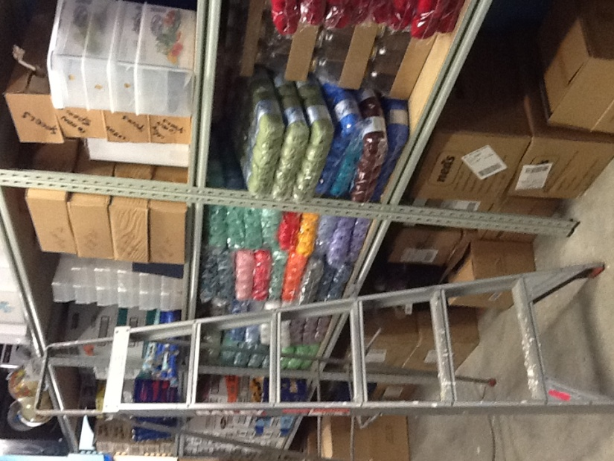 | Stock Handling  - Handling stock on shelves (floor level to ………..mm high)  - loose items, e.g. clothing (max.1.5kg)  - boxed items (max. 5kg)  - larger items (up to 30kg) require a two person lift  (using a step stool or ladder if required) | Doctor Approval  Yes No  Comments:
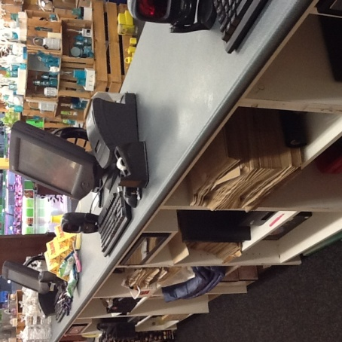 | Processing Transactions  - Walking to and standing at front counter  - Scanning item(s)  - Handling cash or EFT  - Wrapping and bagging item(s) at counter  - Occasional bending and frequent reaching required | Doctor Approval  Yes No  Comments:
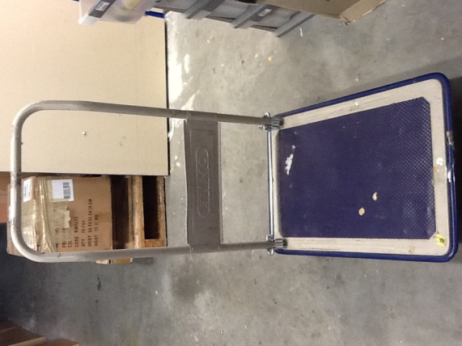 | Processing Stock  - Receiving goods via pallet deliveries several times per week  - Reaching within general body ranges  - Heavy boxes (>30kg) require two person lift, generally stored at the bottom of the pallet  - Stacking boxes onto trolley and transporting as required | Doctor Approval  Yes No  Comments:
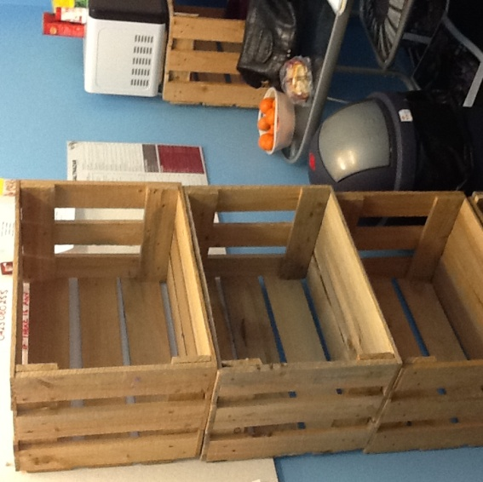 | Stocking Merchandising  - Unpacking boxes and shelving / hanging stock  - Reaching within general body ranges  - Moving and transporting crates for stock displays (approx 4kg) | Doctor Approval  Yes No  Comments:
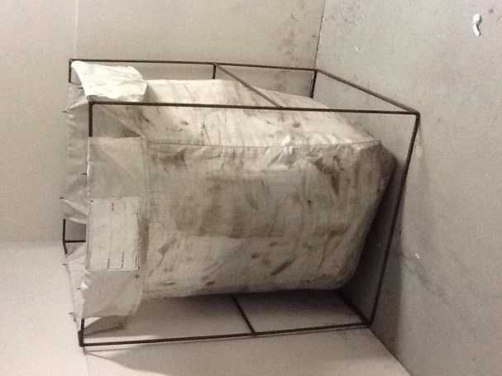  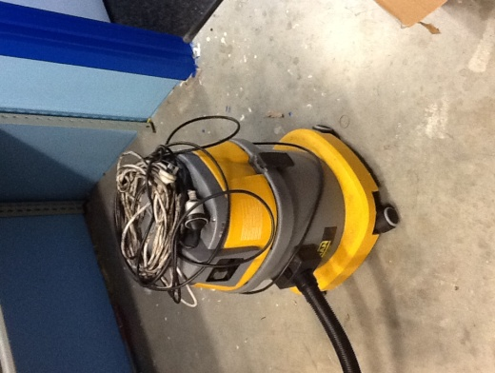 | Daily Cleaning Tasks  - Replacing stock on shelves and on hangers  - Tidying up including bending to pick up light items from floor  - Vacuuming the floor with a pull vacuum cleaner  - Condensing cardboard boxes and folding into box bin | Doctor Approval  Yes No  Comments:
Work Capacity Form
Doctor Review (include final comments)

I confirm that in my view, subject to the above comments, the worker is able to perform certain duties detailed in this Early Medical Assessment.
These duties should be reassessed on: |  | Date:

Signature : |  | Date:

Employers Declaration:
I confirm that I/we have reviewed the Doctor’s recommendations and comments. I/we will make suitable changes to make allowances for the Doctor’s recommendations.
Signature : |  | Date:

Employees Declaration
My Doctor has discussed their recommendations with me. I have been given the opportunity to participate in this process.
Signature : |  | Date:
For information on completing this form, please contact Business SA on 08 8300 0000.
Disclaimer: This document is published by Business SA with funding from ReturnToWorkSA. All workplaces and circumstances are different and this document should be used as a guide only. It is not diagnostic and should not replace consultation, evaluation, or personal services including examination and an agreed course of action by a licensed practitioner. Business SA and ReturnToWorkSA and their affiliates and their respective agents do not accept any liability for injury, loss or damage arising from the use or reliance on this document. The copyright owner provides permission to reproduce and adapt this document for the purposes indicated and to tailor it (as intended) for individual circumstances. (C) 2016 ReturnToWorkSA

