Early Medical Assessment
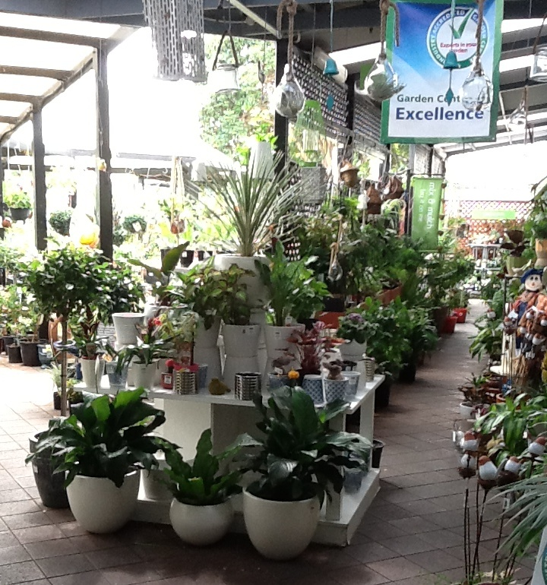
Domestic Hardware and Homeware Retailing
Gardening Assistant

Domestic Hardware and Homeware Retailing
Gardening Assistant
Dear Doctor: This form will take up to 5 minutes to complete. Please review each task the worker undertakes (both picture and written description) and tick whether or not the worker can complete this task. If modification required, please leave comments. Space at the end of this document is available for final comments and recommendations.
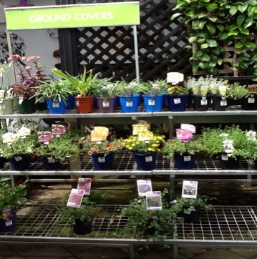 | Maintenance of Plants  - Assessing any overnight damage to plants  - Removing and disposing of damaged plants  - Rotating any plants that were previously shaded to sunny position | Doctor Approval  Yes No  Comments:
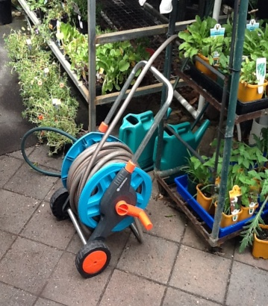 | Watering  - Water all plants using a hose on reel  - Manoeuvring long hose around rows and stands of plants  - Replacing hose when finished | Doctor Approval  Yes No  Comments:
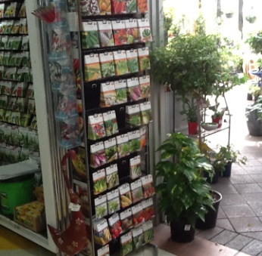  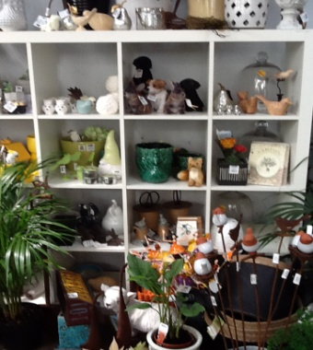 | Re-stocking Shelves  - Restocking shelves with plants and seedlings. Shelf is 1800mm high and 800mm wide  - Stacking pots on shelves which are 1800mm high and 800mm wide | Doctor Approval  Yes No  Comments:
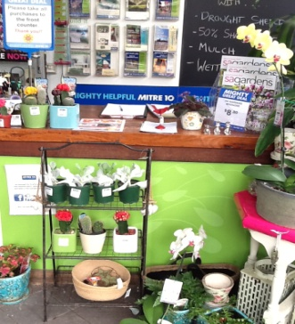 | Customer Service  - Attending to customers  - Carrying items for customers when required to counter which is 900mm high and 700mm wide  - Answering phone queries | Doctor Approval  Yes No  Comments:
Work Capacity Form
Doctor Review (include final comments)

I confirm that in my view, subject to the above comments, the worker is able to perform certain duties detailed in this Early Medical Assessment.
These duties should be reassessed on: |  | Date:

Signature : |  | Date:

Employers Declaration:
I confirm that I/we have reviewed the Doctor’s recommendations and comments. I/we will make suitable changes to make allowances for the Doctor’s recommendations.
Signature : |  | Date:

Employees Declaration
My Doctor has discussed their recommendations with me. I have been given the opportunity to participate in this process.
Signature : |  | Date:
For information on completing this form, please contact Business SA on 08 8300 0000.
Disclaimer: This document is published by Business SA with funding from ReturnToWorkSA. All workplaces and circumstances are different and this document should be used as a guide only. It is not diagnostic and should not replace consultation, evaluation, or personal services including examination and an agreed course of action by a licensed practitioner. Business SA and ReturnToWorkSA and their affiliates and their respective agents do not accept any liability for injury, loss or damage arising from the use or reliance on this document. The copyright owner provides permission to reproduce and adapt this document for the purposes indicated and to tailor it (as intended) for individual circumstances. (C) 2016 ReturnToWorkSA

