Early Medical Assessment

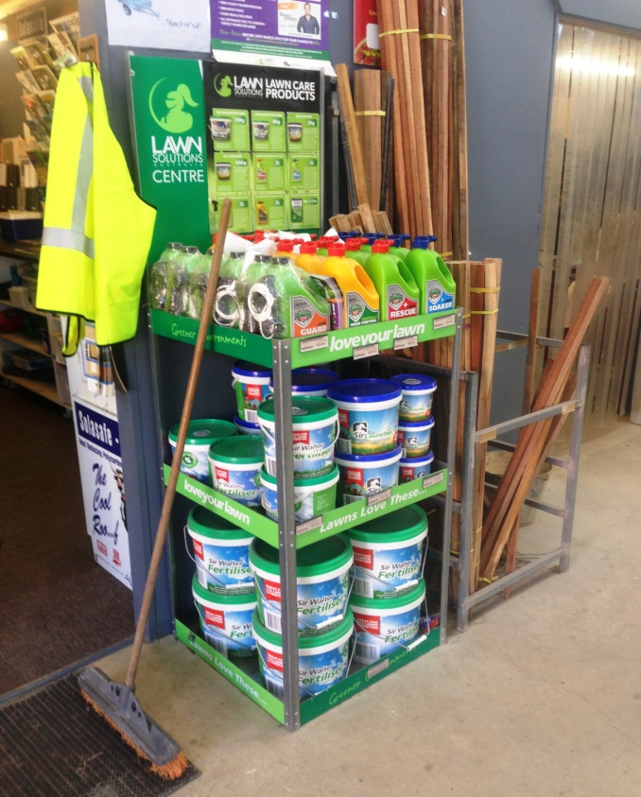

Domestic Hardware and Homeware Retailing
Customer Service

Domestic Hardware and Homeware Retailing
Customer Service
Dear Doctor: This form will take up to 5 minutes to complete. Please review each task the worker undertakes (both picture and written description) and tick whether or not the worker can complete this task. If modification required, please leave comments. Space at the end of this document is available for final comments and recommendations.
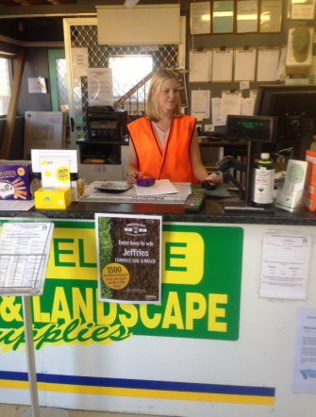 | Point of Sale System and Money Handling  - Standing at service desk to operate computer system  - Forward reaching within close range. | Doctor Approval  Yes No  Comments:
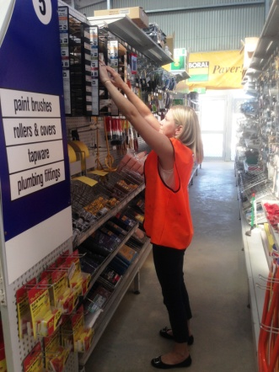  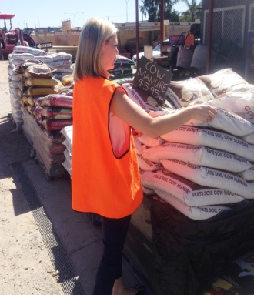  (pic of reaching to shelves + lifting sand bags + rollers with turf + shovelling + pallet with bricks) | Customer Service  - Walking between aisles, reaching to obtain product.  - Some fine handling of nails and the like.  - Lifting up to 30kg from ground to waist height  - Pushing wheelbarrow  - Pulling turf and cloths off rollers  - Filling gas bottles 3.7-9kg  - Shovelling | Doctor Approval  Yes No  Comments:
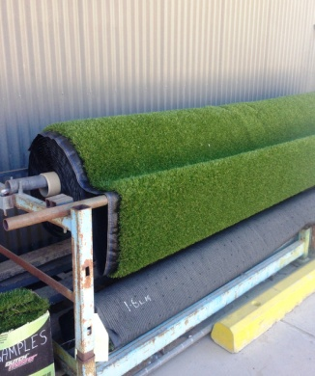
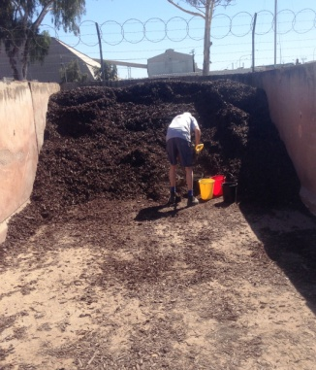
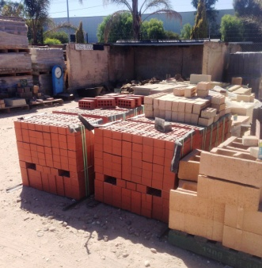
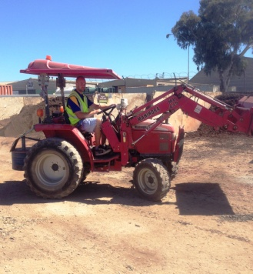 | Forklift driving  - Climbing in/out of forklift  - Sitting to drive  - Neck and spinal rotation for reversing  - Reaching for steering and use of levers. | Doctor Approval  Yes No  Comments:
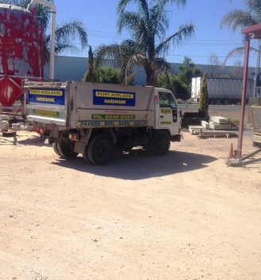 | Deliveries  - Sitting for driving.  - Occasional climbing in/out of cabin  - Dropping sides of truck at delivery and climbing on/off tray (gripping to use levers)  - Washing out truck tray using hose.  - Lifting may be required at delivery point. Receiver of delivery usually helps to unload. | Doctor Approval  Yes No  Comments:
Work Capacity Form
Doctor Review (include final comments)

I confirm that in my view, subject to the above comments, the worker is able to perform certain duties detailed in this Early Medical Assessment.
These duties should be reassessed on: |  | Date:

Signature : |  | Date:

Employers Declaration:
I confirm that I/we have reviewed the Doctor’s recommendations and comments. I/we will make suitable changes to make allowances for the Doctor’s recommendations.
Signature : |  | Date:

Employees Declaration
My Doctor has discussed their recommendations with me. I have been given the opportunity to participate in this process.
Signature : |  | Date:
For information on completing this form, please contact Business SA on 08 8300 0000.
Disclaimer: This document is published by Business SA with funding from ReturnToWorkSA. All workplaces and circumstances are different and this document should be used as a guide only. It is not diagnostic and should not replace consultation, evaluation, or personal services including examination and an agreed course of action by a licensed practitioner. Business SA and ReturnToWorkSA and their affiliates and their respective agents do not accept any liability for injury, loss or damage arising from the use or reliance on this document. The copyright owner provides permission to reproduce and adapt this document for the purposes indicated and to tailor it (as intended) for individual circumstances. (C) 2016 ReturnToWorkSA

