Early Medical Assessment

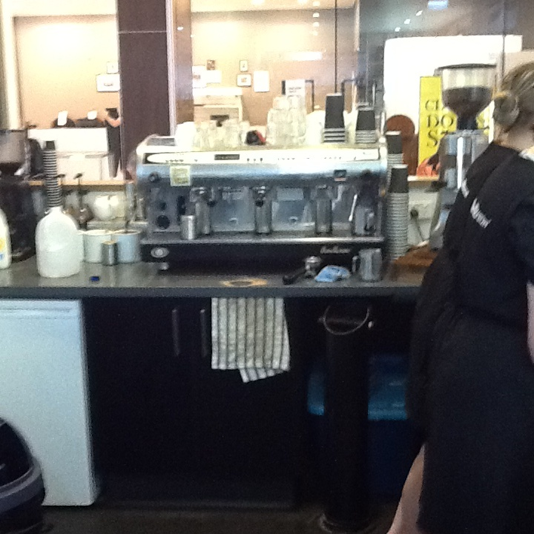

Domestic Hardware and Homeware Retailing
Cafe Assistant

Domestic Hardware and Homeware Retailing
Cafe Assistant
Dear Doctor: This form will take up to 5 minutes to complete. Please review each task the worker undertakes (both picture and written description) and tick whether or not the worker can complete this task. If modification required, please leave comments. Space at the end of this document is available for final comments and recommendations.
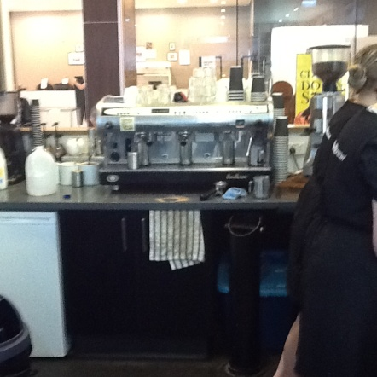  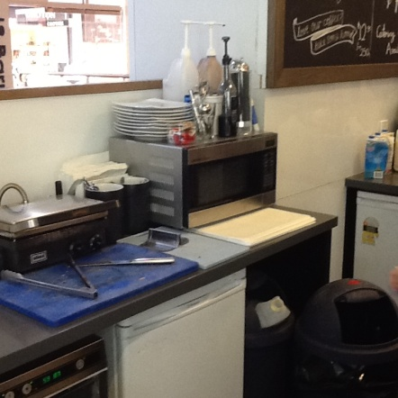 | Customer Service  - Attending to customers utilizing coffee machine and microwave when and as required.  - Constant standing and frequent grasping. | Doctor Approval  Yes No  Comments:
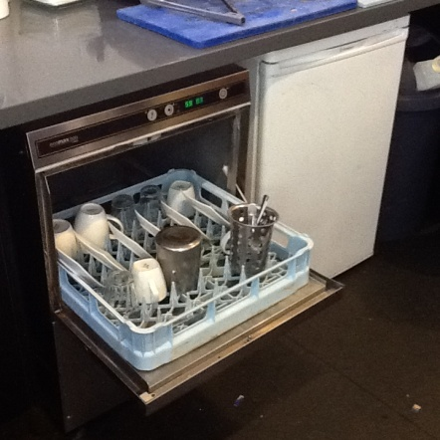  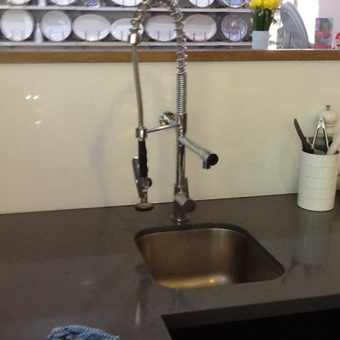 | Clean Crockery  - Loading and unloading dishwasher as required – squatting and bending required.  - Washing items as required. | Doctor Approval  Yes No  Comments:
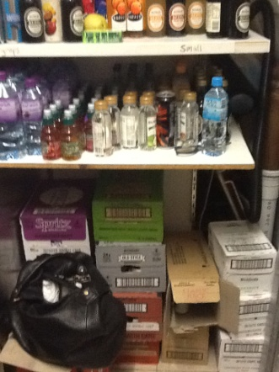 | Replenish Drink Refrigerator  - Unpacking drink boxes – squatting/stooping to retrieve drinks from shelves.  - Refilling refrigerator when required. | Doctor Approval  Yes No  Comments:
Work Capacity Form
Doctor Review (include final comments)

I confirm that in my view, subject to the above comments, the worker is able to perform certain duties detailed in this Early Medical Assessment.
These duties should be reassessed on: |  | Date:

Signature : |  | Date:

Employers Declaration:
I confirm that I/we have reviewed the Doctor’s recommendations and comments. I/we will make suitable changes to make allowances for the Doctor’s recommendations.
Signature : |  | Date:

Employees Declaration
My Doctor has discussed their recommendations with me. I have been given the opportunity to participate in this process.
Signature : |  | Date:
For information on completing this form, please contact Business SA on 08 8300 0000.
Disclaimer: This document is published by Business SA with funding from ReturnToWorkSA. All workplaces and circumstances are different and this document should be used as a guide only. It is not diagnostic and should not replace consultation, evaluation, or personal services including examination and an agreed course of action by a licensed practitioner. Business SA and ReturnToWorkSA and their affiliates and their respective agents do not accept any liability for injury, loss or damage arising from the use or reliance on this document. The copyright owner provides permission to reproduce and adapt this document for the purposes indicated and to tailor it (as intended) for individual circumstances. (C) 2016 ReturnToWorkSA

