Early Medical Assessment
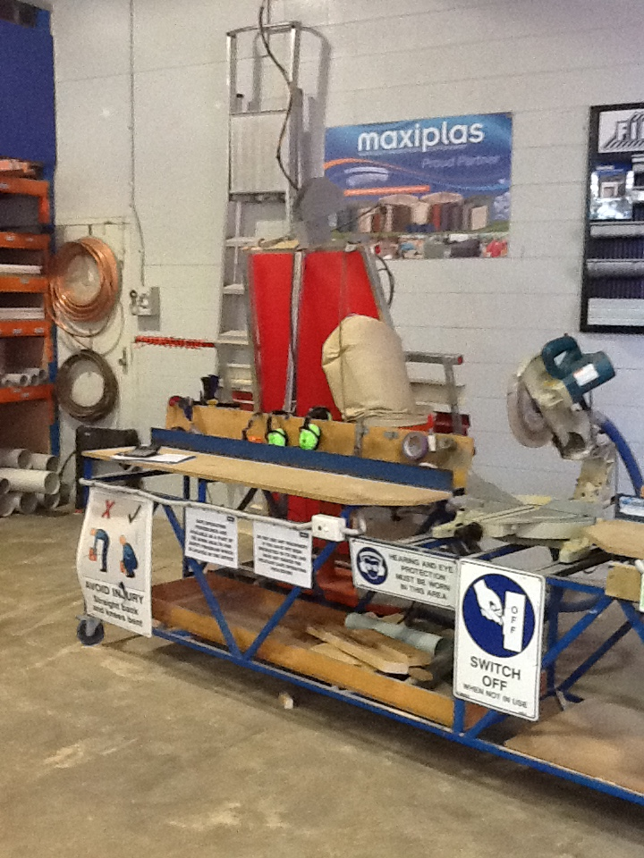
Domestic Hardware and Homeware Retailing
Building Yard Attendant
Domestic Hardware and Homeware Retailing
Building Yard Attendant
Dear Doctor: This form will take up to 5 minutes to complete. Please review each task the worker undertakes (both picture and written description) and tick whether or not the worker can complete this task. If modification required, please leave comments. Space at the end of this document is available for final comments and recommendations.
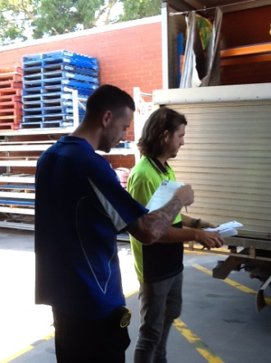  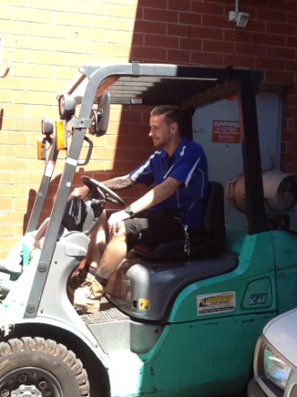 | Deliveries/Forklift Driving  - Receiving stock delivery, delivery drivers and trucks  - Receiving goods on pallets from trucks and moving to pallet racking using forklift or manual pallet jack (push/pull force)  - Bilateral upper and lower limb coordination to operate the foot and hand controls when in operation  - Frequent cervical neck flexion, extension and rotation  - Occasional thoracic lumbar twisting to view behind forklift when reversing | Doctor Approval  Yes No  Comments:
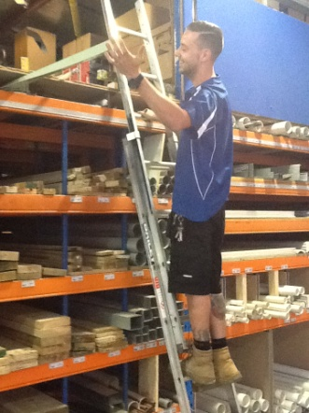 | Stacking Shelves  - Placing pieces of wood of varying lengths into shelves – up to 6m lengths  - Accessing items from above head heights using ladder  - Lower items require squatting/kneeling, lumbar stooping and overhead reaching with shoulders flexed to greater than 160 degrees | Doctor Approval  Yes No  Comments:
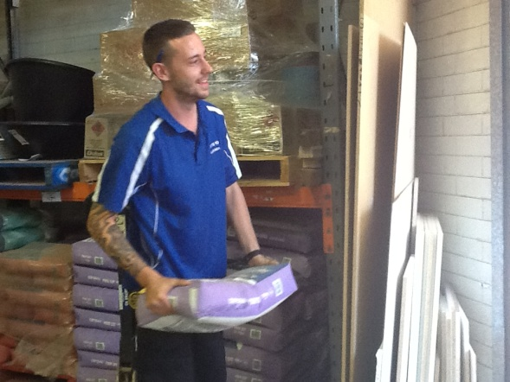 | Customer Service  - Attending to customers and carrying items for customers when required | Doctor Approval  Yes No  Comments:
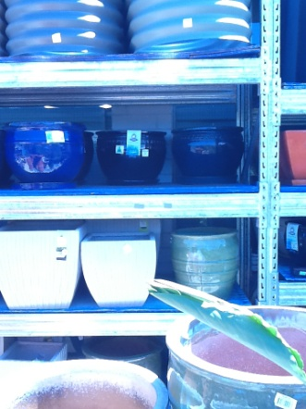 | Assist Gardening Section  - Carrying heavier pots to Gardening section  - Restocking shelves in gardening section – shelf height varies. | Doctor Approval  Yes No  Comments:
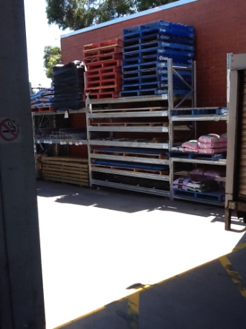  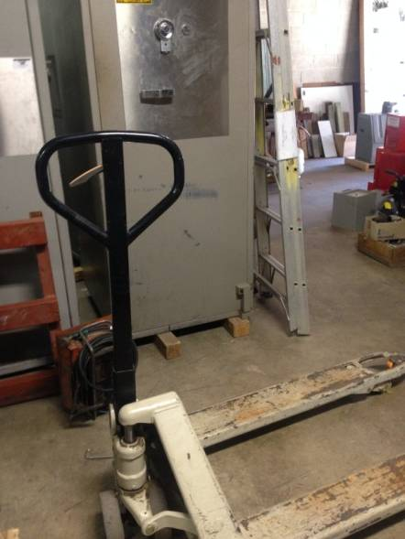 | Moving Stock  - Moving pallets and large stock using forklift or pallet jack and stacking against wall | Doctor Approval  Yes No  Comments:
Work Capacity Form
Doctor Review (include final comments)

I confirm that in my view, subject to the above comments, the worker is able to perform certain duties detailed in this Early Medical Assessment.
These duties should be reassessed on: |  | Date:

Signature : |  | Date:

Employers Declaration:
I confirm that I/we have reviewed the Doctor’s recommendations and comments. I/we will make suitable changes to make allowances for the Doctor’s recommendations.
Signature : |  | Date:

Employees Declaration
My Doctor has discussed their recommendations with me. I have been given the opportunity to participate in this process.
Signature : |  | Date:
For information on completing this form, please contact Business SA on 08 8300 0000.
Disclaimer: This document is published by Business SA with funding from ReturnToWorkSA. All workplaces and circumstances are different and this document should be used as a guide only. It is not diagnostic and should not replace consultation, evaluation, or personal services including examination and an agreed course of action by a licensed practitioner. Business SA and ReturnToWorkSA and their affiliates and their respective agents do not accept any liability for injury, loss or damage arising from the use or reliance on this document. The copyright owner provides permission to reproduce and adapt this document for the purposes indicated and to tailor it (as intended) for individual circumstances. (C) 2016 ReturnToWorkSA

