Early Medical Assessment

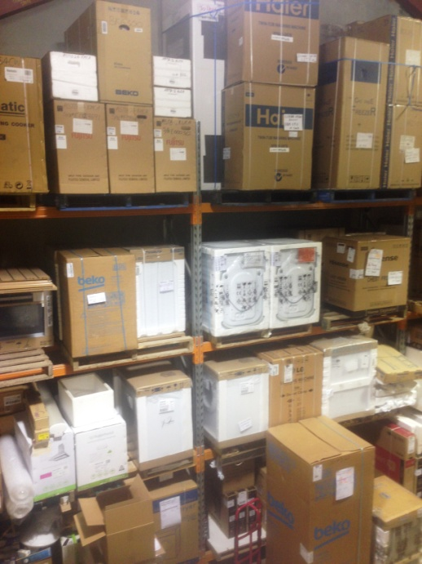

Domestic Appliance Retailing
Storeperson

Domestic Appliance Retailing
Store Person
Dear Doctor: This form will take up to 5 minutes to complete. Please review each task the worker undertakes (both picture and written description) and tick whether or not the worker can complete this task. If modification required, please leave comments. Space at the end of this document is available for final comments and recommendations.
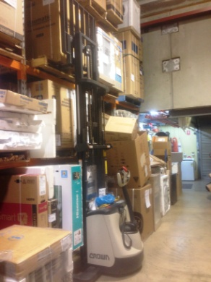 | Receiving Goods  - Goods are delivered by truck to loading bay.  - Unloading truck using hand driven forklift .  - Complete paperwork.  - Arranging products on pallet for lifting into shelving with forklift. Some maneuvering of product on sack truck to get onto pallet may be required. Weights of items range up to 86kg (fridge). | Doctor Approval  Yes No  Comments:
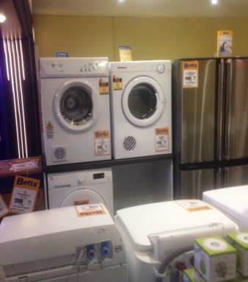  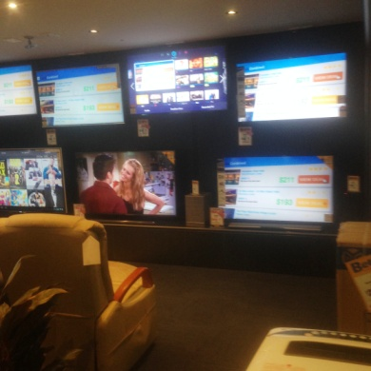 | Store Displays  - Taking display products out of boxes (and retaining for later in a storeroom). Handling of boxes, tape and reaching at varying ranges remove box off.  - Pushing sack truck with product on it to showroom and placing in appropriate position.  - With a second worker placing TVs on wall mounts infrequently.  - Constant standing, occasional bending, frequent pushing, constant handling. | Doctor Approval  Yes No  Comments:
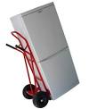  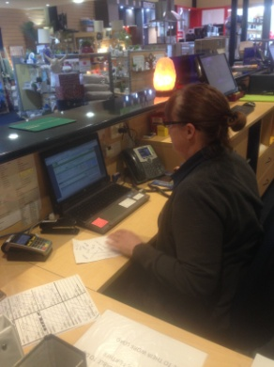 | Organizing Deliveries  - Organizing deliveries of goods to customers with delivery driver. Picking order and placing by roller door for collection.  - Use of sack truck and / or forklift to pick order.  - Undertaking necessary paperwork associated with deliveries.  - Constant standing, occasional bending and twisting, frequent pushing, constant handling. | Doctor Approval  Yes No  Comments:
Work Capacity Form
Doctor Review (include final comments)

I confirm that in my view, subject to the above comments, the worker is able to perform certain duties detailed in this Early Medical Assessment.
These duties should be reassessed on: |  | Date:

Signature : |  | Date:

Employers Declaration:
I confirm that I/we have reviewed the Doctor’s recommendations and comments. I/we will make suitable changes to make allowances for the Dr’s recommendations.
Signature : |  | Date:

Employees Declaration
My Doctor has discussed their recommendations with me. I have been given the opportunity to participate in this process.
Signature : |  | Date:
For information on completing this form, please contact Business SA on 08 8300 0000.
Disclaimer: This document is published by Business SA with funding from ReturnToWorkSA. All workplaces and circumstances are different and this document should be used as a guide only. It is not diagnostic and should not replace consultation, evaluation, or personal services including examination and an agreed course of action by a licensed practitioner. Business SA and ReturnToWorkSA and their affiliates and their respective agents do not accept any liability for injury, loss or damage arising from the use or reliance on this document. The copyright owner provides permission to reproduce and adapt this document for the purposes indicated and to tailor it (as intended) for individual circumstances. (C) 2016 ReturnToWorkSA

