Early Medical Assessment

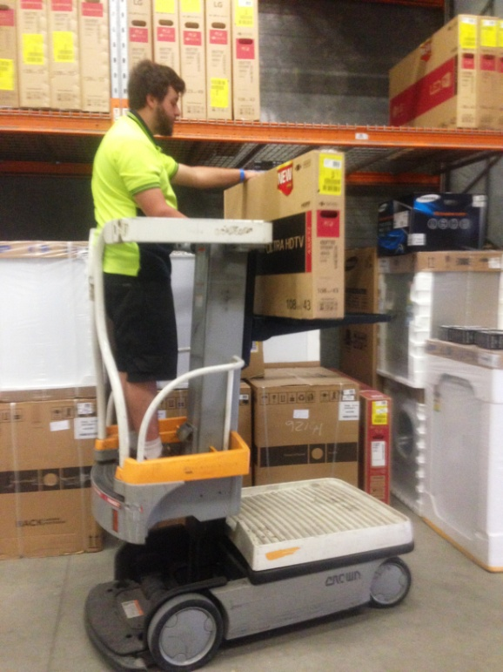

Domestic Appliance Retailing
Storeperson – Electrical

Domestic Appliance Retailing
Storeperson
Dear Doctor: This form will take up to 5 minutes to complete. Please review each task the worker undertakes (both picture and written description) and tick whether or not the worker can complete this task. If modification required, please leave comments. Space at the end of this document is available for final comments and recommendations.
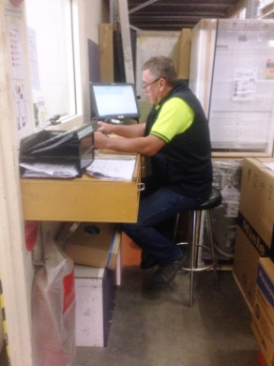  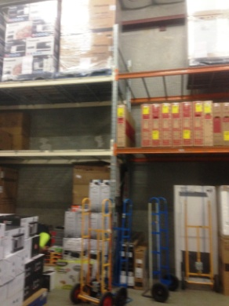  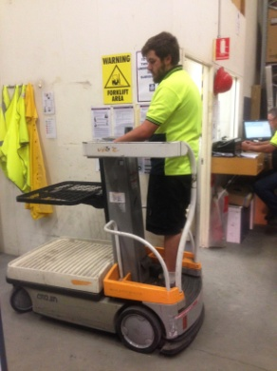  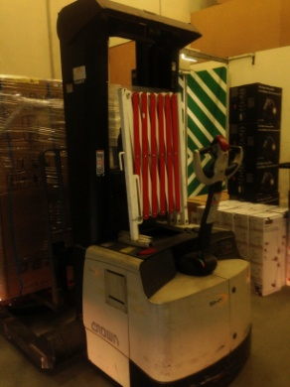 | Stock Control  - Entering stock into computer system whilst seated.  - Printing and placing a coded sticker onto each item of stock.  - Organizing stock onto a pallet or flat bed trolley to enable it to be moved to showroom. Lifting and carrying may be required for manageable weights.  - Trolley truck, flat bed trolley, sack truck can be pushed or automatic Work Assisted Vehicle) WAV can be used to move stock.  - WAV is operated by standing on it and using bilateral hand controls to raise platform. Stock is then slid from shelf onto tray in front of worker. Some rotation of spine and reaching may be required to access stock on shelves.  - A hand controlled forklift also available for those who are trained to use it. Front handle is pulled down to comfortable height and both hands are used to control it. Neck extension required to view objects on high shelving. Neck rotation for looking behind self if moving backwards.  - Many items are kept in showroom on floor to chest height shelving. Higher shelves are used however WAV or forklift is used. Overflow items are kept on shelving in the warehouse. | Doctor Approval  Yes No  Comments:
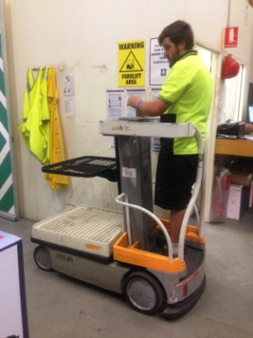 | Receiving Deliveries  - Truck is generally unloaded by truck driver.  - Checking and counting stock against invoice.  - Moving stock from outside delivery area to holding area using assistive equipment.  - Sitting to enter data into computer. | Doctor Approval  Yes No  Comments:
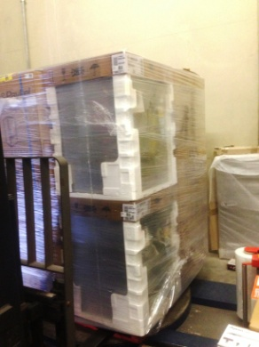 | Pallet Wrapping  - Pallet is placed on rotating disk using forklift.  - Plastic is held upright on a roller which automatically rises to wrap palletized products. Controlled with buttons. | Doctor Approval  Yes No  Comments:
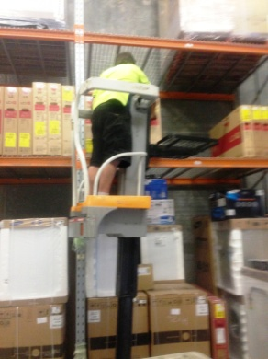  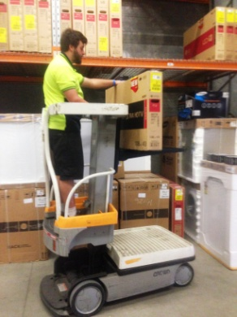 | Picking Orders  - Orders for next day delivery are picked from display room floor or warehouse by storeperson and arranged at rear of warehouse for collection by a contract driver. | Doctor Approval  Yes No  Comments:
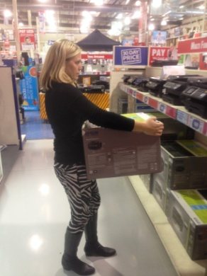 | Assisting Customer Service  - During the course of the day the storeperson will be asked to assist the customer service representatives to move floor stock for customers either by lifting and carrying or using available machinery. | Doctor Approval  Yes No  Comments:
Work Capacity Form
Doctor Review (include final comments)

I confirm that in my view, subject to the above comments, the worker is able to perform certain duties detailed in this Early Medical Assessment.
These duties should be reassessed on: |  | Date:

Signature : |  | Date:

Employers Declaration:
I confirm that I/we have reviewed the Doctor’s recommendations and comments. I/we will make suitable changes to make allowances for the Dr’s recommendations.
Signature : |  | Date:

Employees Declaration
My Doctor has discussed their recommendations with me. I have been given the opportunity to participate in this process.
Signature : |  | Date:
For information on completing this form, please contact Business SA on 08 8300 0000.
Disclaimer: This document is published by Business SA with funding from ReturnToWorkSA. All workplaces and circumstances are different and this document should be used as a guide only. It is not diagnostic and should not replace consultation, evaluation, or personal services including examination and an agreed course of action by a licensed practitioner. Business SA and ReturnToWorkSA and their affiliates and their respective agents do not accept any liability for injury, loss or damage arising from the use or reliance on this document. The copyright owner provides permission to reproduce and adapt this document for the purposes indicated and to tailor it (as intended) for individual circumstances. (C) 2016 ReturnToWorkSA

