Early Medical Assessment

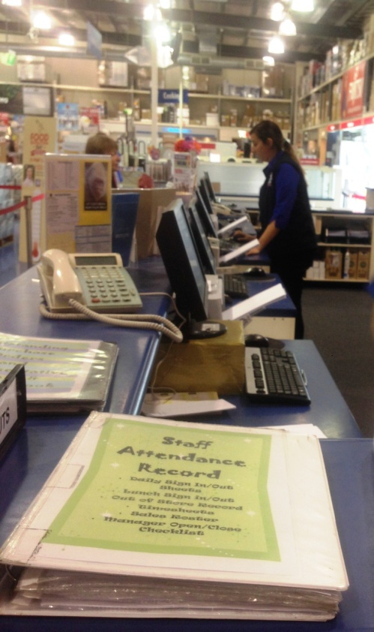

Domestic Appliance Retailing
Sales Person

Domestic Appliance Retailing
Sales Person
Dear Doctor: This form will take up to 5 minutes to complete. Please review each task the worker undertakes (both picture and written description) and tick whether or not the worker can complete this task. If modification required, please leave comments. Space at the end of this document is available for final comments and recommendations.
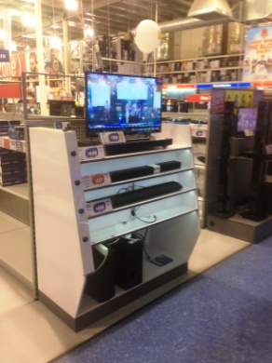 | Customer Service  - Constant standing and walking whist interacting with customers.  - Demonstrating products and moving them for customers.  - Entering sale details on computer whilst standing.  - Verbally giving details to Administrators who put the sale through. | Doctor Approval  Yes No  Comments:
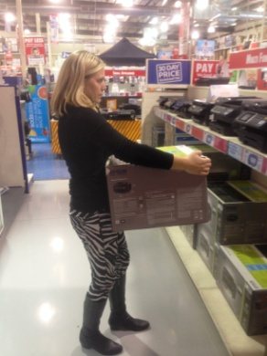  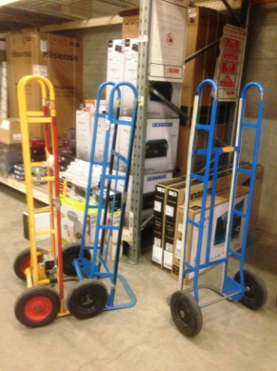  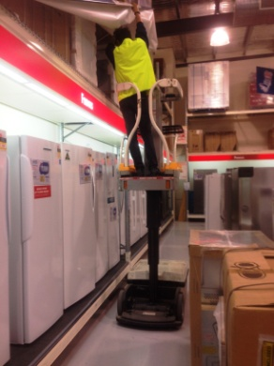 | Moving Stock  - Whilst merchandising or assisting the customer to their vehicle.  - Lifting and carrying boxed items of varying weights.  - If required assistance can be provided from the Warehouse team.  - Trolley truck, flat bed trolley, sack truck can be pushed or automatic Work Assisted Vehicle) WAV can be used to move stock. | Doctor Approval  Yes No  Comments:
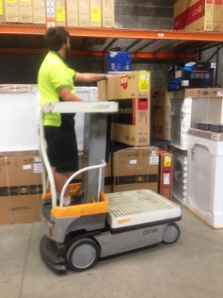  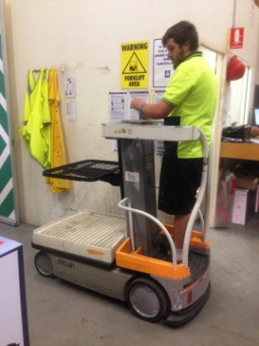 | Restocking Shelves  - Moving stock from storeroom to shop floor to refill shelves  - Frequent lifting utilized to restock shelves between floor and chest height.  - Trolley truck, flat bed trolley, sack truck can be pushed or automatic Work Assisted Vehicle) WAV can be used to move stock.
Work Capacity Form
Doctor Review (include final comments)

I confirm that in my view, subject to the above comments, the worker is able to perform certain duties detailed in this Early Medical Assessment.
These duties should be reassessed on: |  | Date:

Signature : |  | Date:

Employers Declaration:
I confirm that I/we have reviewed the Doctor’s recommendations and comments. I/we will make suitable changes to make allowances for the Dr’s recommendations.
Signature : |  | Date:

Employees Declaration
My Doctor has discussed their recommendations with me. I have been given the opportunity to participate in this process.
Signature : |  | Date:
For information on completing this form, please contact Business SA on 08 8300 0000.
Disclaimer: This document is published by Business SA with funding from ReturnToWorkSA. All workplaces and circumstances are different and this document should be used as a guide only. It is not diagnostic and should not replace consultation, evaluation, or personal services including examination and an agreed course of action by a licensed practitioner. Business SA and ReturnToWorkSA and their affiliates and their respective agents do not accept any liability for injury, loss or damage arising from the use or reliance on this document. The copyright owner provides permission to reproduce and adapt this document for the purposes indicated and to tailor it (as intended) for individual circumstances. (C) 2016 ReturnToWorkSA

