Early Medical Assessment

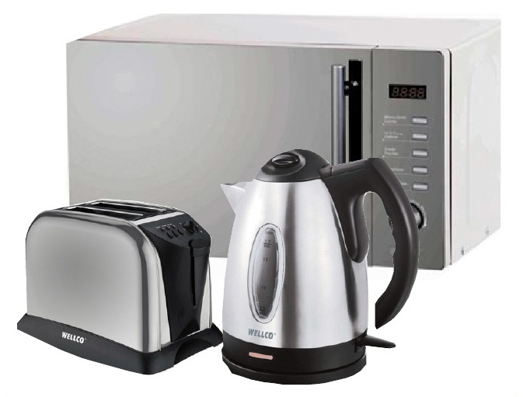

Domestic Appliance Retailing
Sales Person

Domestic Appliance Retailing
Sales Person
Dear Doctor: This form will take up to 5 minutes to complete. Please review each task the worker undertakes (both picture and written description) and tick whether or not the worker can complete this task. If modification required, please leave comments. Space at the end of this document is available for final comments and recommendations.
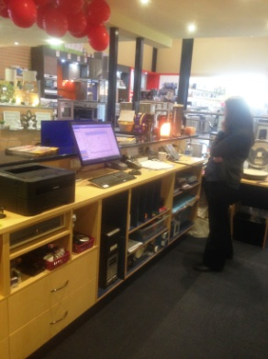  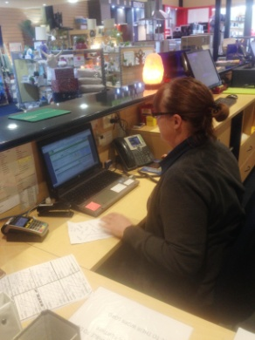 | Customer Service  - Constant standing at service counter and walking around store assisting customers.  - Occasional sitting to undertake computer based duties.  - Demonstrating products as necessary.  - Shelves located between floor and overhead height with most being on shelving at or below chest height. Therefore low level postures may be required and reaching through all ranges.  - Use of POS whilst standing at bench with computer. Product numbers entered via keyboard. | Doctor Approval  Yes No  Comments:
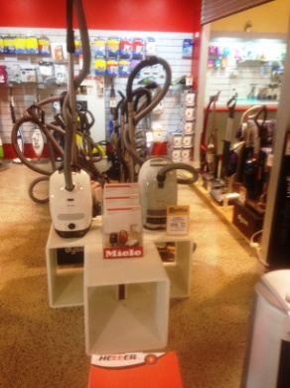  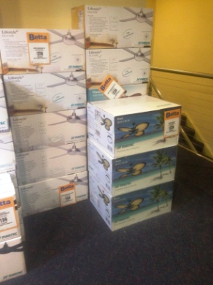 | Stock Handling  - Shelving as above.  - Lighter products are stored on higher shelves.  - Store person handles heavier whitegoods and browngoods.  - Sales person can replace and face up lighter objects at comfortable weight / height.  - Constant standing and walking in showroom and warehouse, reaching at all levels, stair climbing to storeroom of lightweight (<10kg) products), occasional low level postures, constant handling. | Doctor Approval  Yes No  Comments:
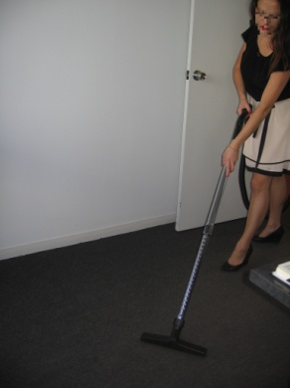  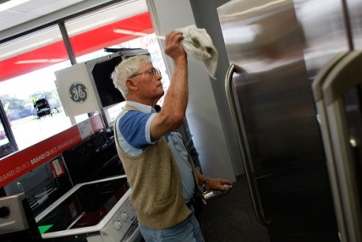 | Cleaning  - Vacuuming as required.  - Dusting and wiping surfaces. | Doctor Approval  Yes No  Comments:
Work Capacity Form
Doctor Review (include final comments)

I confirm that in my view, subject to the above comments, the worker is able to perform certain duties detailed in this Early Medical Assessment.
These duties should be reassessed on: |  | Date:

Signature : |  | Date:

Employers Declaration:
I confirm that I/we have reviewed the Doctor’s recommendations and comments. I/we will make suitable changes to make allowances for the Dr’s recommendations.
Signature : |  | Date:

Employees Declaration
My Doctor has discussed their recommendations with me. I have been given the opportunity to participate in this process.
Signature : |  | Date:
For information on completing this form, please contact Business SA on 08 8300 0000.
Disclaimer: This document is published by Business SA with funding from ReturnToWorkSA. All workplaces and circumstances are different and this document should be used as a guide only. It is not diagnostic and should not replace consultation, evaluation, or personal services including examination and an agreed course of action by a licensed practitioner. Business SA and ReturnToWorkSA and their affiliates and their respective agents do not accept any liability for injury, loss or damage arising from the use or reliance on this document. The copyright owner provides permission to reproduce and adapt this document for the purposes indicated and to tailor it (as intended) for individual circumstances. (C) 2016 ReturnToWorkSA

