Early Medical Assessment

Domestic Appliance Retailing
Refrigeration Mechanic, Service Technician

Domestic Appliance Retailing
Refrigeration Mechanic, Service Technician
Dear Doctor: This form will take up to 5 minutes to complete. Please review each task the worker undertakes (both picture and written description) and tick whether or not the worker can complete this task. If modification required, please leave comments. Space at the end of this document is available for final comments and recommendations.
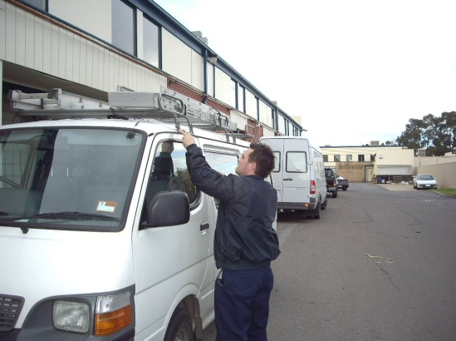  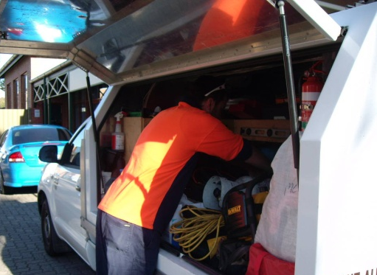 | Manual Handling  - Occasional lifting in excess of 35kg, often while in awkward positions.  - Frequent handling of power tools; testing tools and gauges.  - Frequent handling of small parts.  - Gathering ladders from the top of the work vehicle conducted in a standing position requiring shoulder flexion greater than 90° .  - Gathering items from the rear of the vehicle requiring some stooping and bending. | Doctor Approval  Yes No  Comments:
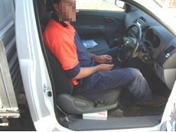 | Working Conditions  - Sitting/driving for prolonged periods when travelling to remote areas.  - Conducting work in freezers at below -5°C and fridges at 0°-4°C.  - Conducting work on roof tops with temperatures above 50°C.  - Conducting work in confined spaces. | Doctor Approval  Yes No  Comments:
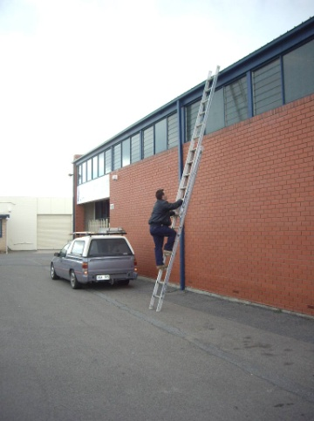  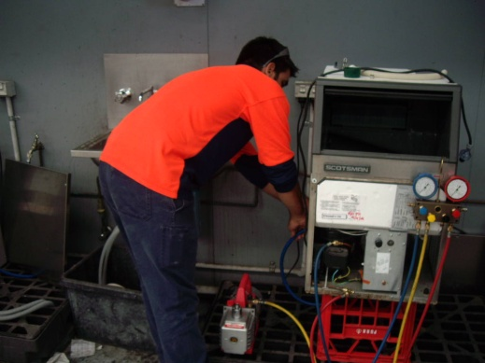  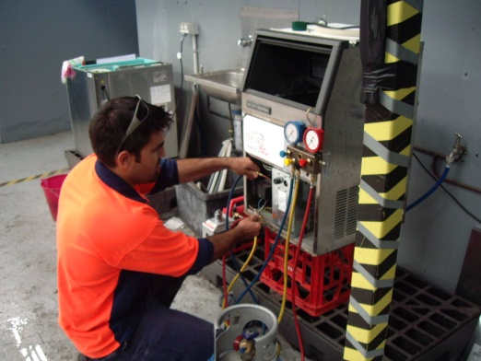 | Physical Requirements  - Repetitive and prolonged periods of either climbing ladders, squatting, or kneeling, involving bilateral lower limbs and knees.  - Reaches are generally within the body ranges however occasional reaching outside of the body, sometimes in awkward positions.  - Reaching from floor level to above head heights with 75% of work conducted either in a kneeling position or on a ladder.  - Leaning into or around fridges and over equipment causing moderate to high muscle strain when stooped.  - Bilateral upper and lower limb coordination to get in/out of Utility vehicle and to operate the foot pedals and hand controls when driving. | Doctor Approval  Yes No  Comments:
Work Capacity Form
Doctor Review (include final comments)

I confirm that in my view, subject to the above comments, the worker is able to perform certain duties detailed in this Early Medical Assessment.
These duties should be reassessed on: |  | Date:

Signature : |  | Date:

Employers Declaration:
I confirm that I/we have reviewed the Doctor’s recommendations and comments. I/we will make suitable changes to make allowances for the Dr’s recommendations.
Signature : |  | Date:

Employees Declaration
My Doctor has discussed their recommendations with me. I have been given the opportunity to participate in this process.
Signature : |  | Date:
For information on completing this form, please contact Business SA on 08 8300 0000.
Disclaimer: This document is published by Business SA with funding from ReturnToWorkSA. All workplaces and circumstances are different and this document should be used as a guide only. It is not diagnostic and should not replace consultation, evaluation, or personal services including examination and an agreed course of action by a licensed practitioner. Business SA and ReturnToWorkSA and their affiliates and their respective agents do not accept any liability for injury, loss or damage arising from the use or reliance on this document. The copyright owner provides permission to reproduce and adapt this document for the purposes indicated and to tailor it (as intended) for individual circumstances. (C) 2016 ReturnToWorkSA

